**Investigation of the Ability of Normality Tests in Detecting Issues in Downstream Tests--Research Report**

**Ella Li**

**Research Abstract**

The assumption of normality needs to be checked for many statistical procedures, namely parametric tests, since their validity depends on it. Researchers have studied and compared the type I error rate and power of normality tests under different distributions and concluded the most powerful normality tests for normal distribution and non-normal distributions respectively.

Although statistical procedures usually provide relatively accurate results except for the situation for which there are extreme violations of normality assumption, violation of normality assumption in downstream test may result in inflated type-I error rate or loss of power. We are attempting to understand how well the normality tests are able to detect such issues in downstream tests using simulated data. With the difference of type-I error rates and powers of downstream tests between normal and non-normal distributions obtained, we combined the type-I error rates and powers of normality test for the specific non-normal distribution with it to explore the ability of normality tests in detecting issues such as inflated type-I error rate or loss of power in downstream tests.

**General Bases -- User-Defined Functions**

1. generate_data ~ Simulate data from different distribution but located similarly

2. generate_tests ~ Apply different tests on simulated data

**Paper/Literature Review**

*-Paper Reference: Öztuna et al. (2006). Investigation of four different normality tests in terms of type 1 error rate and power under different distributions.*

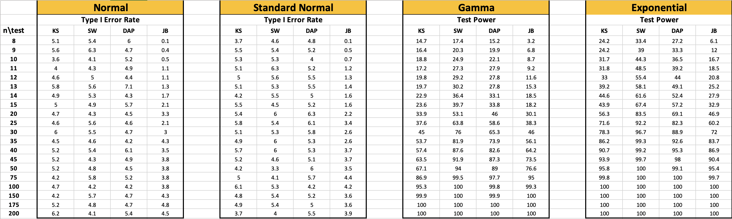

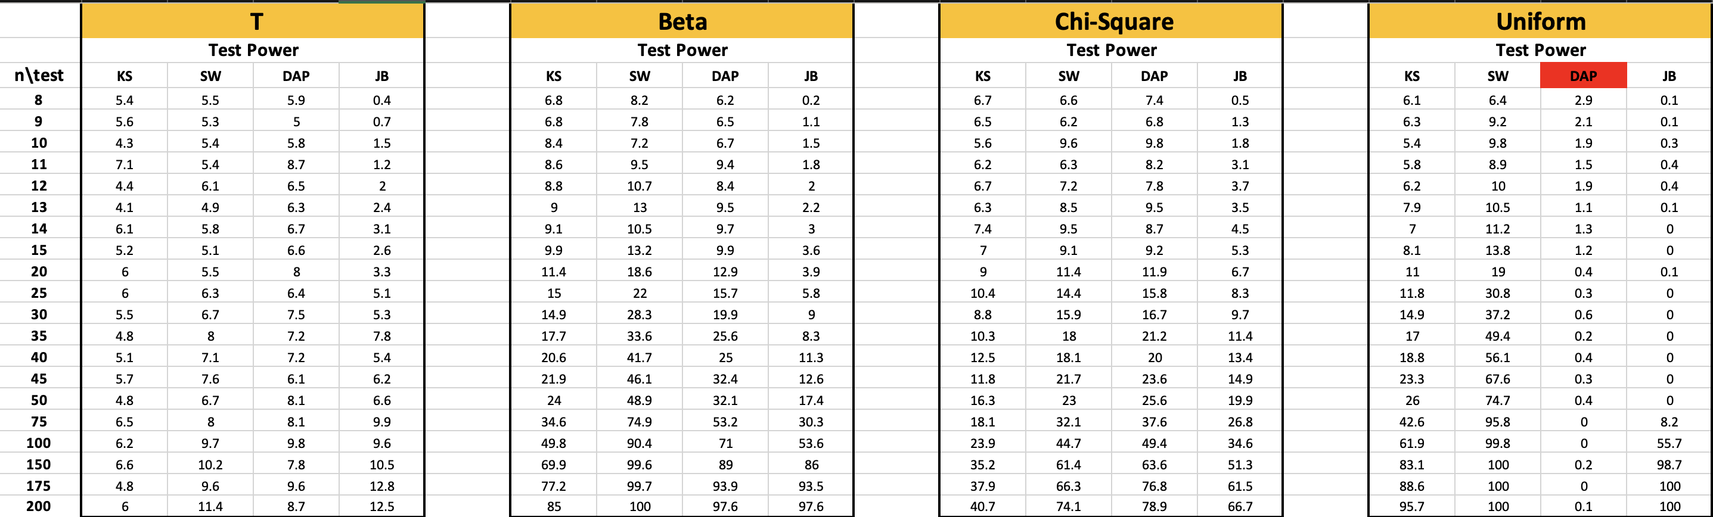

After comparison of results with original paper, only the test power of DAP test for Uniform distribution is different. (As noted in above picture)

**One-Sample t test ---SW test**

1. **Chi-Square Distribution**

* **Type I Error Rate**

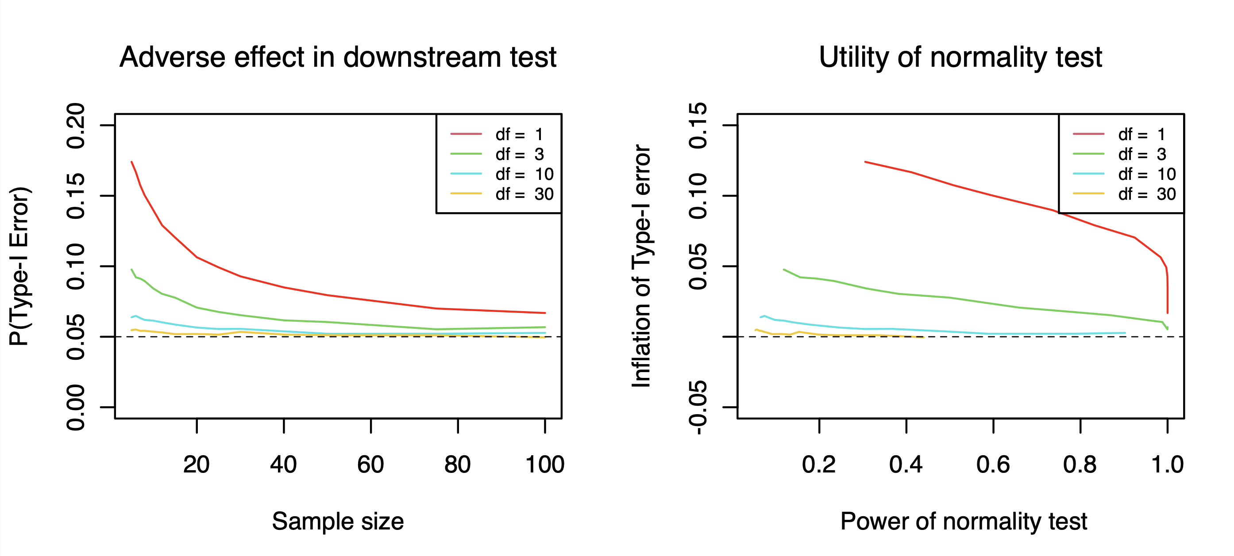

* **Power—d=0.5**

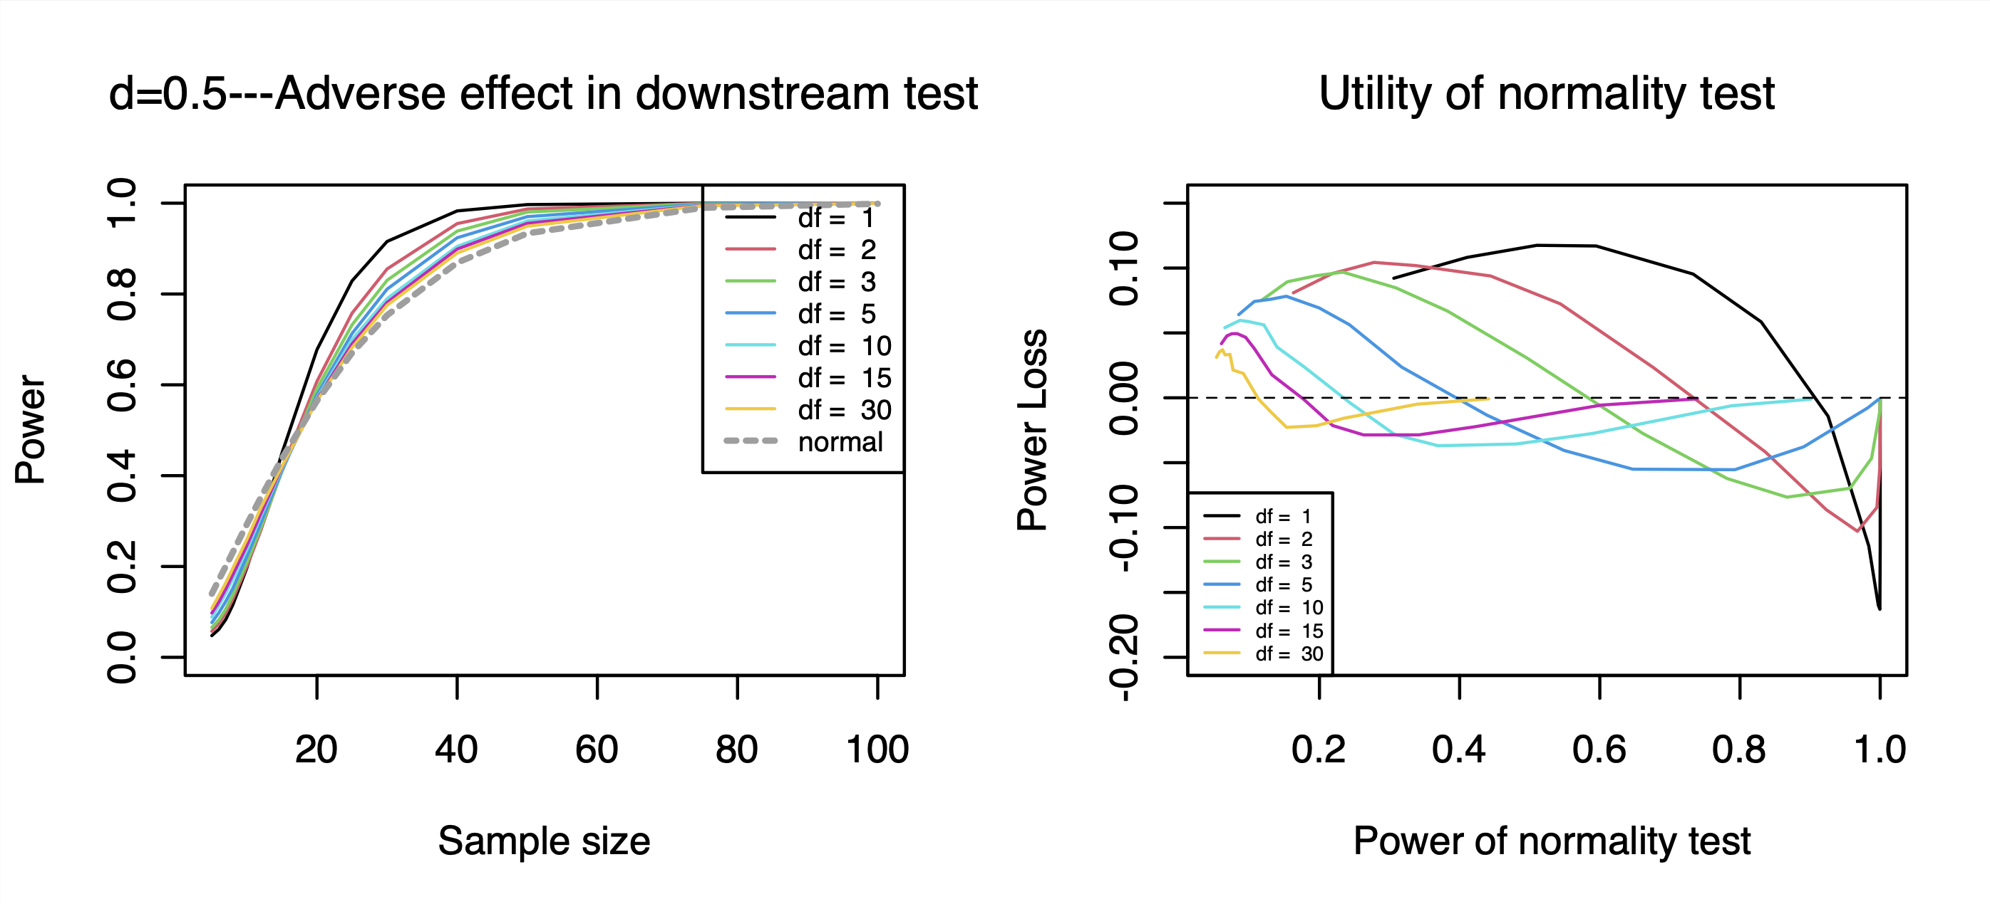

* **Power—d=1**

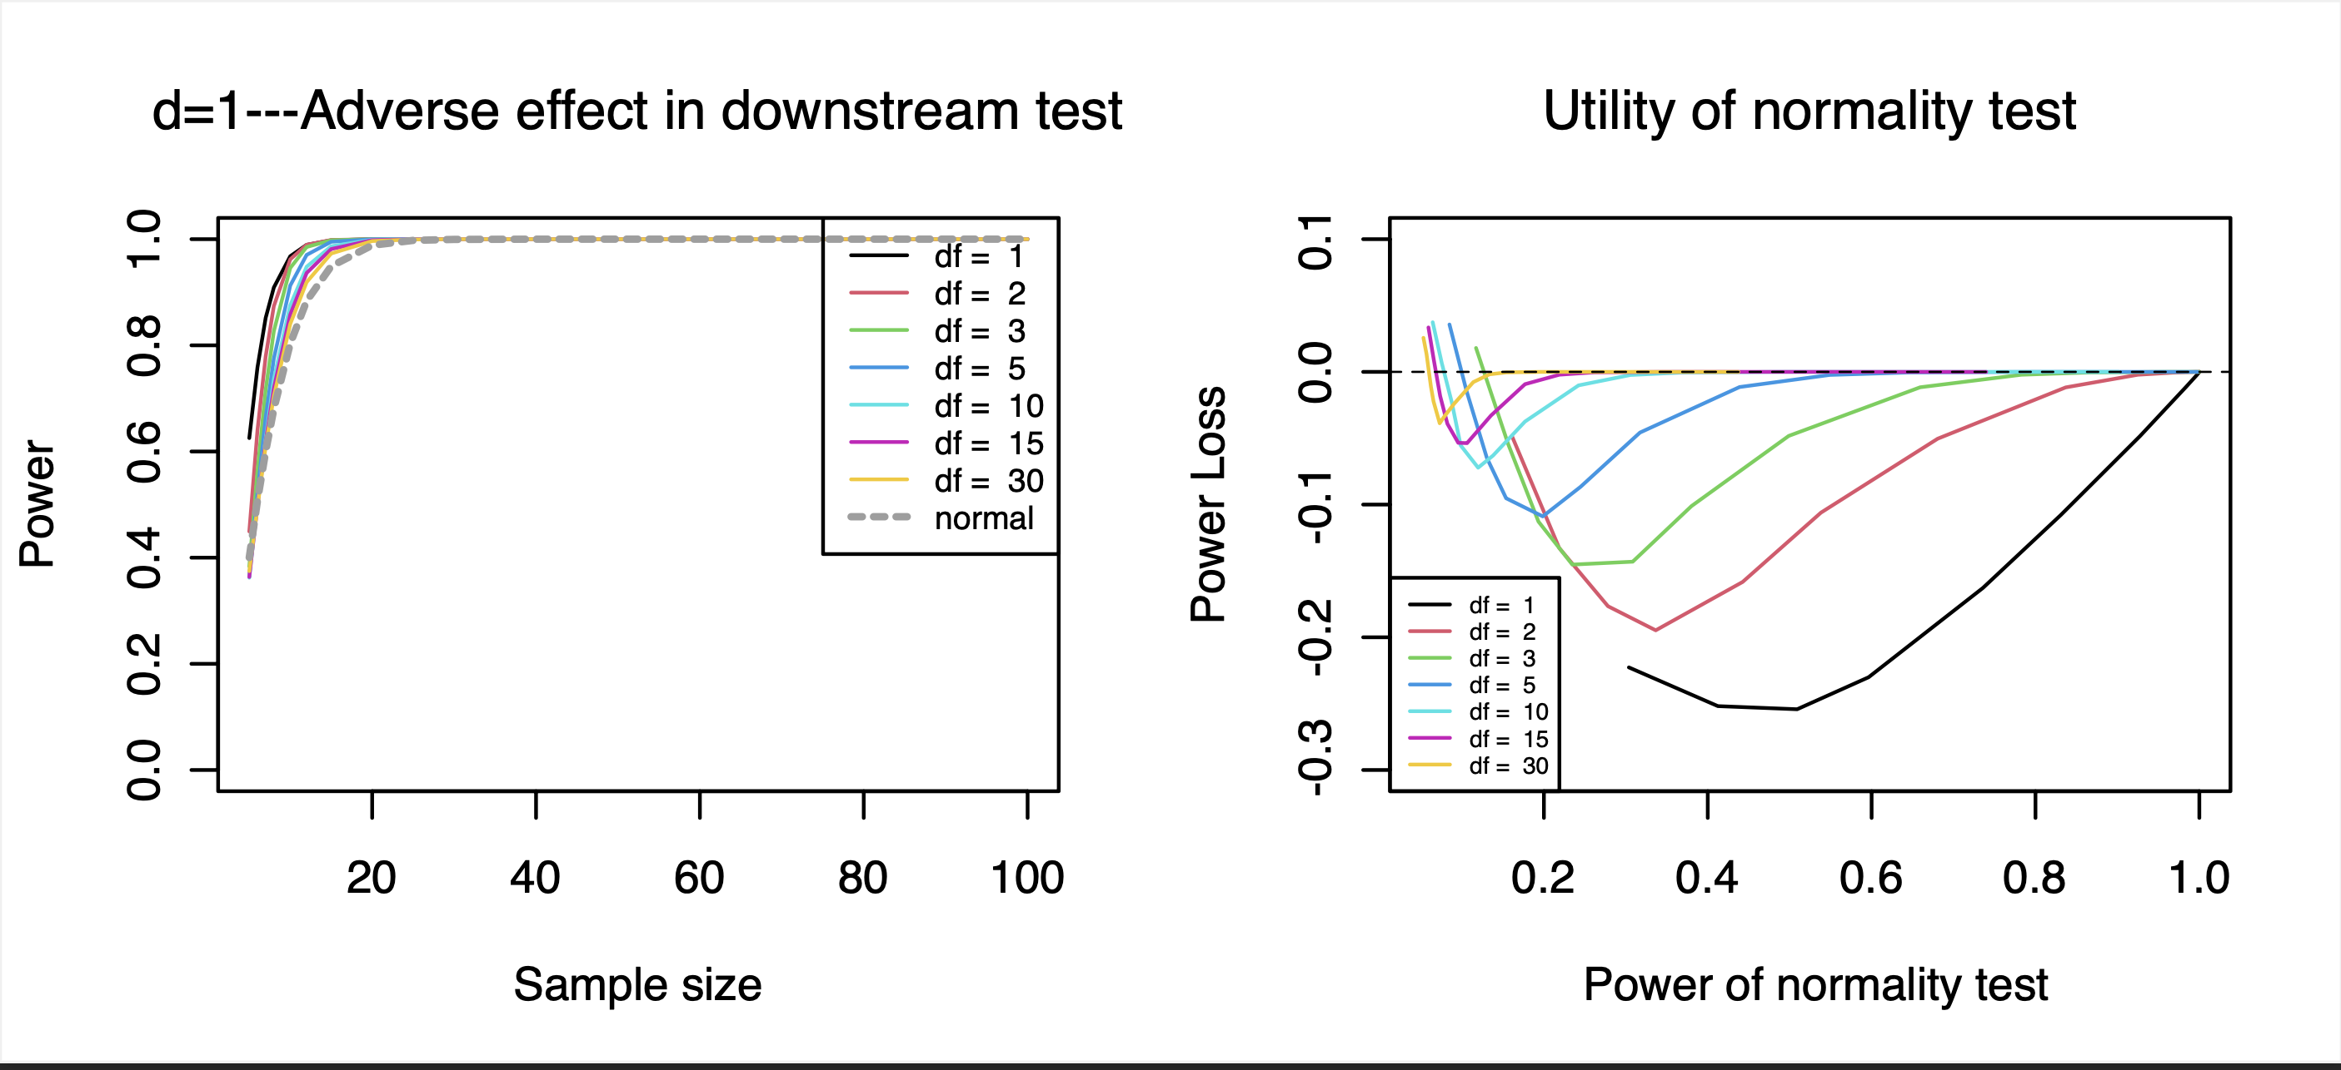

1. **Beta Distribution**

* **Type I Error Rate**

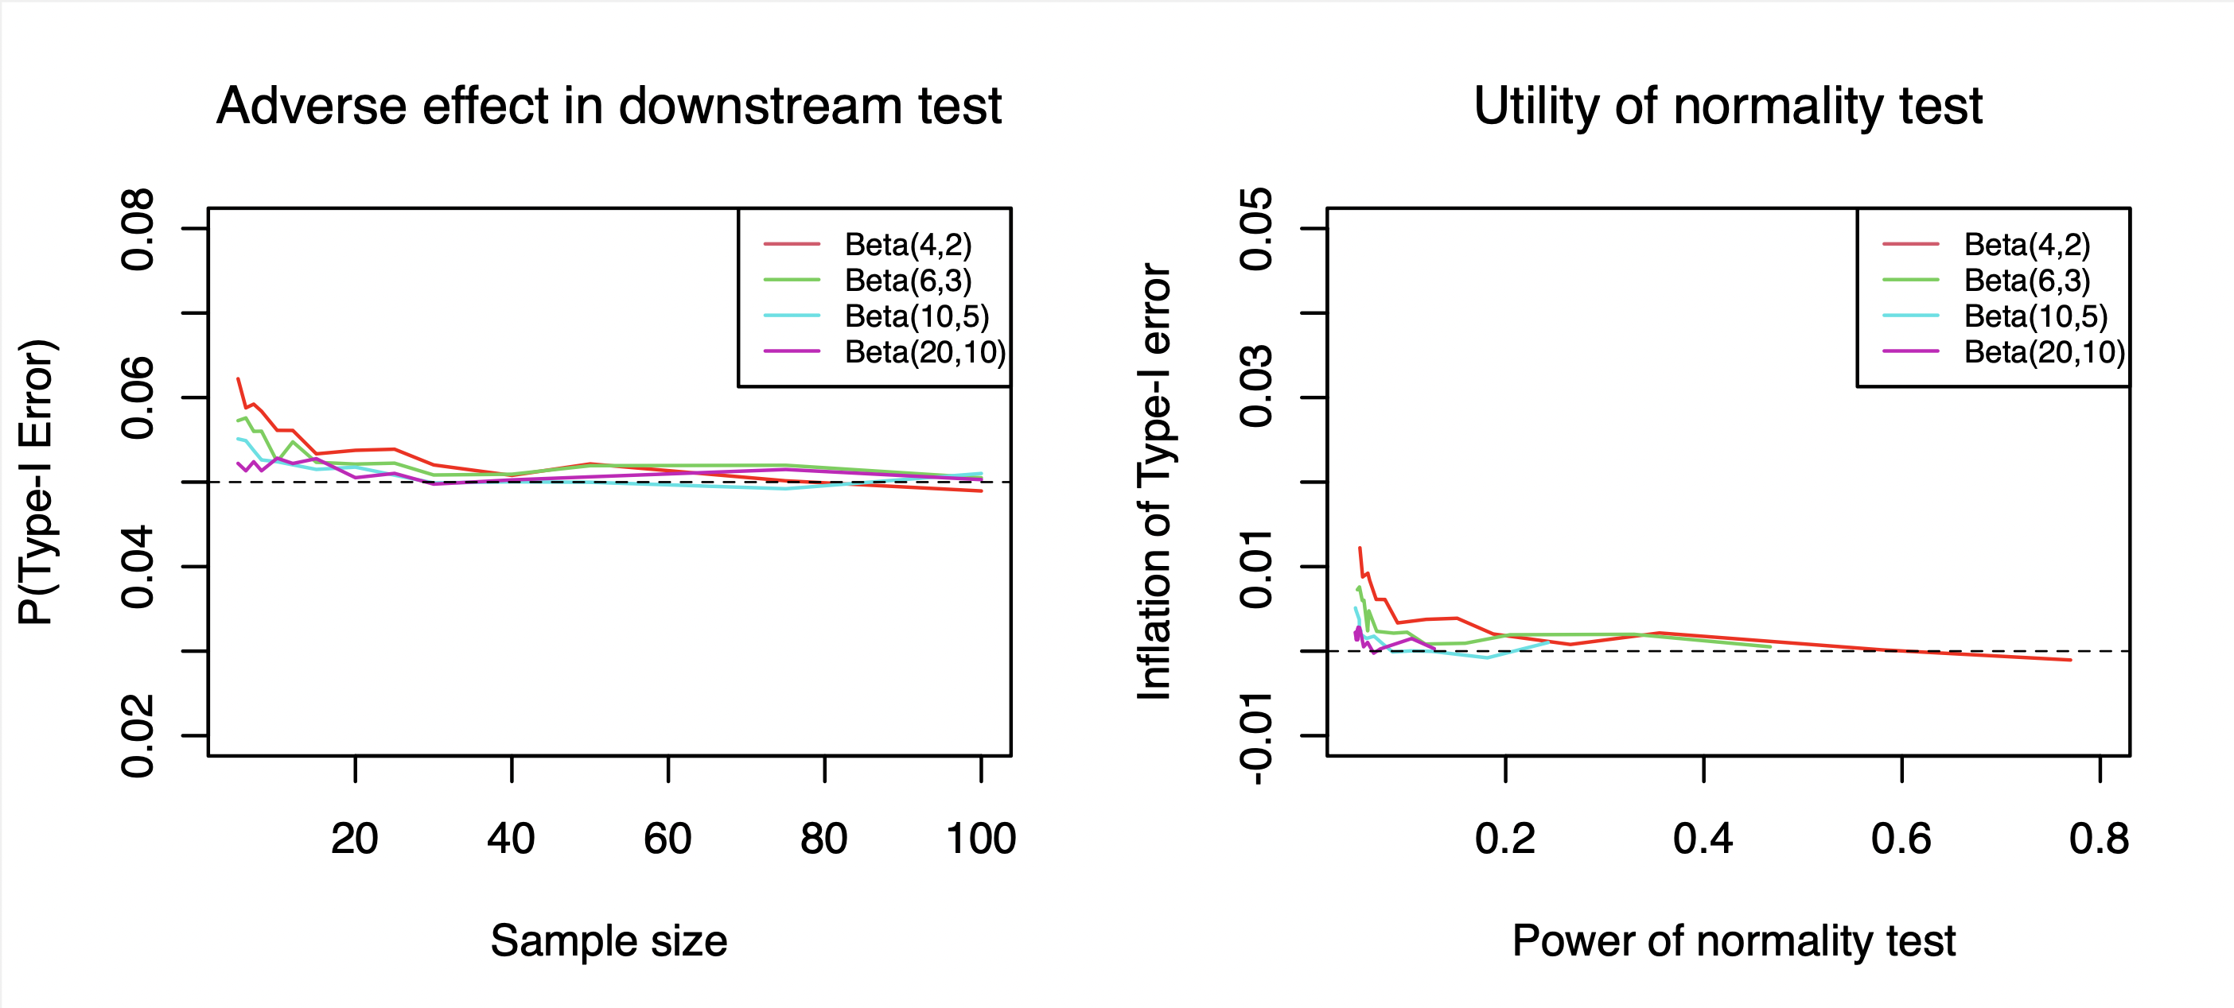

* **Power—d=0.5**

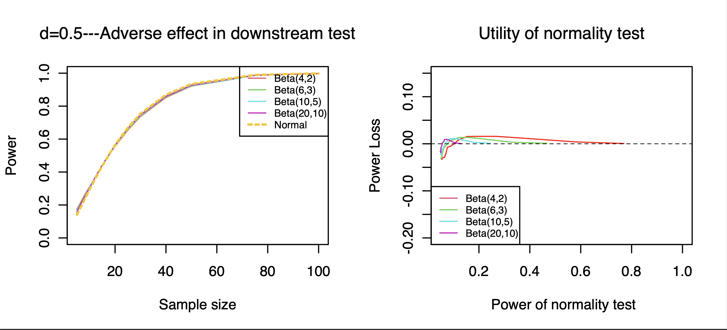

* **Power—d=1**

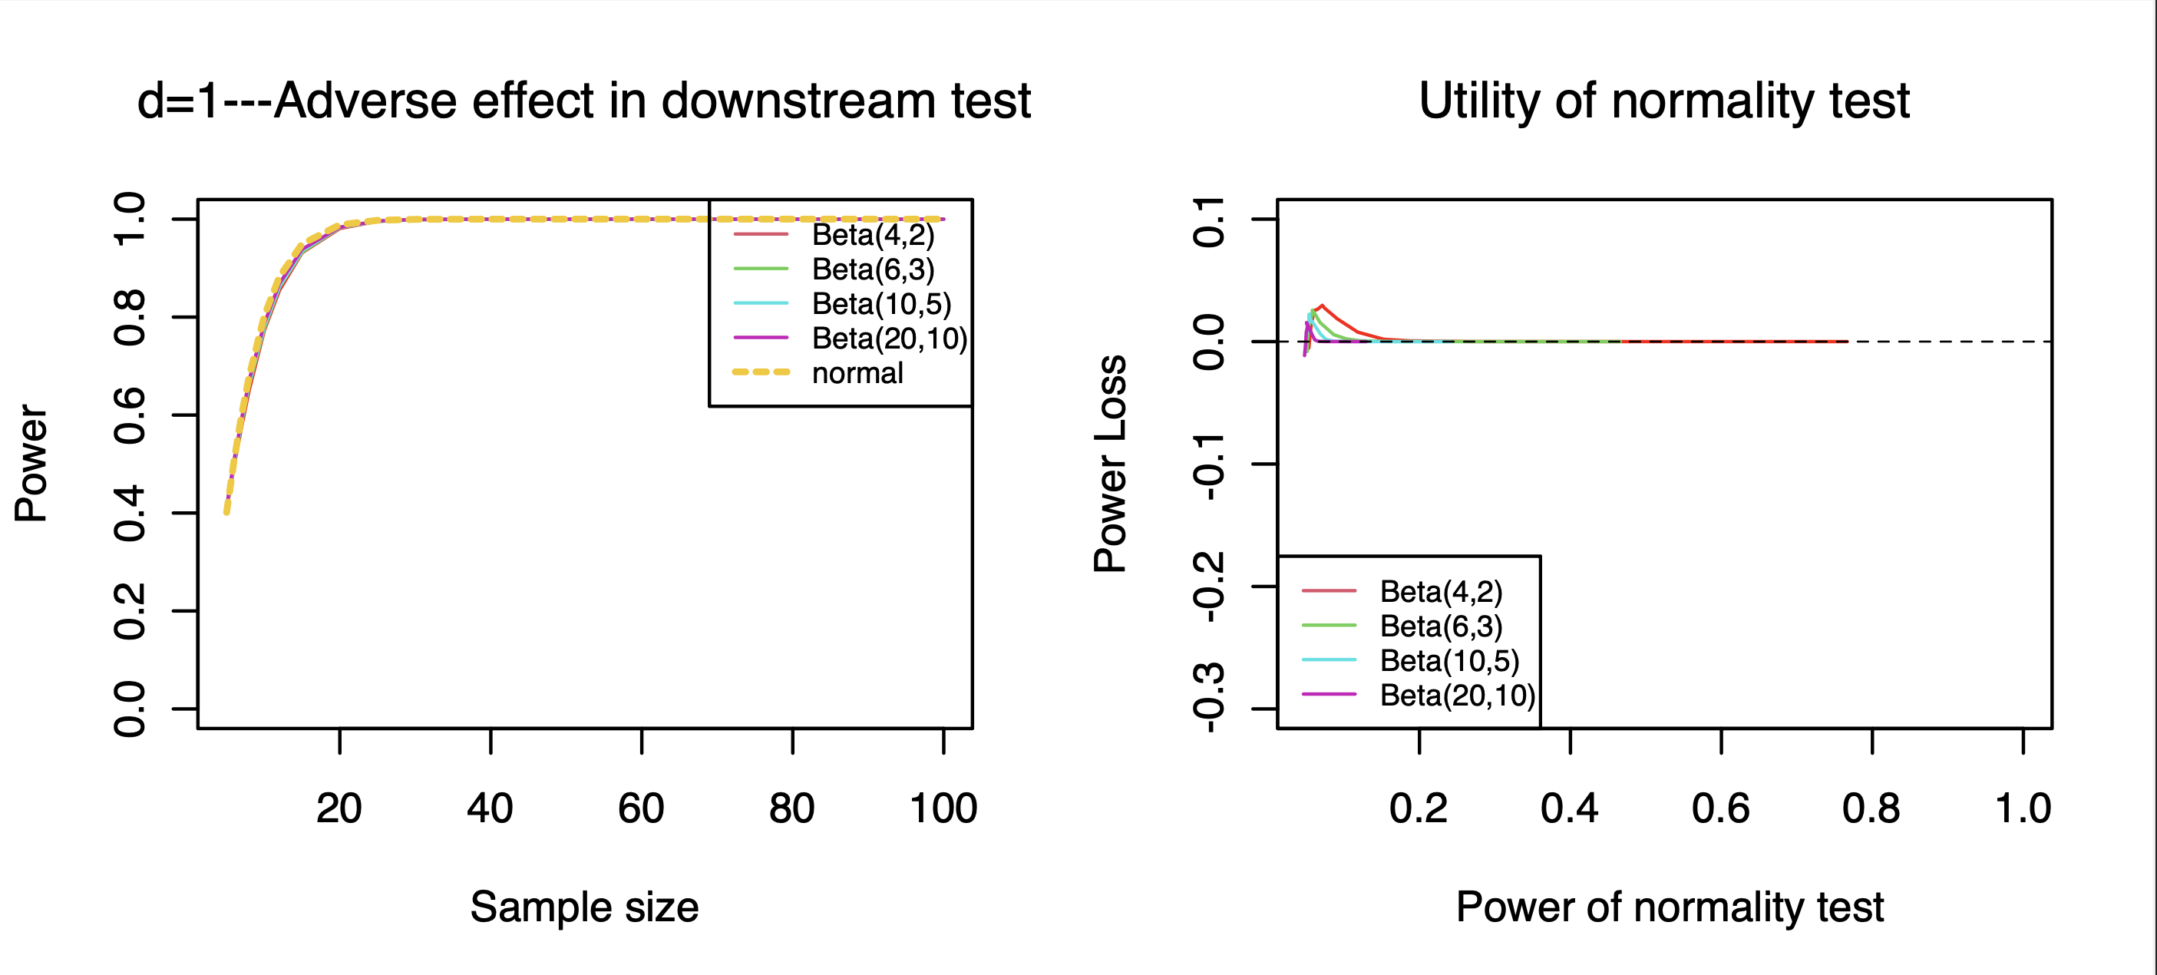

1. **Student’s t-Distribution**

* **Type I Error Rate**

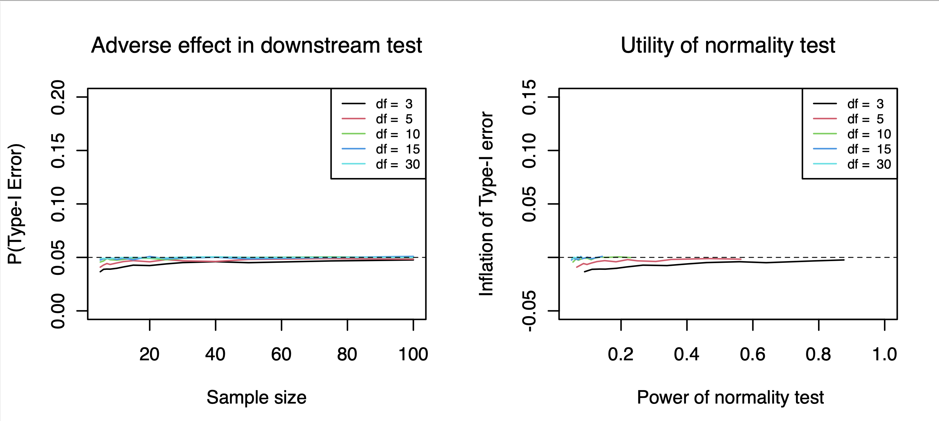

* **Power—d=0.5**

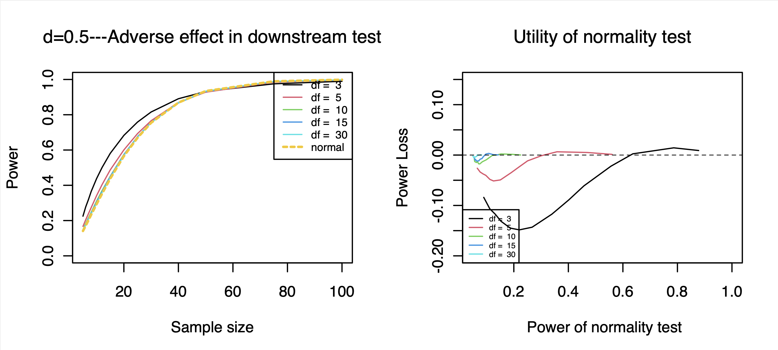

* **Power—d=1**

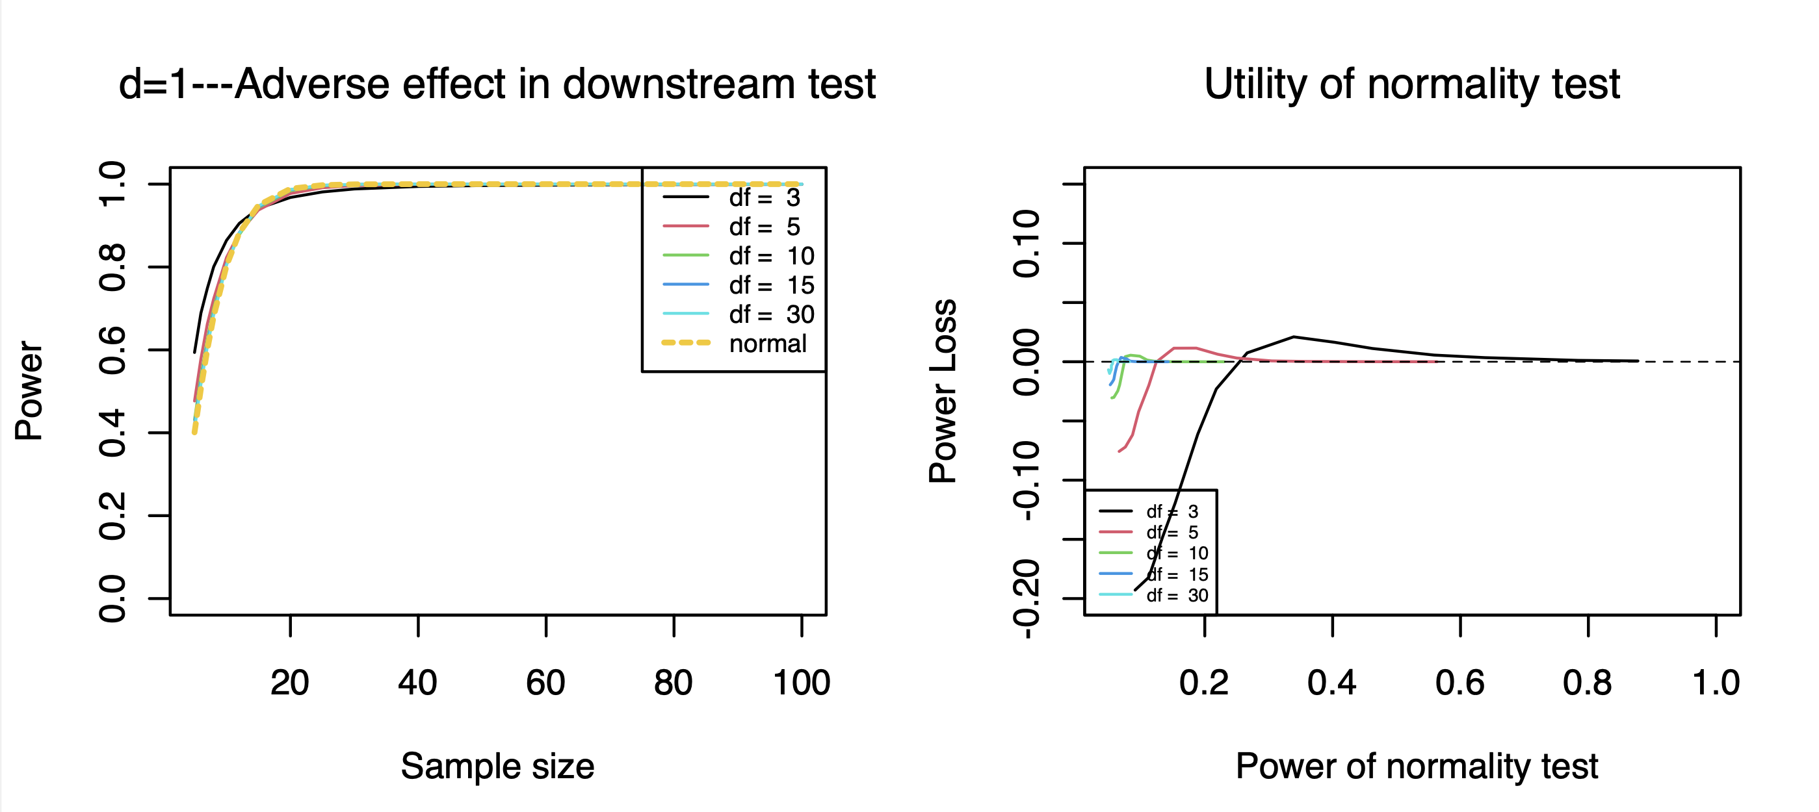

1. **Uniform Distribution**

* **Type I Error Rate**

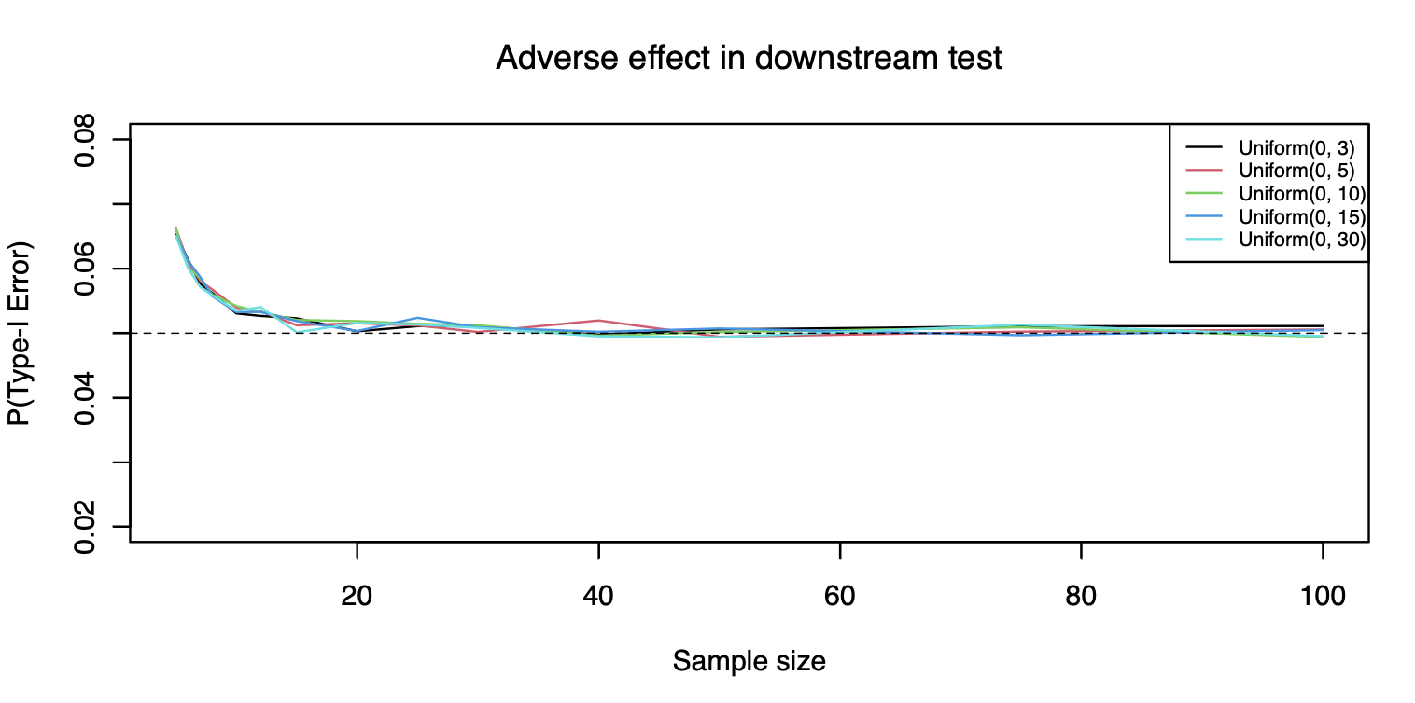 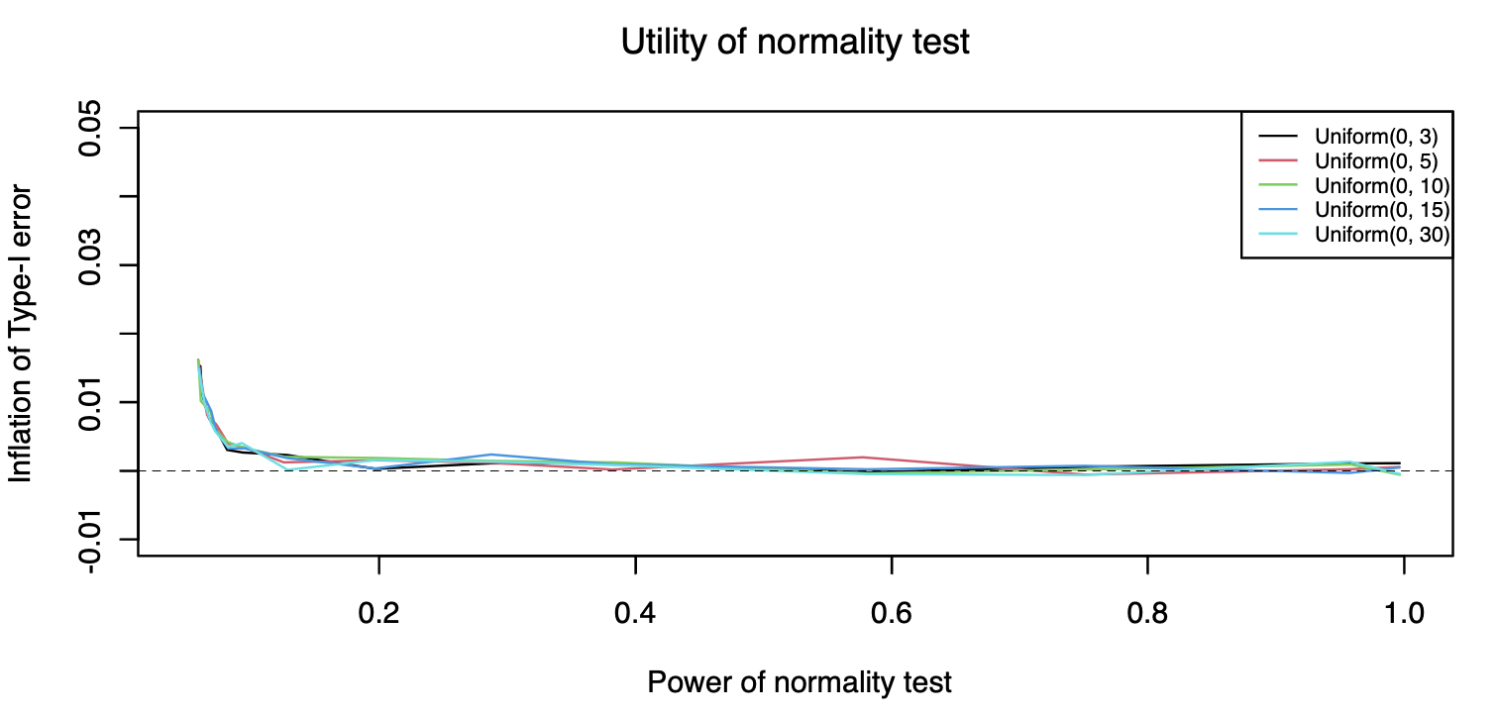

* **Power—d=0.5**

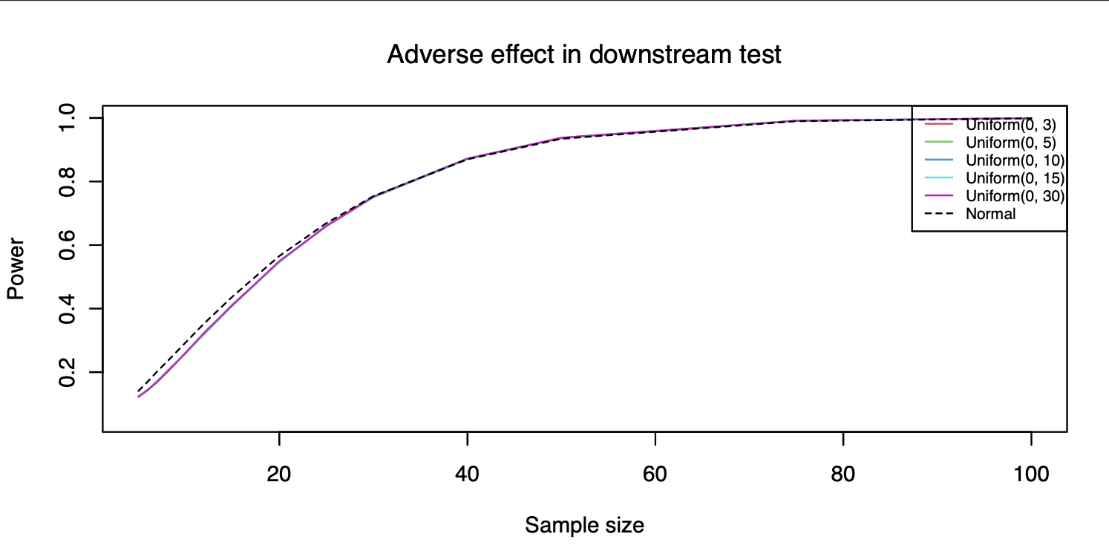 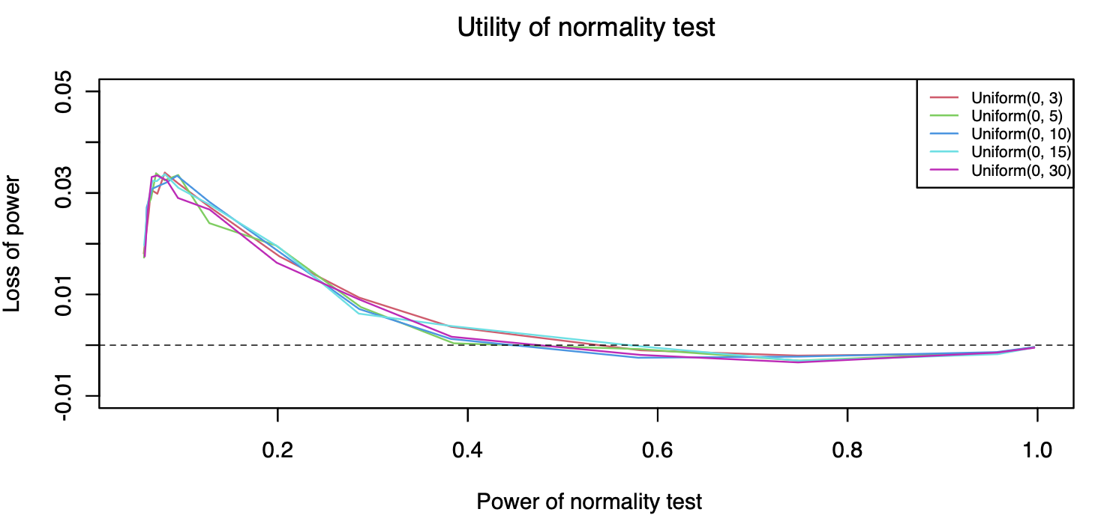

* **Power—d=1**

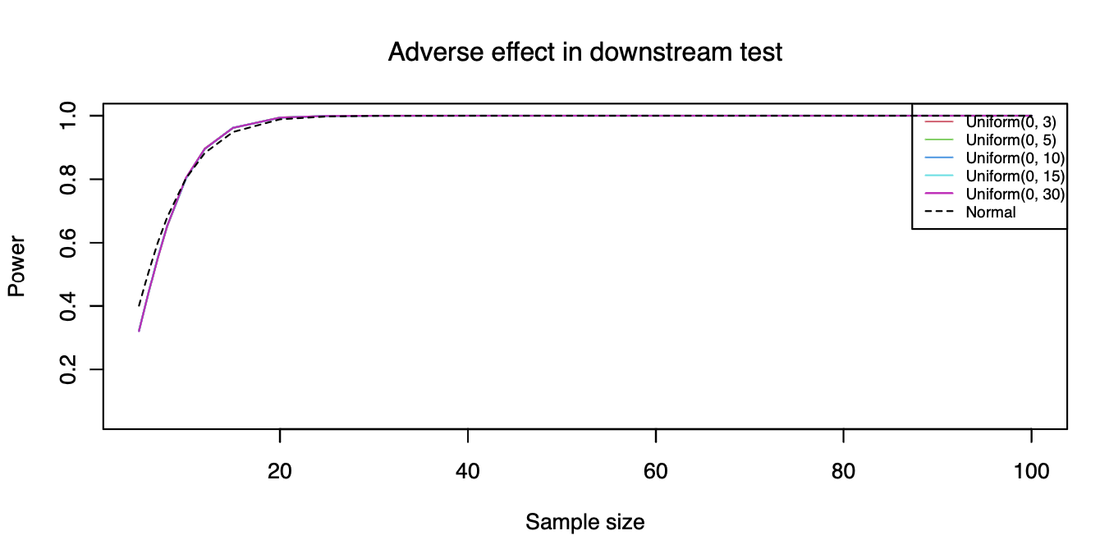 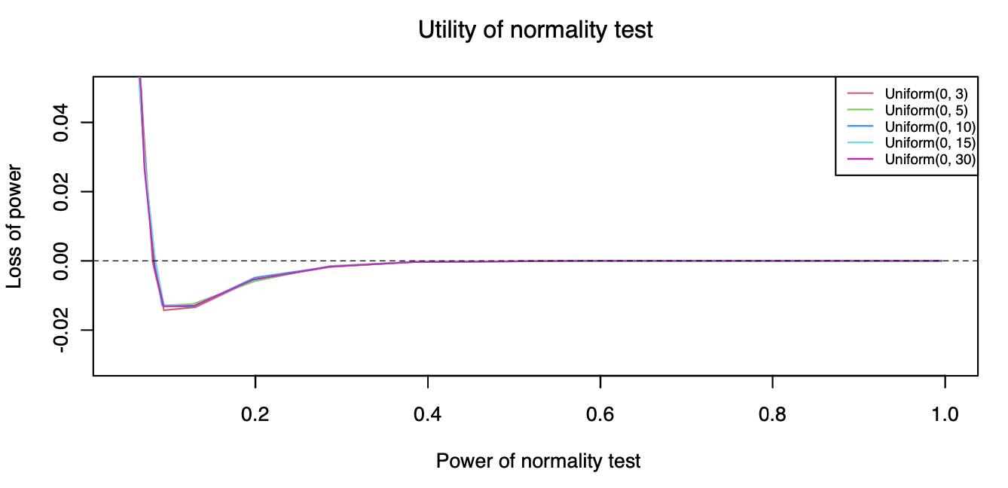

1. **Exponential Distribution**

* **Type I Error Rate**

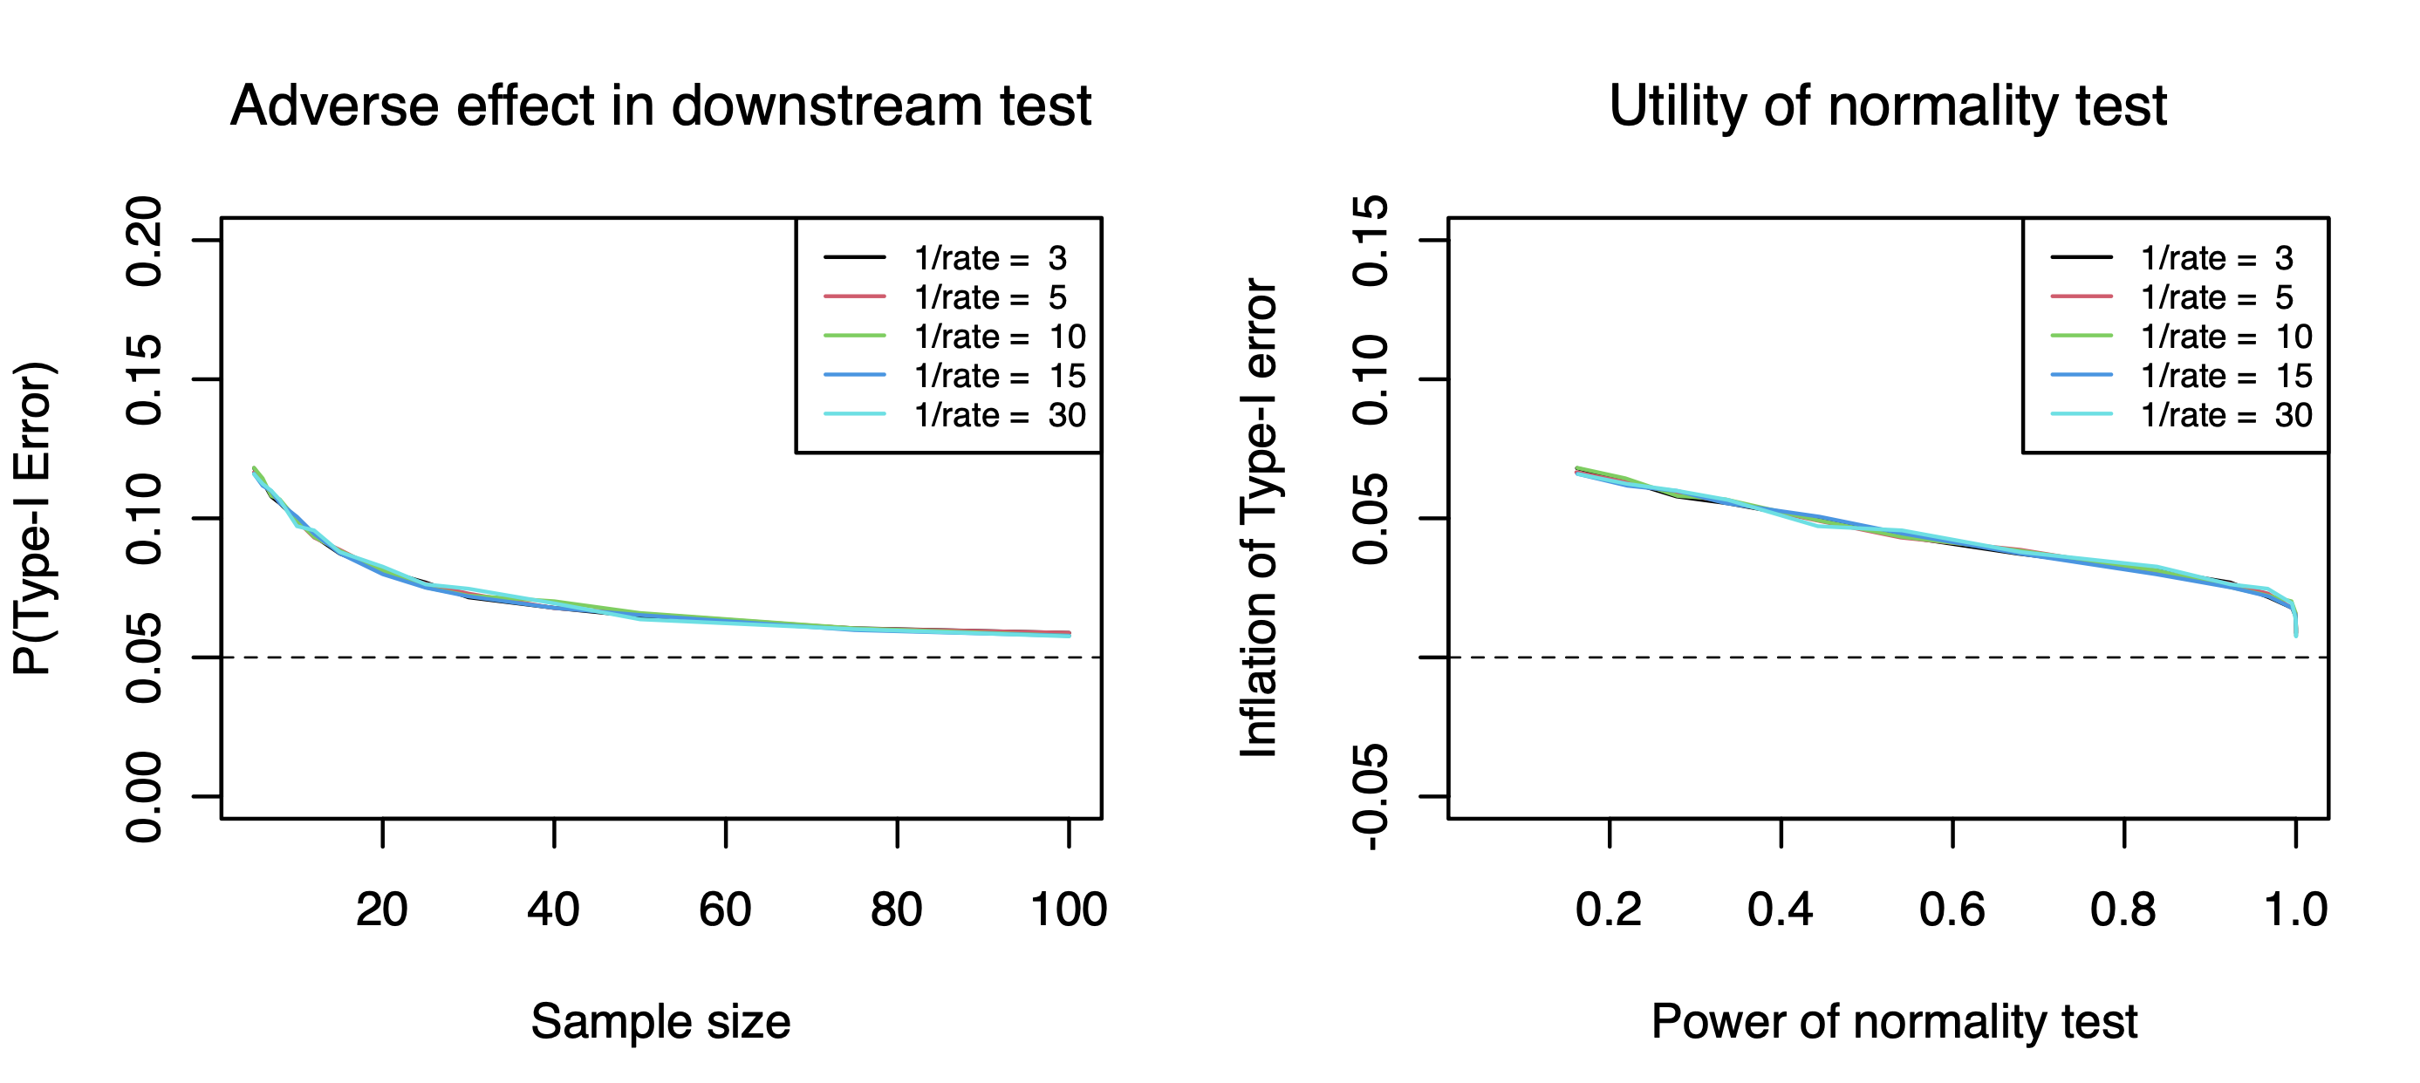

* **Power—d=0.5**

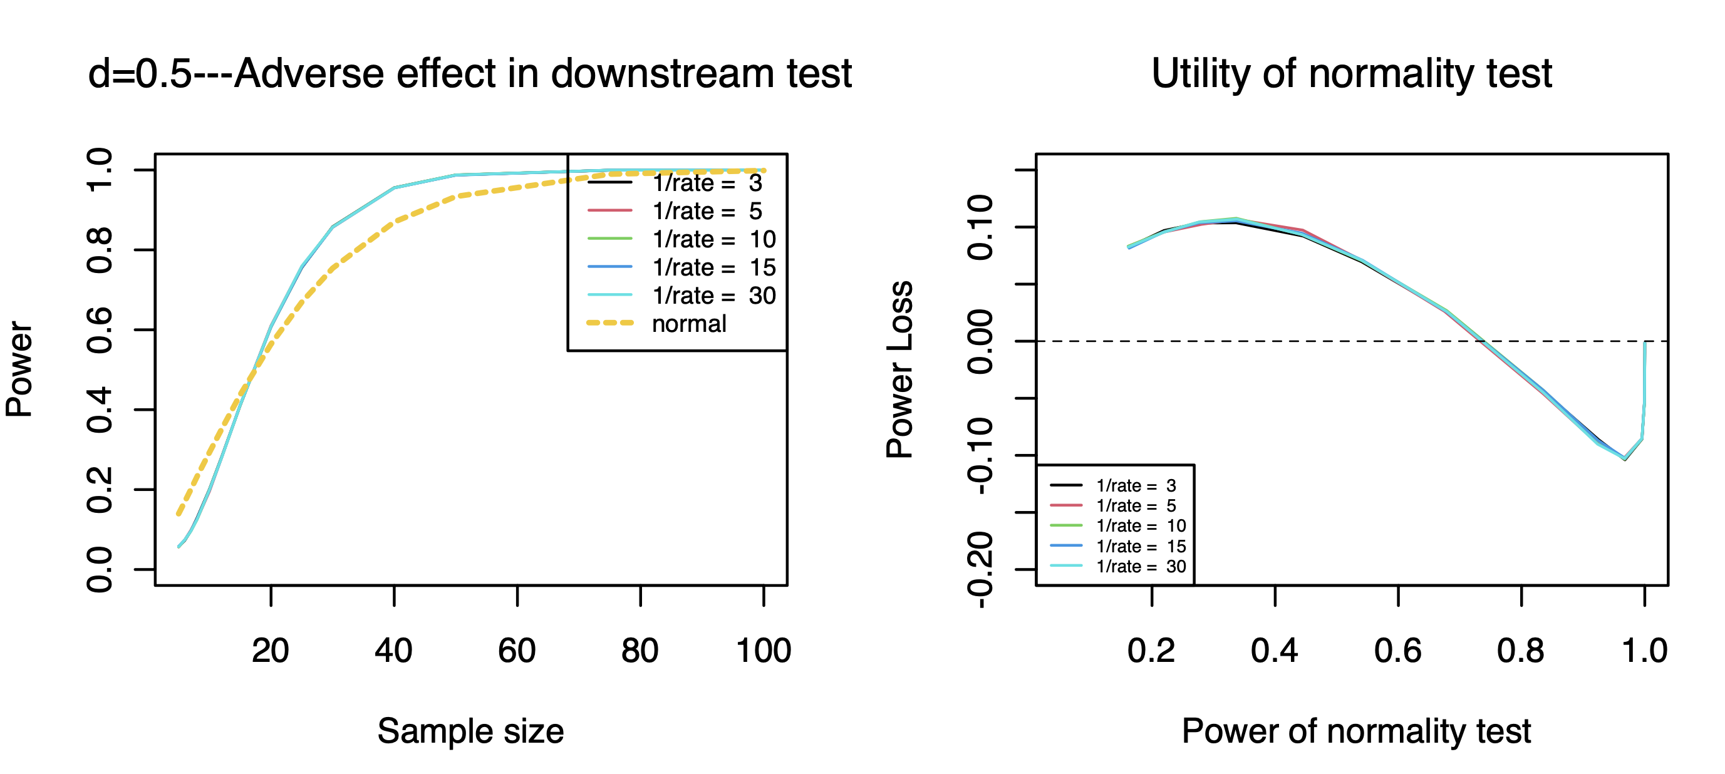

* **Power—d=1**

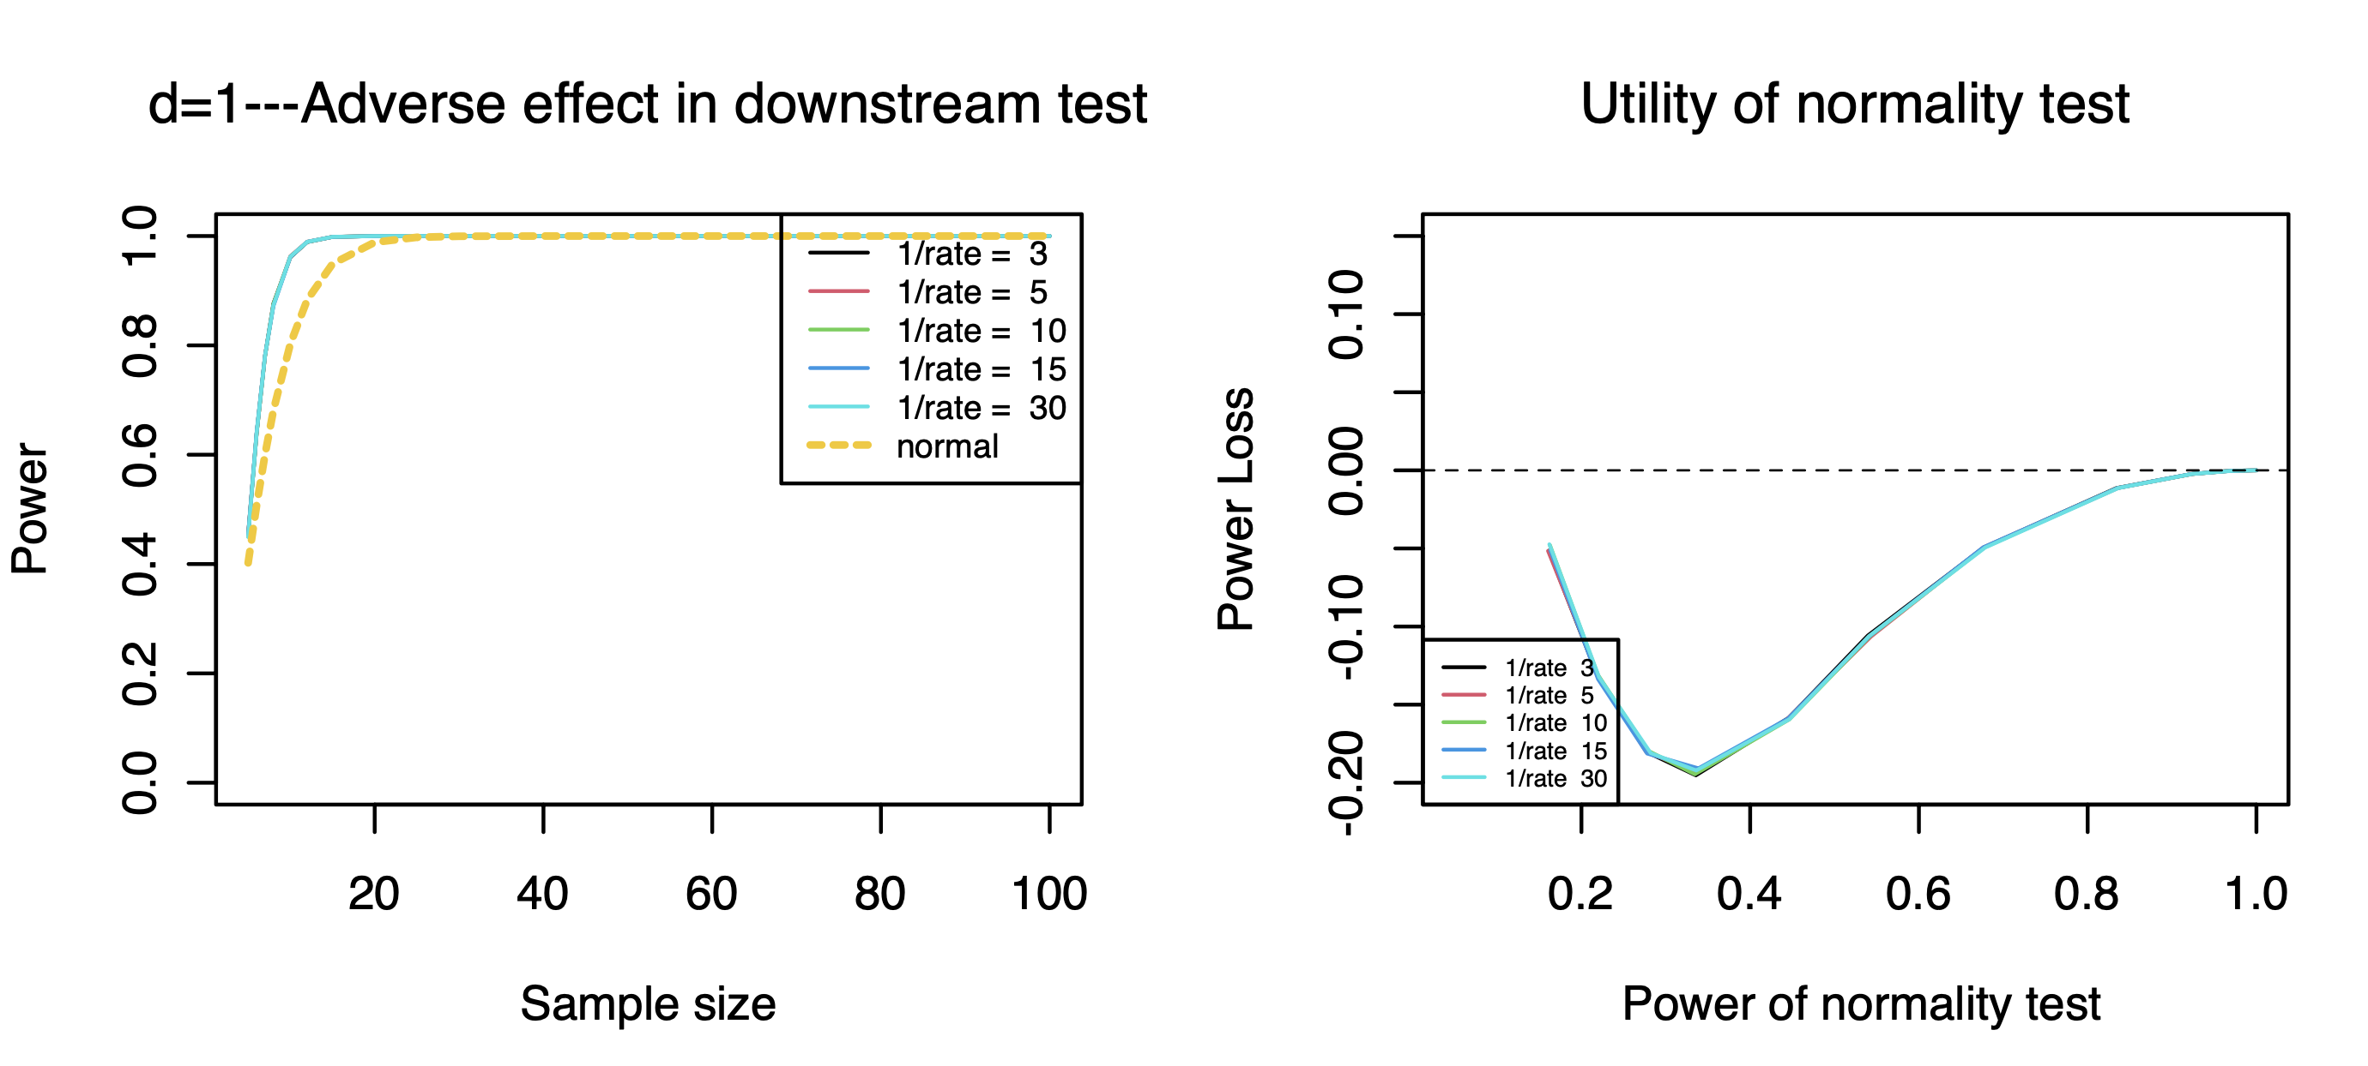

**One-Sample t test ---KS test**

1. **Chi-Square Distribution**

* **Type I Error Rate**

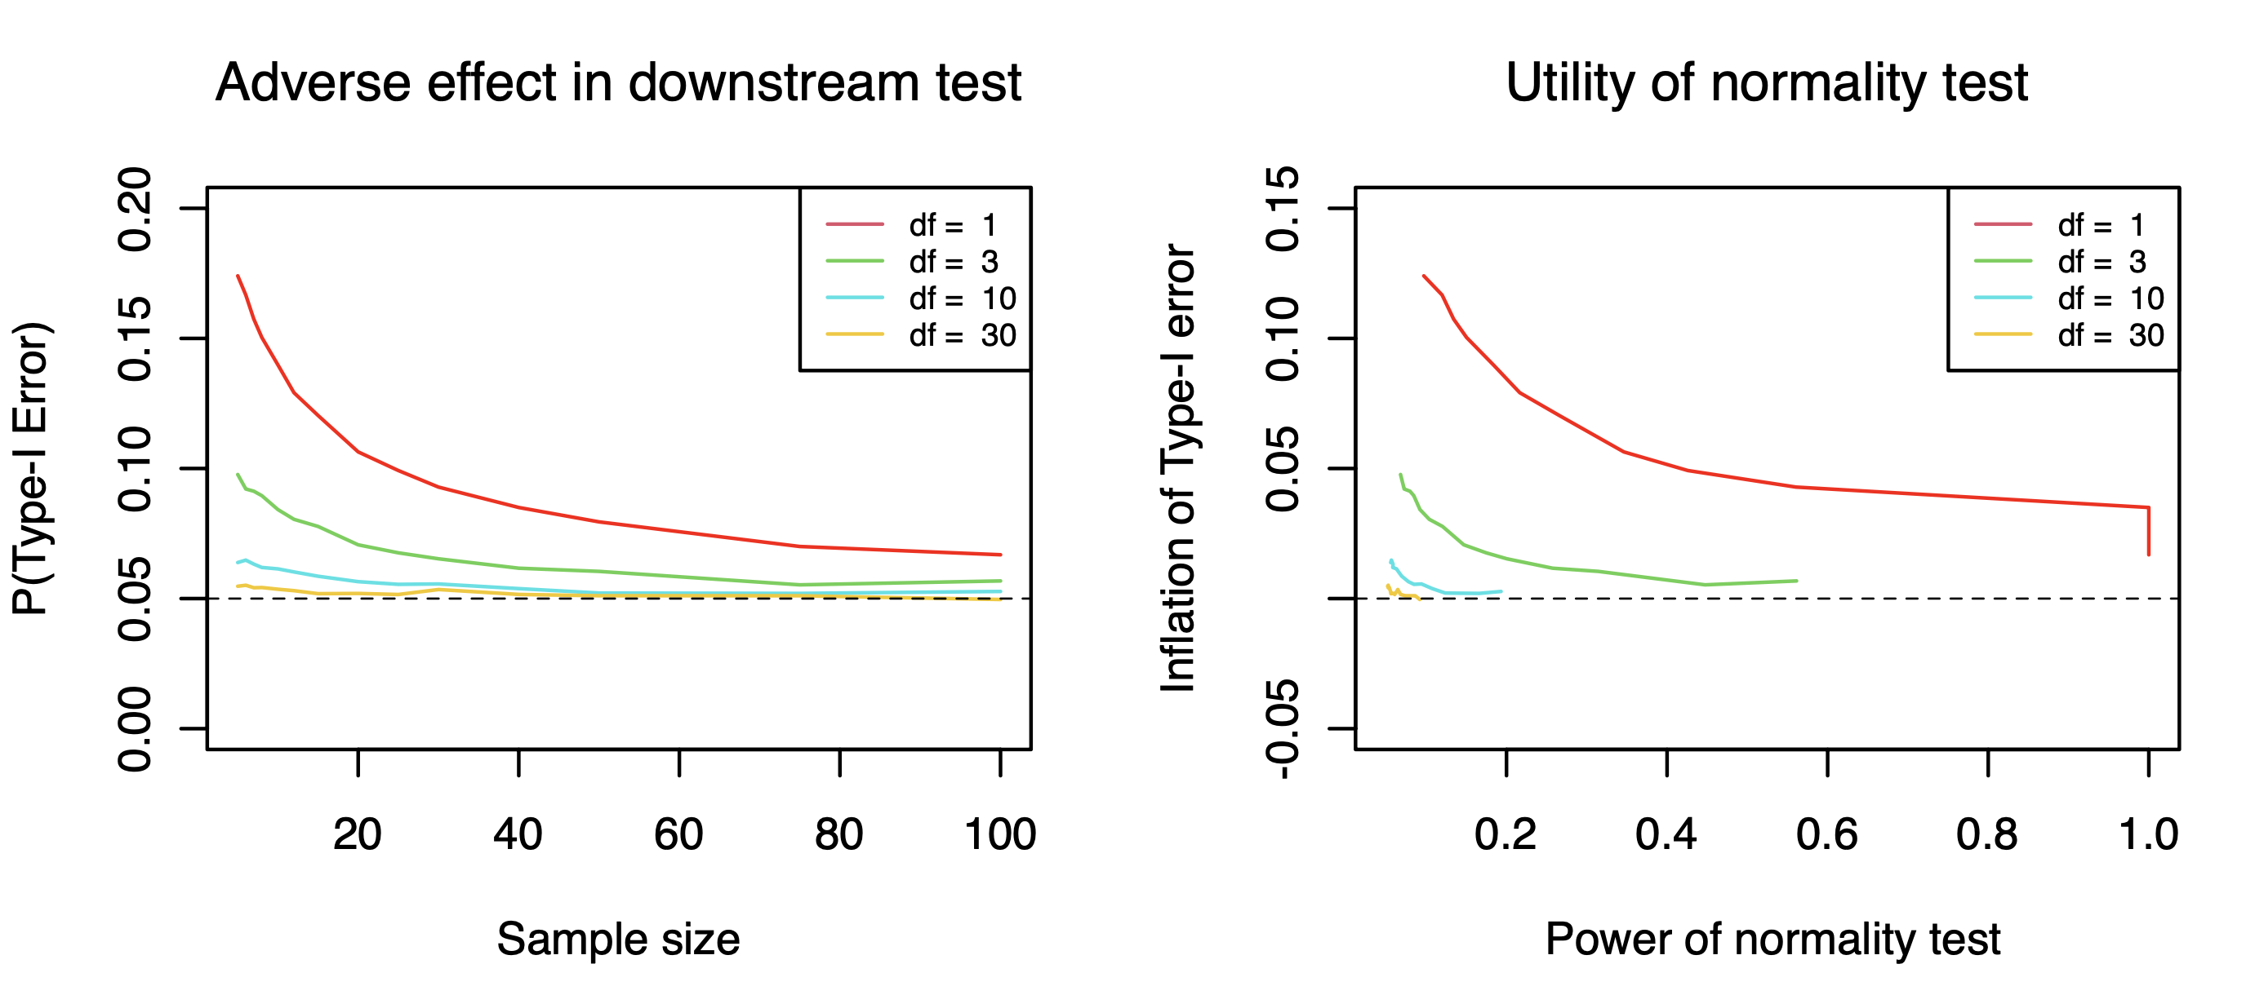

* **Power—d=0.5**

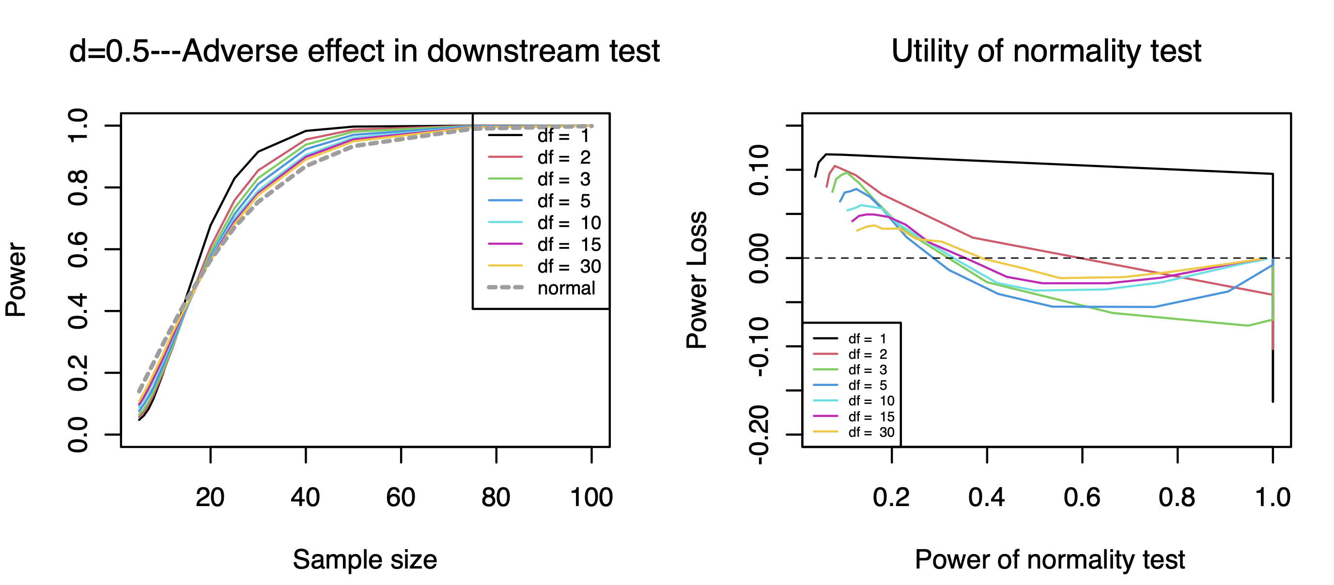

* **Power—d=1**

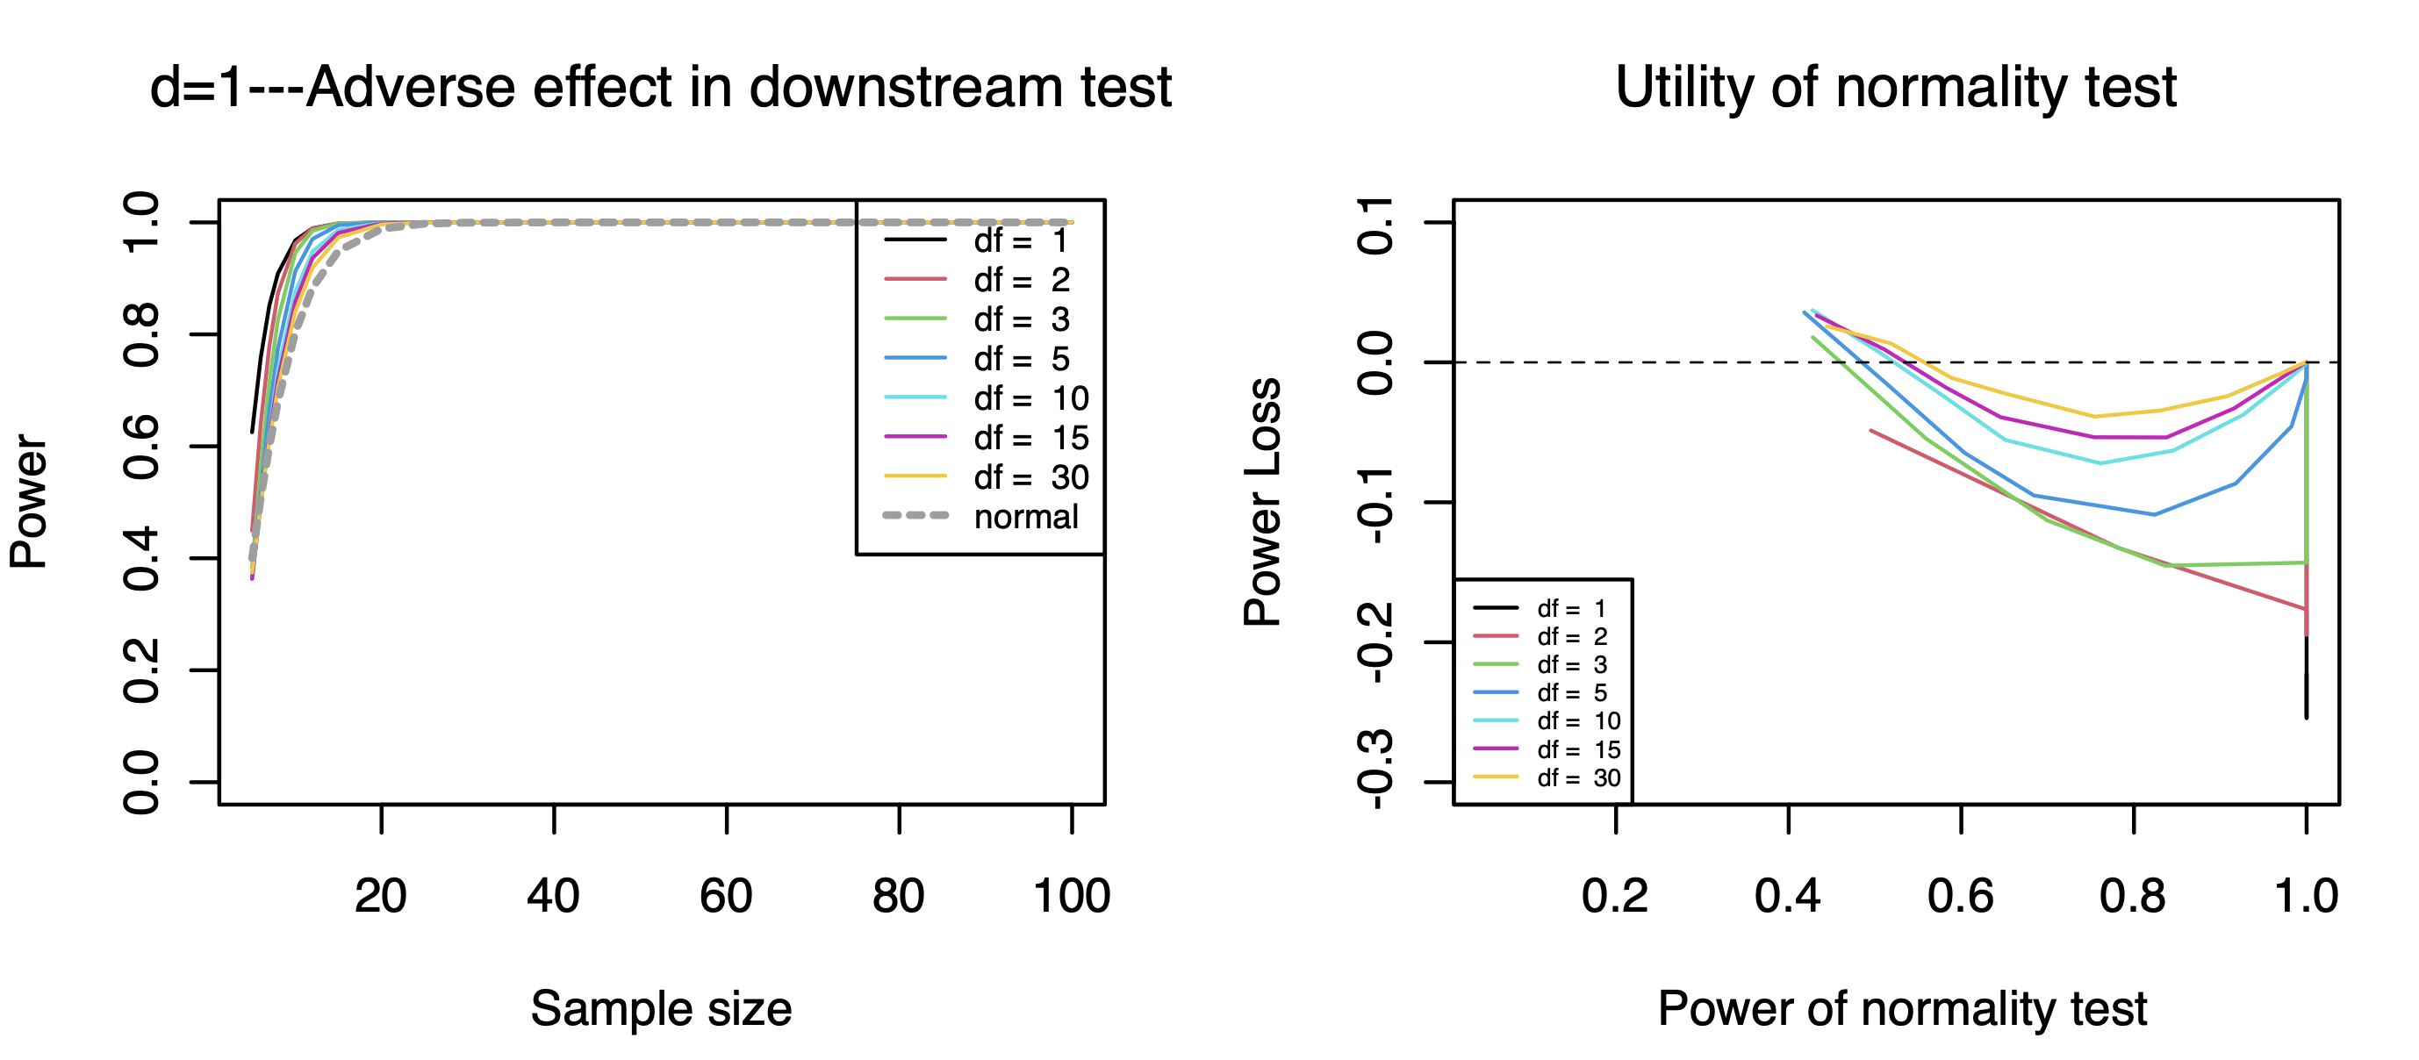

1. **Beta Distribution**

* **Type I Error Rate**

**Two-Sample t test**

1. **Chi-Square Distribution**

* **Type I Error Rate**

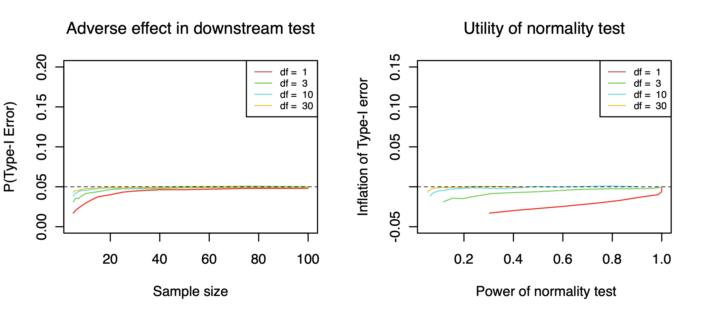

* **Power—d=0.5**

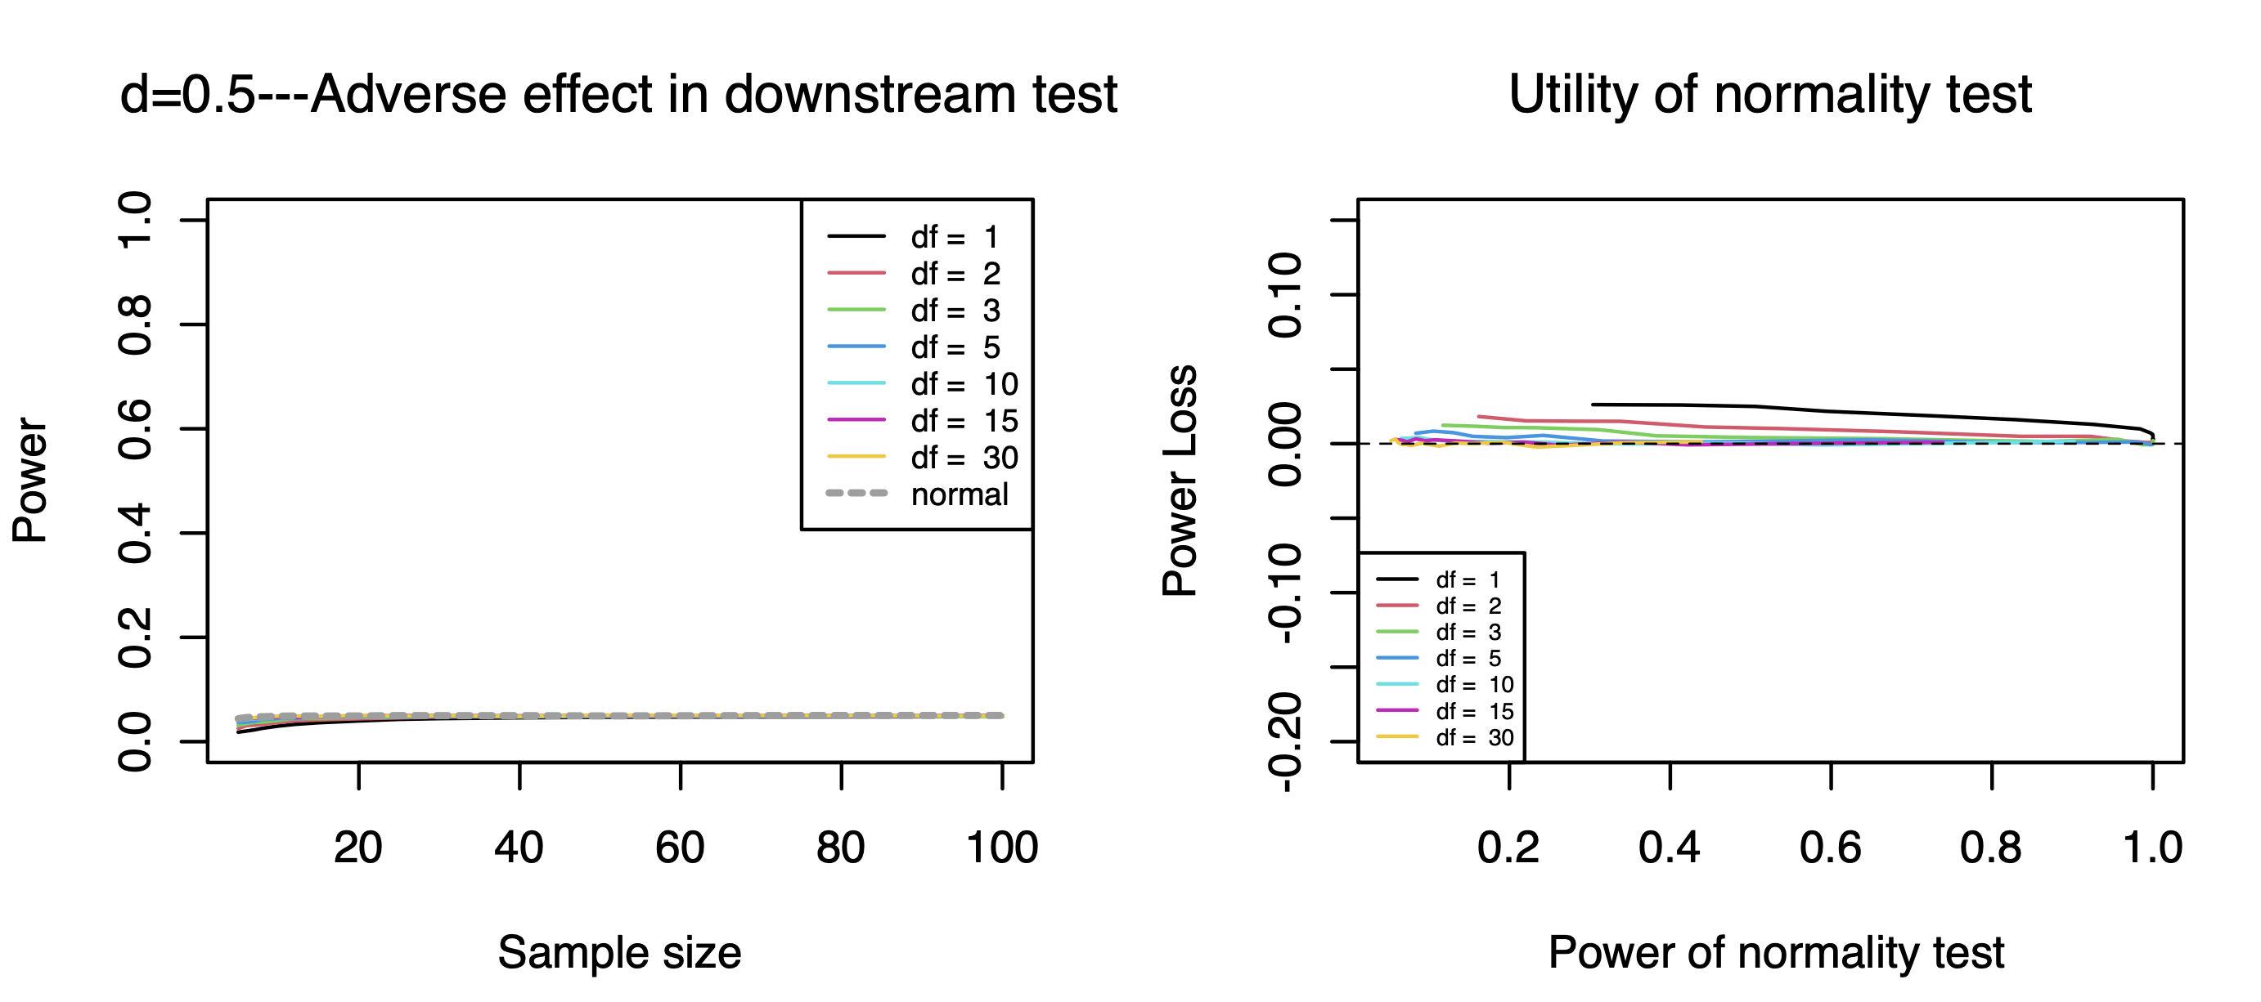

* **Power—d=1**

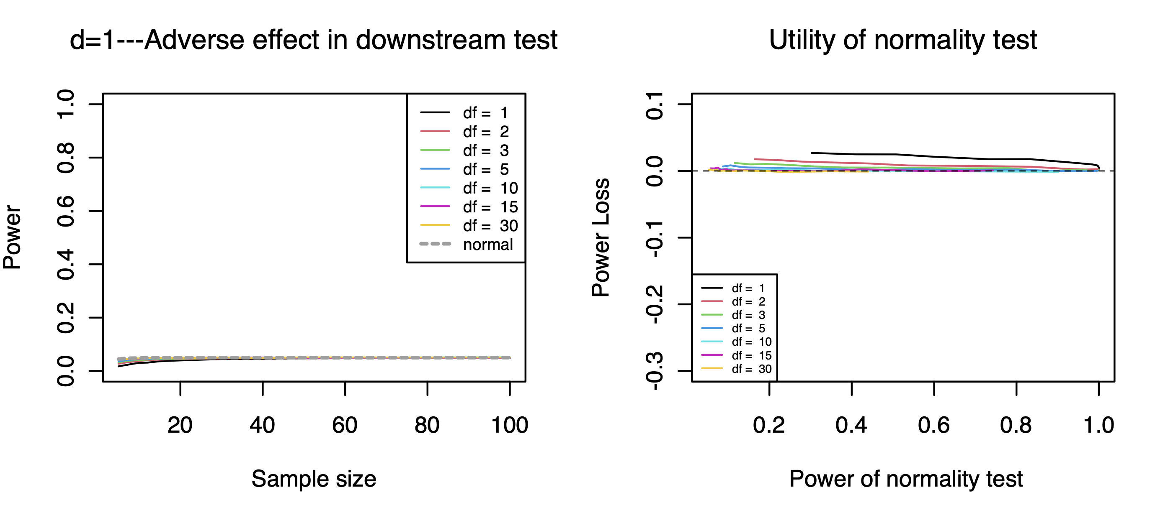

1. **Beta Distribution**

* **Type I Error Rate**

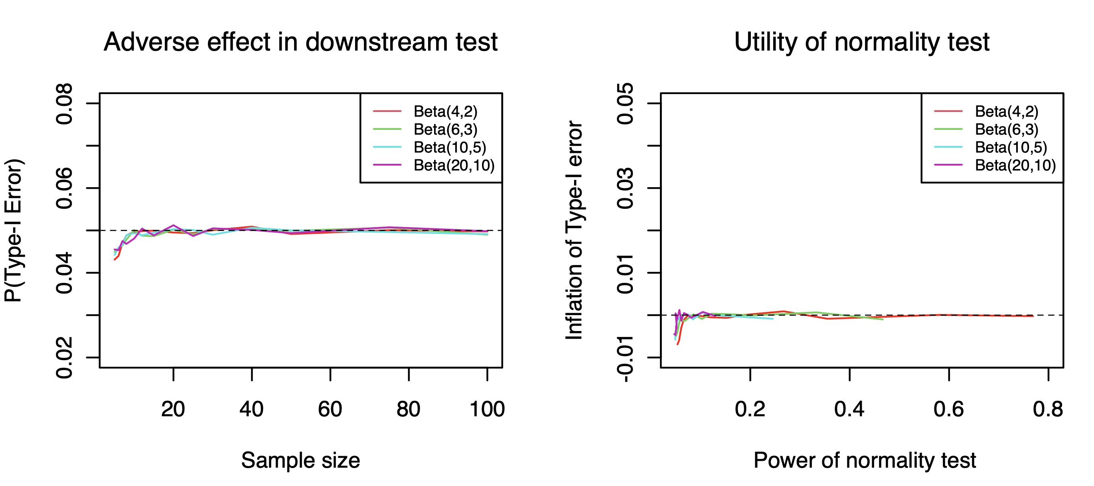

* **Power—d=0.5**

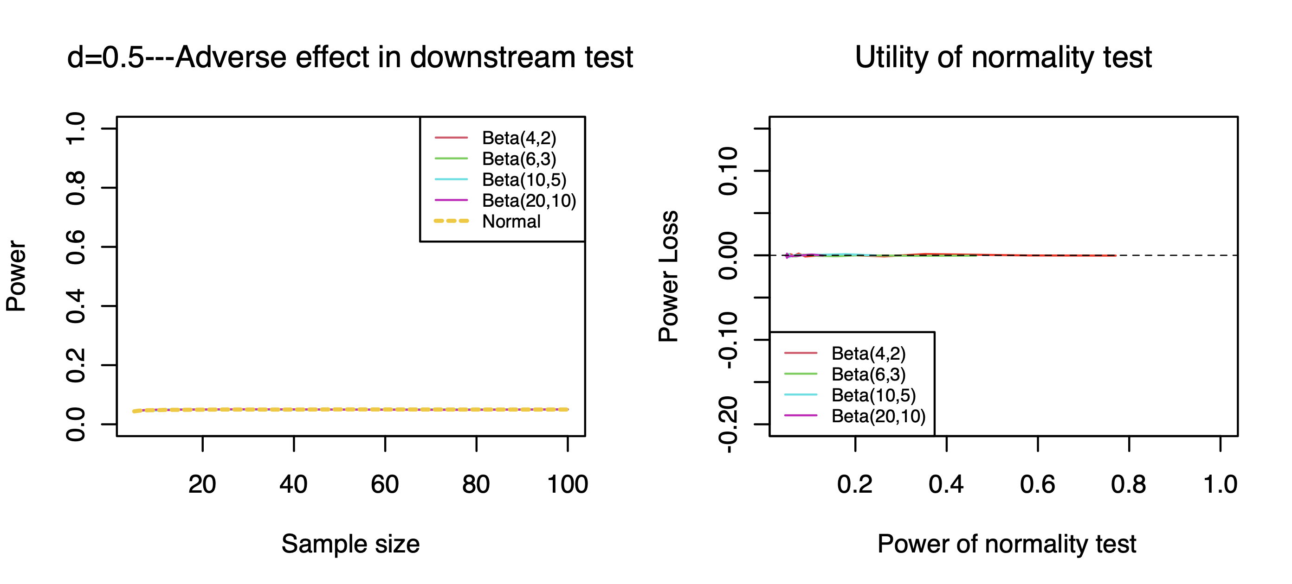

* **Power—d=1**

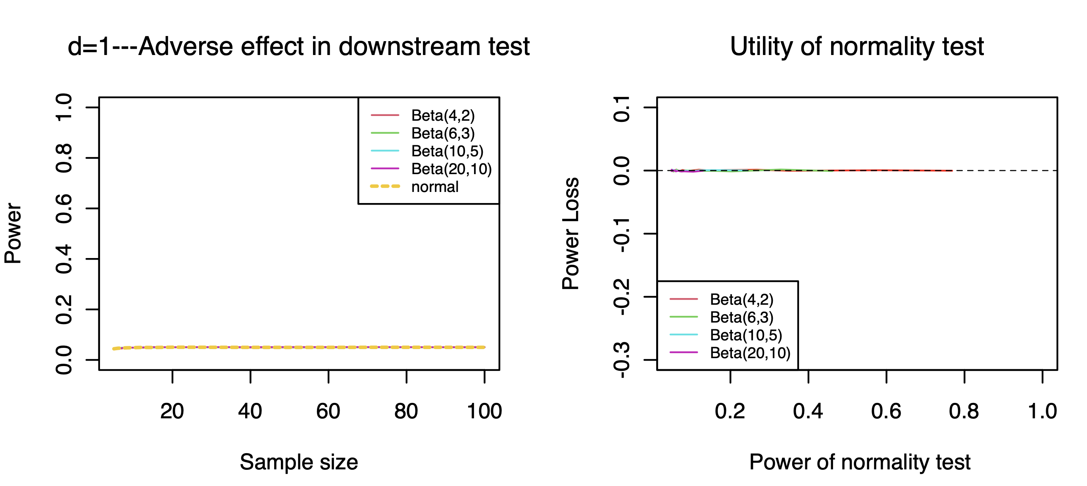

1. **Student’s t Distribution**

* **Type I Error Rate**

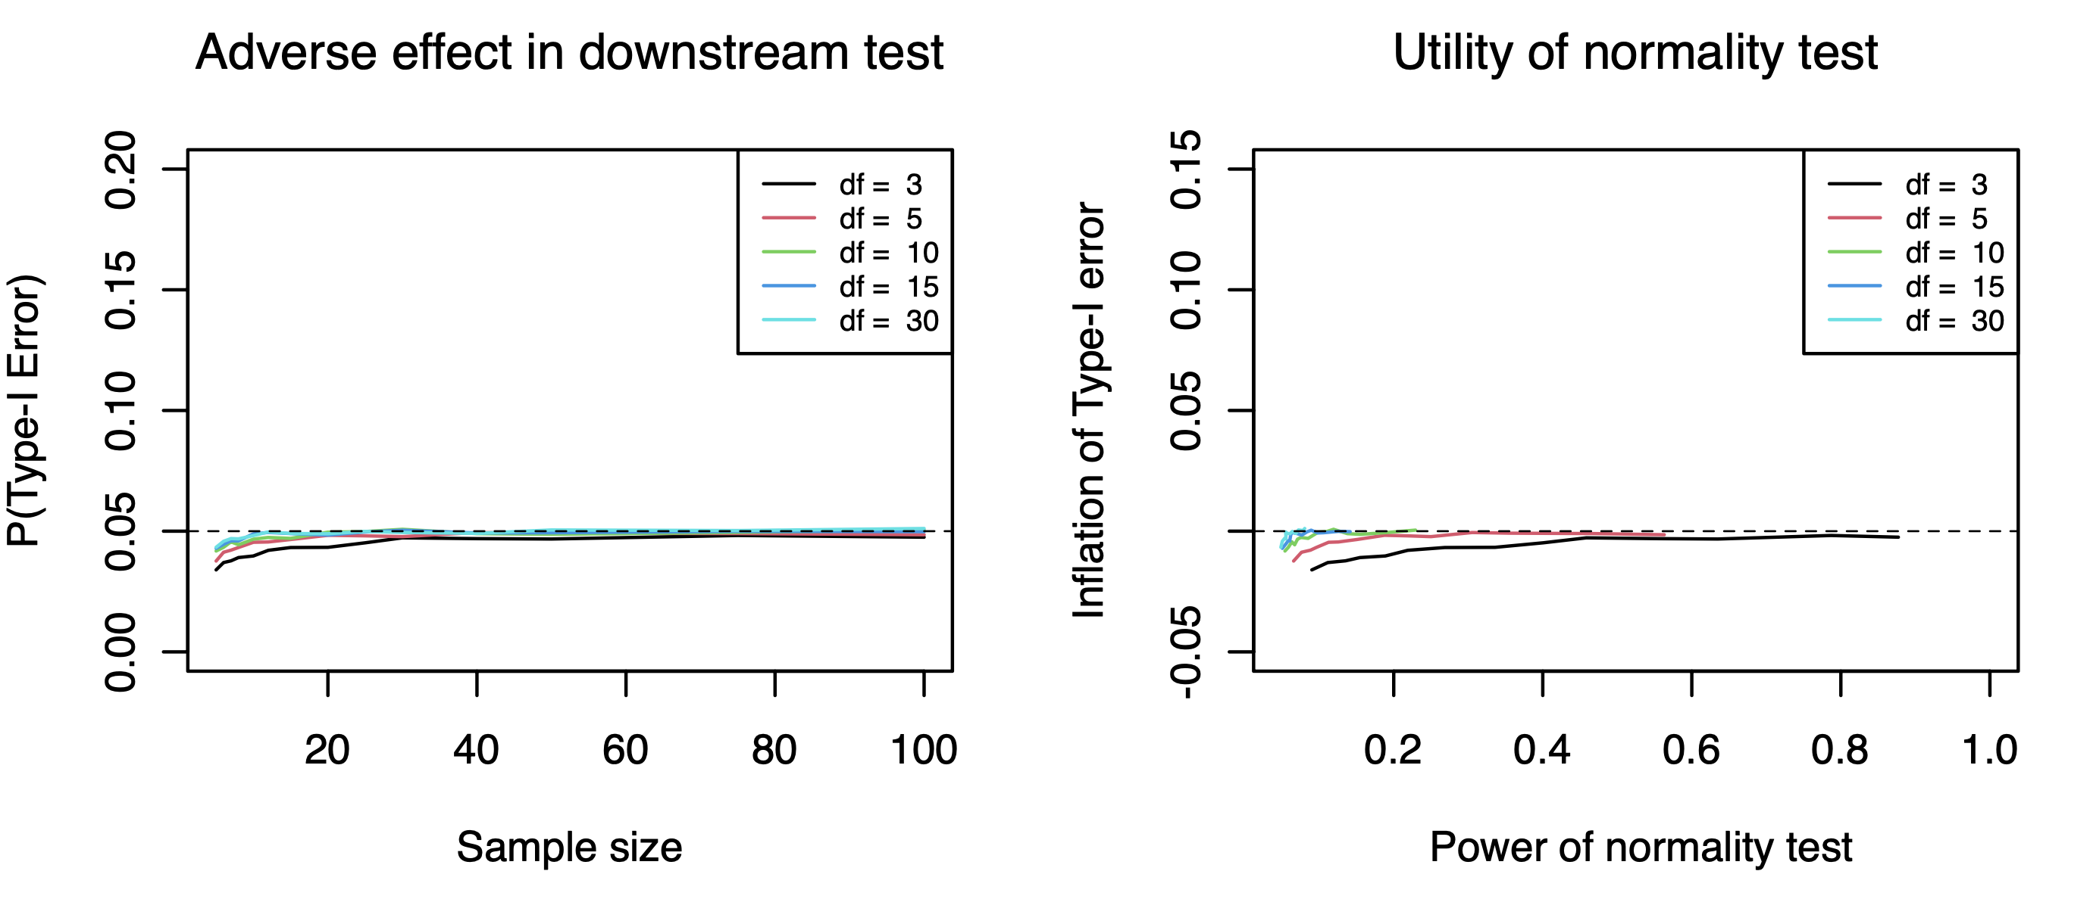

* **Power—d=0.5**

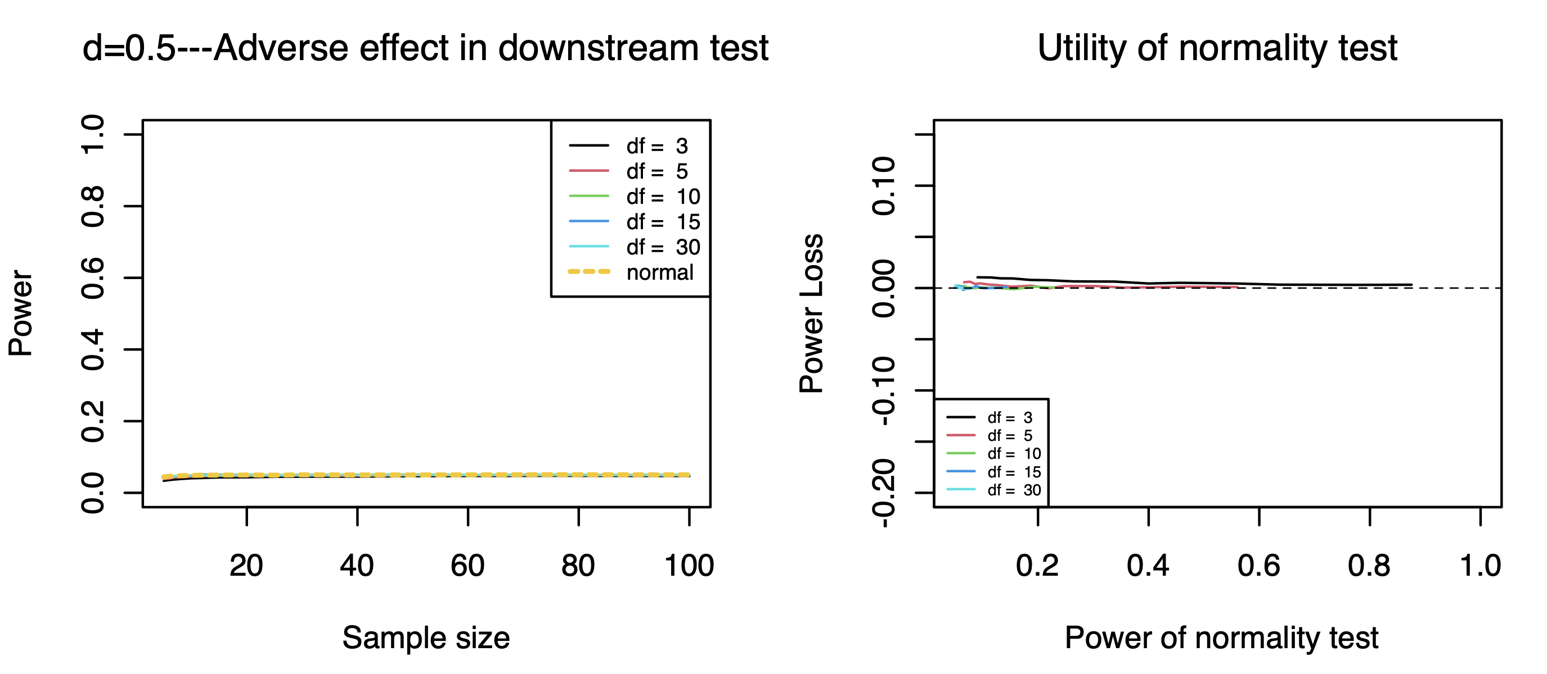

* **Power—d=1**

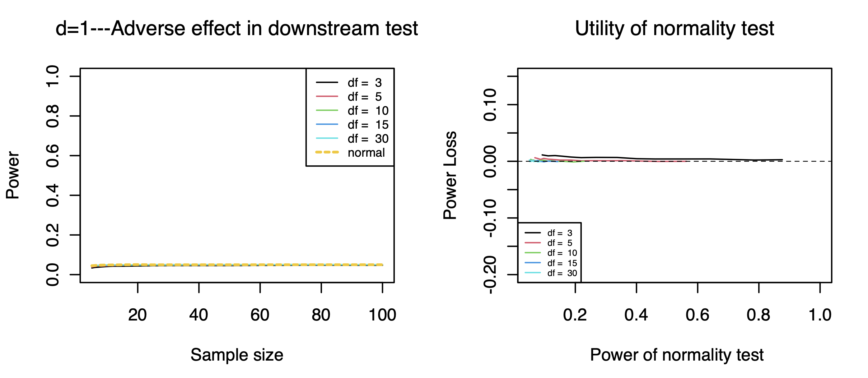

1. **Exponential Distribution**

* **Type I Error Rate**

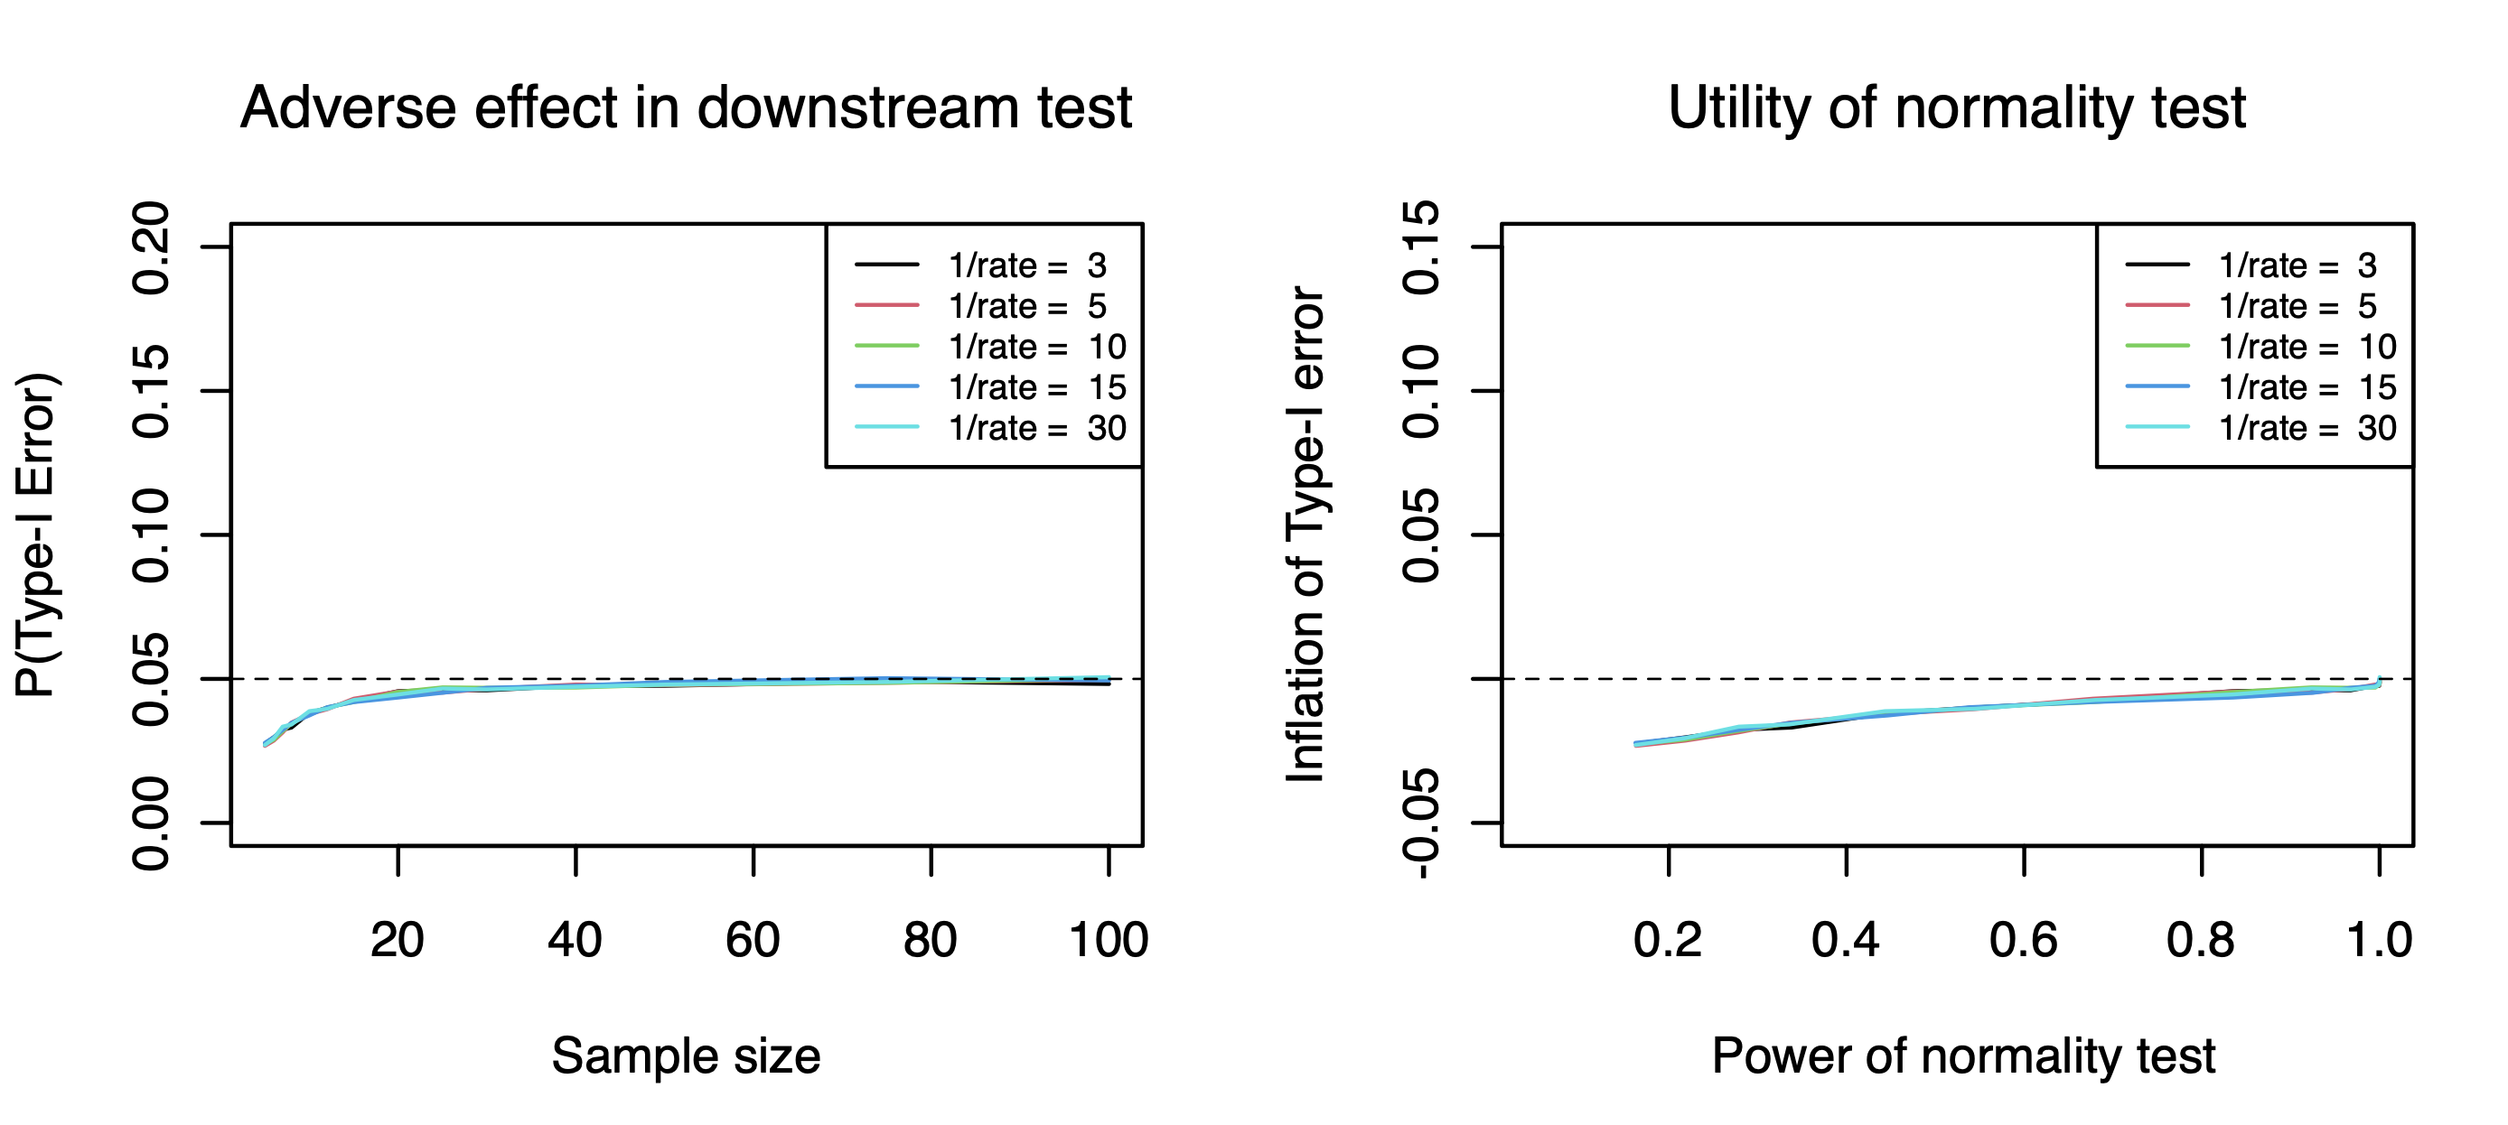

* **Power—d=0.5**

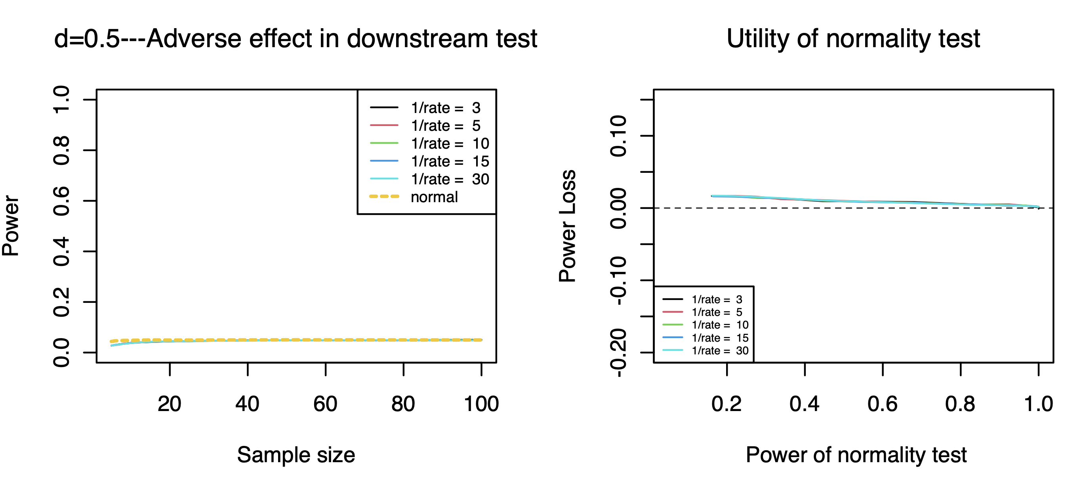

* **Power—d=1**

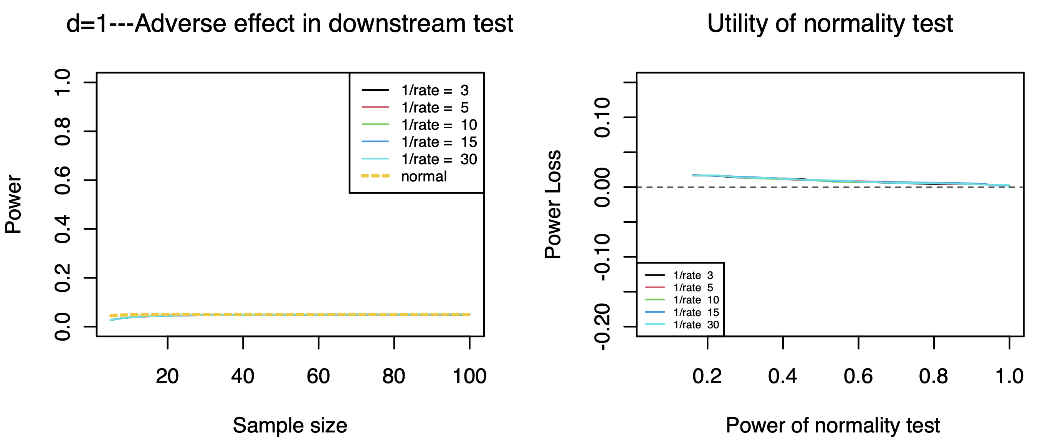

1. **Uniform Distribution**

* **Type I Error Rate**

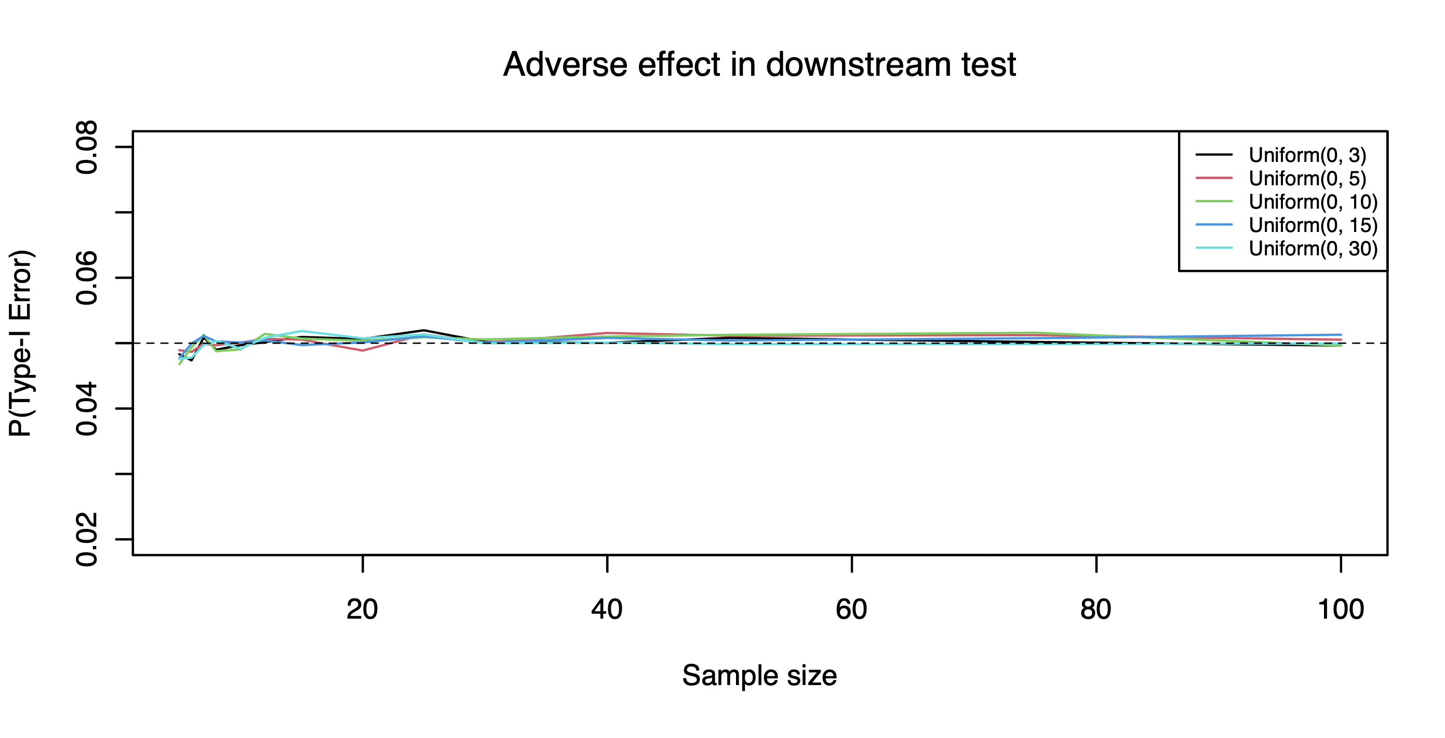 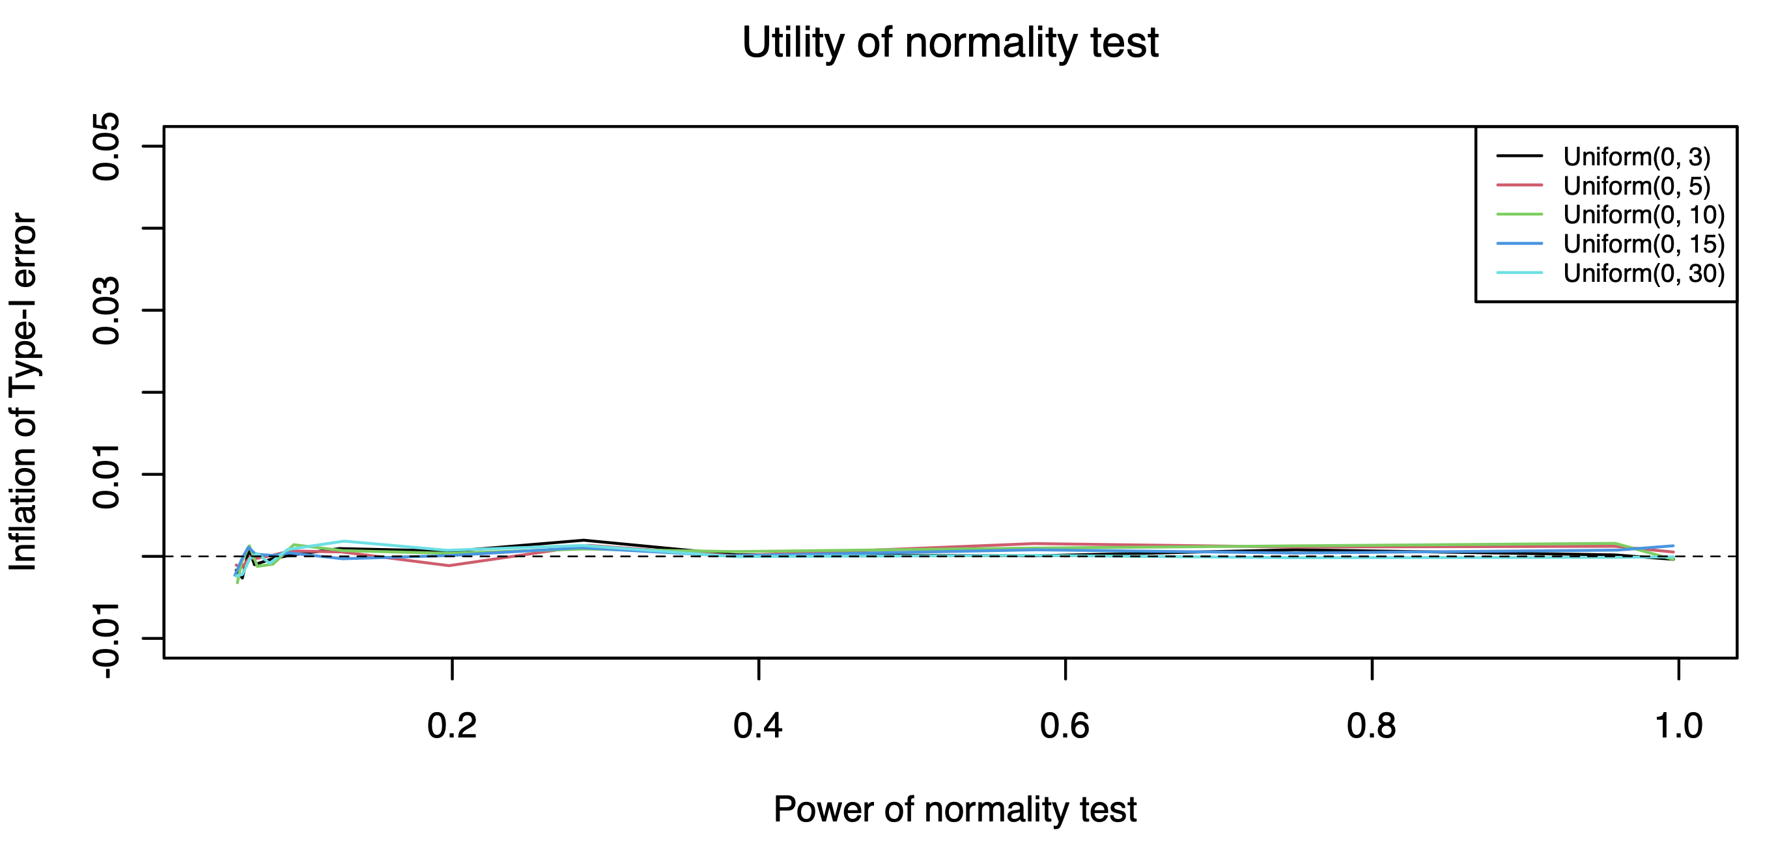

* **Power—d=0.5**

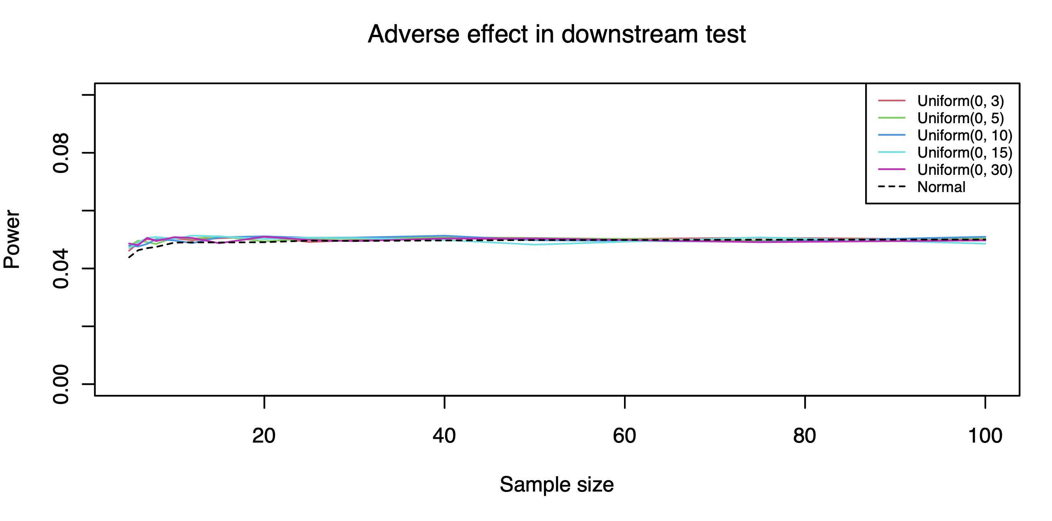 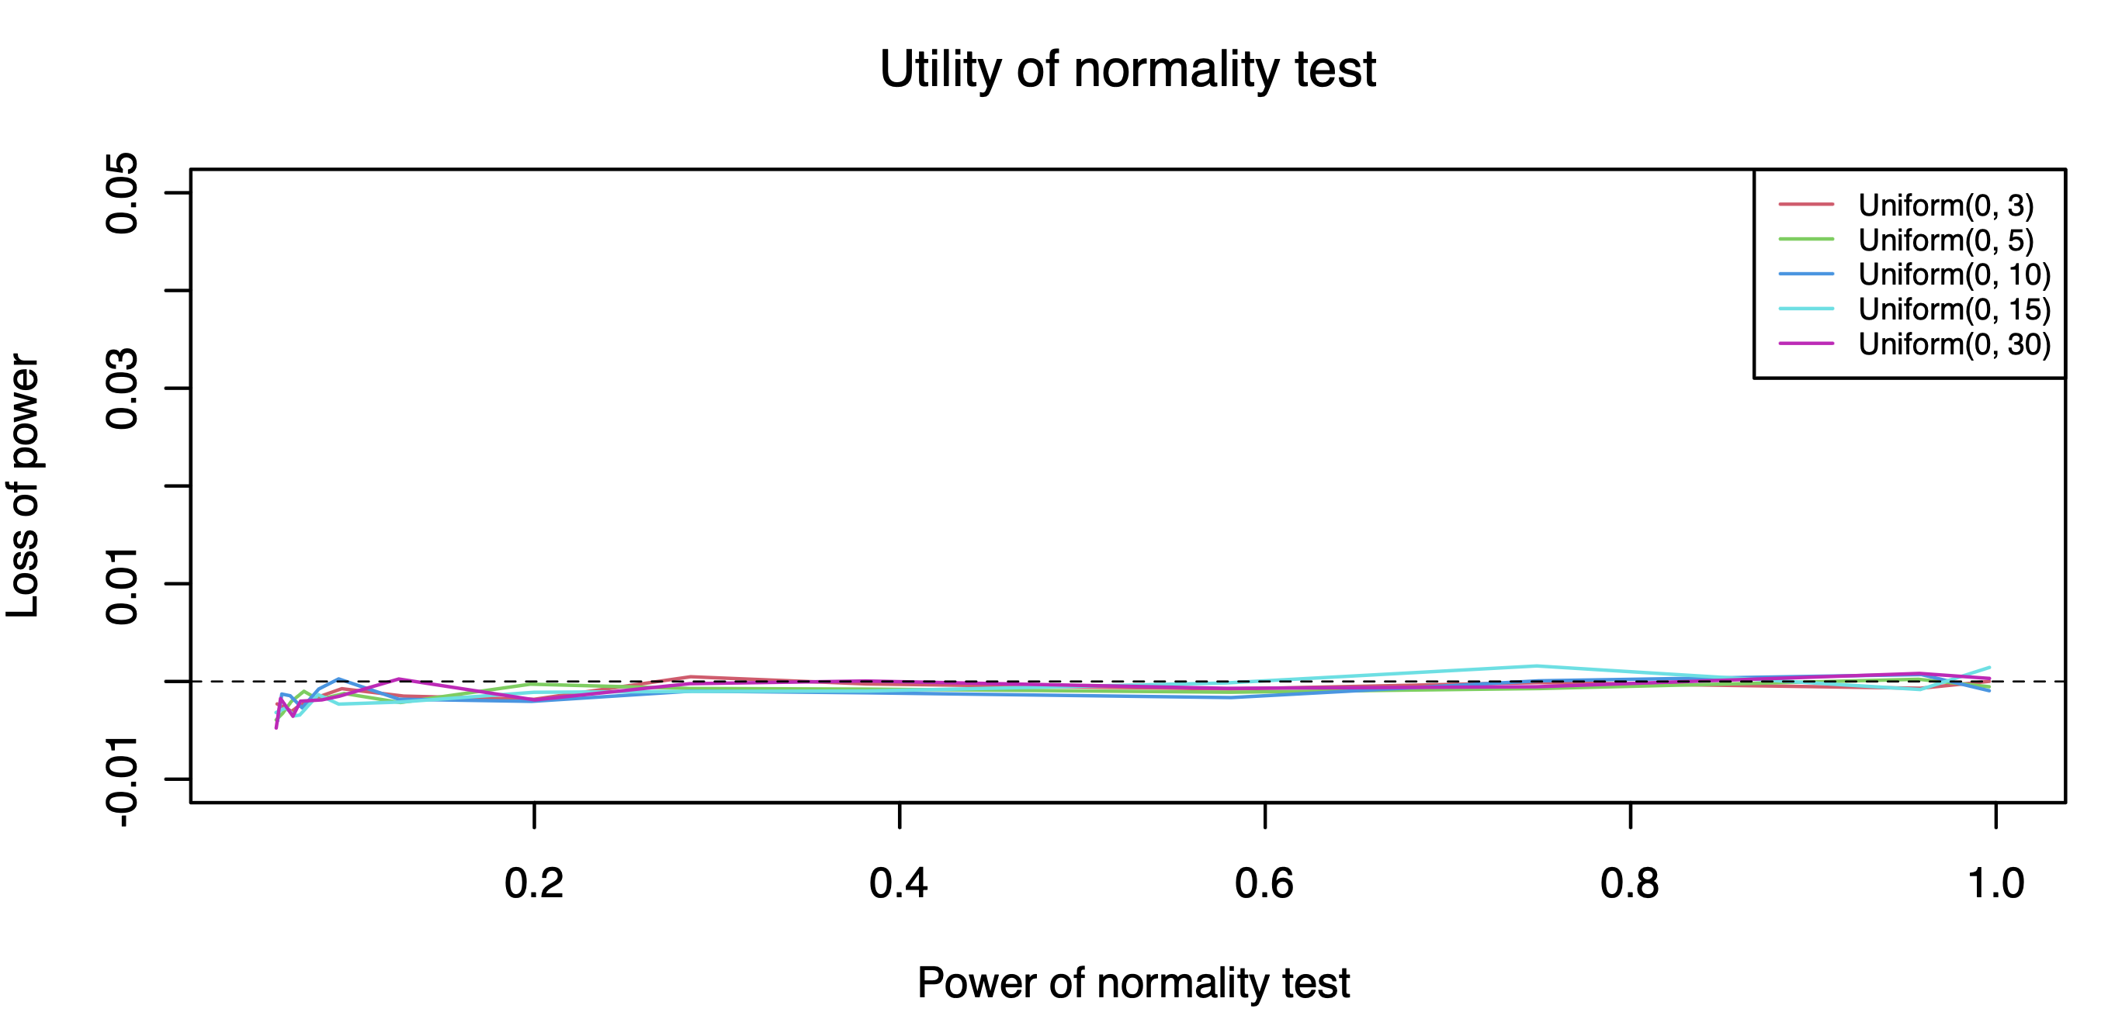

* **Power—d=1**

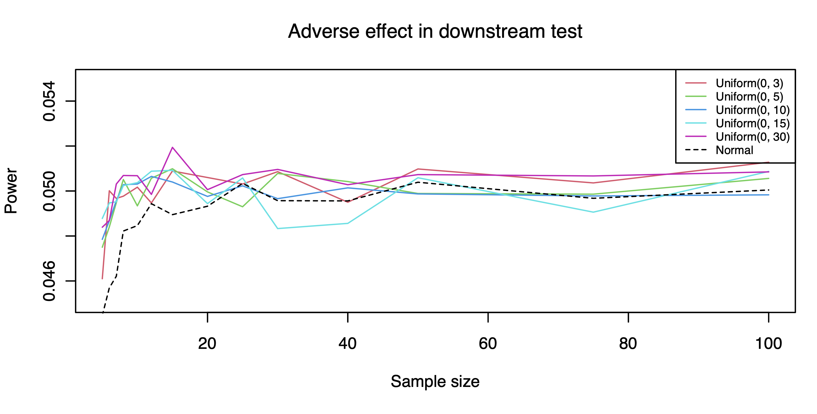 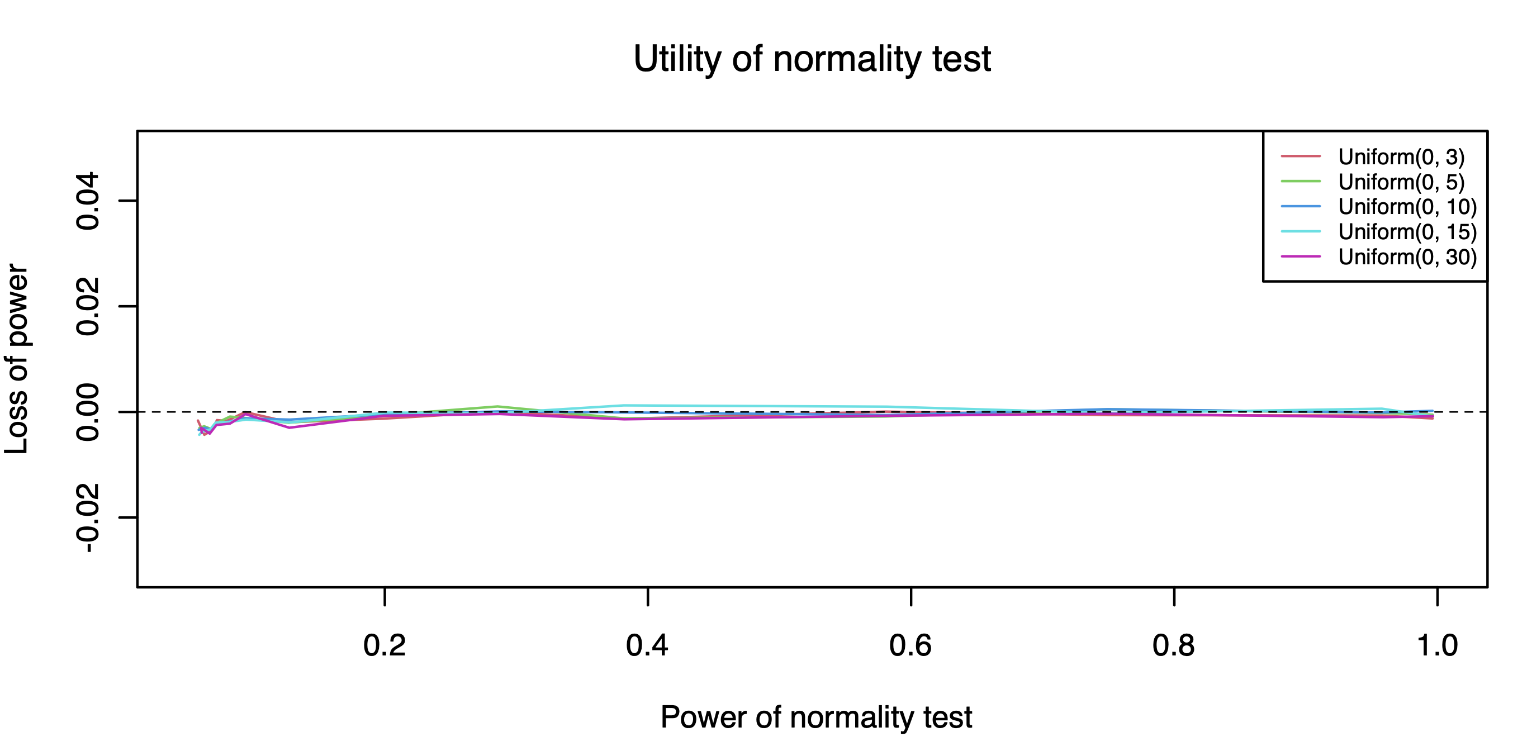

**Regression test (SLR)**

1. **Chi-Square Distribution**

* **Find b1 value with good power**

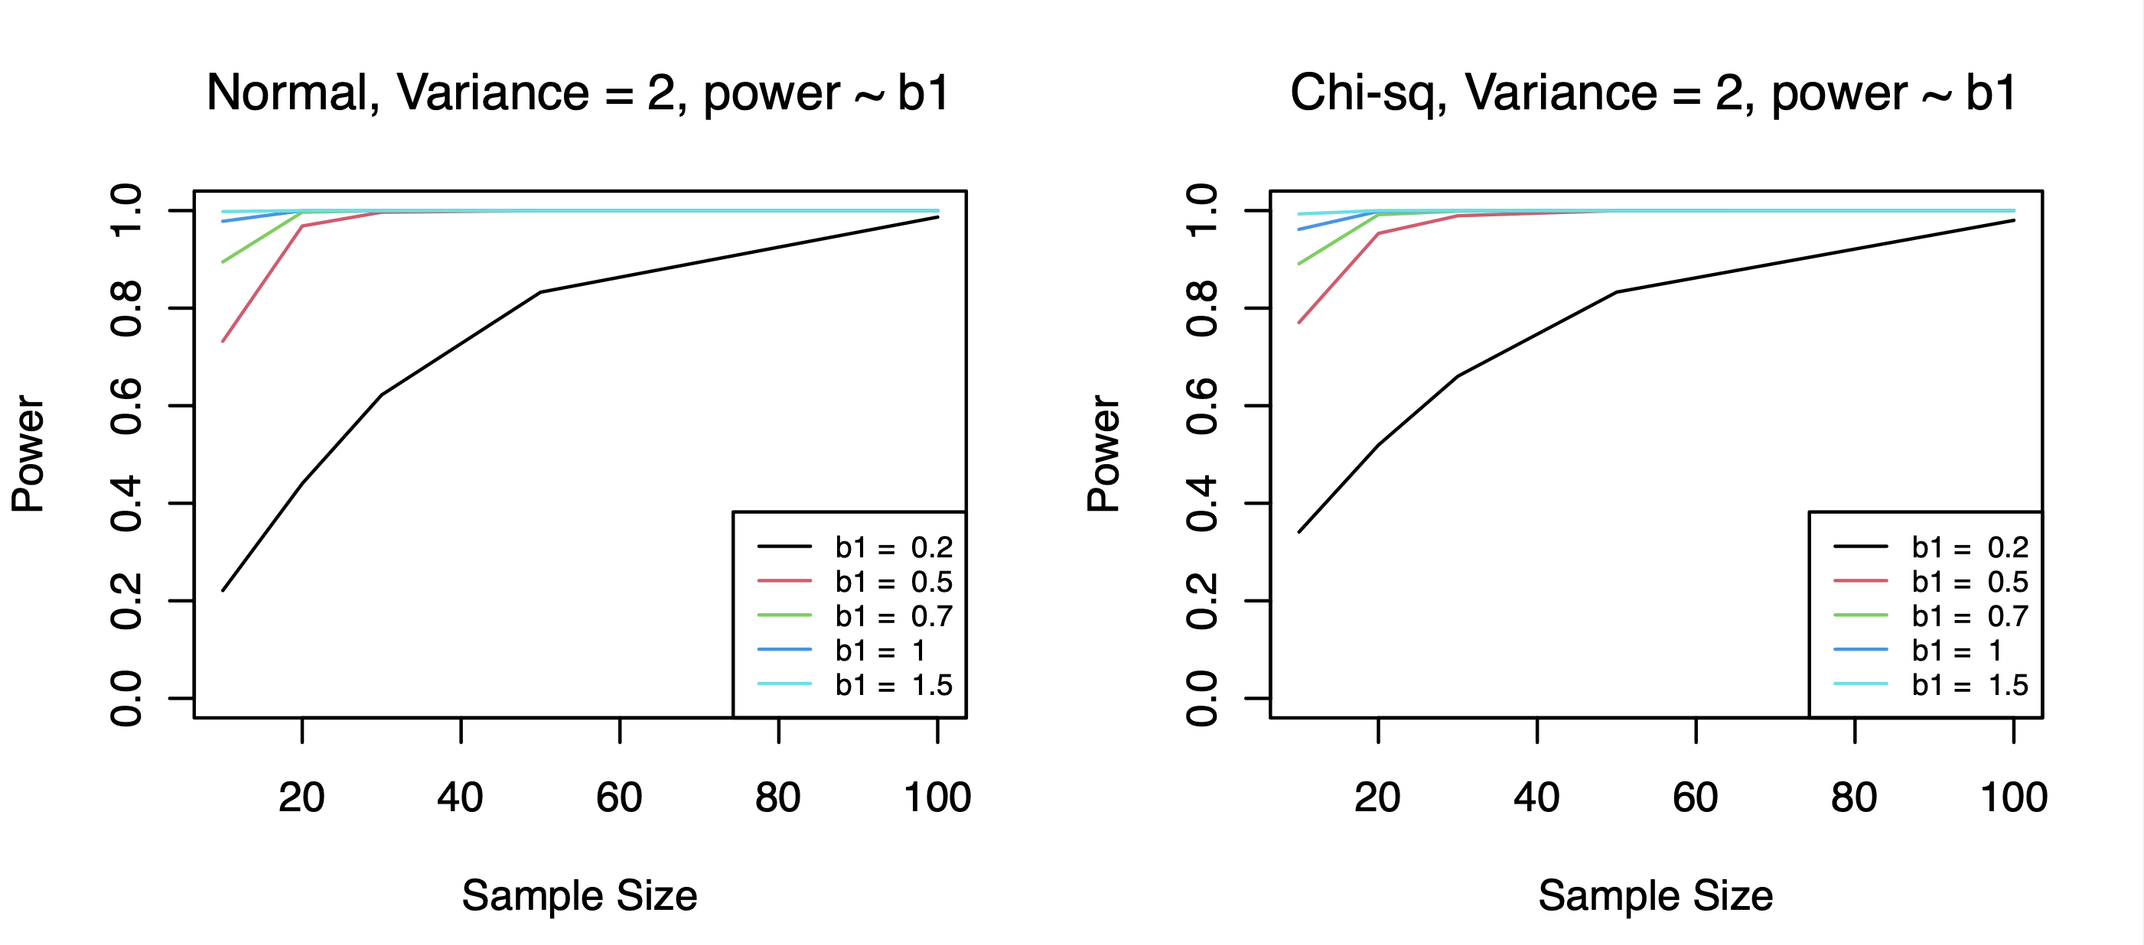

Observation: when b1=0.2, the power trend is clearer, power not overwhelming large.

* **Type I error rates**

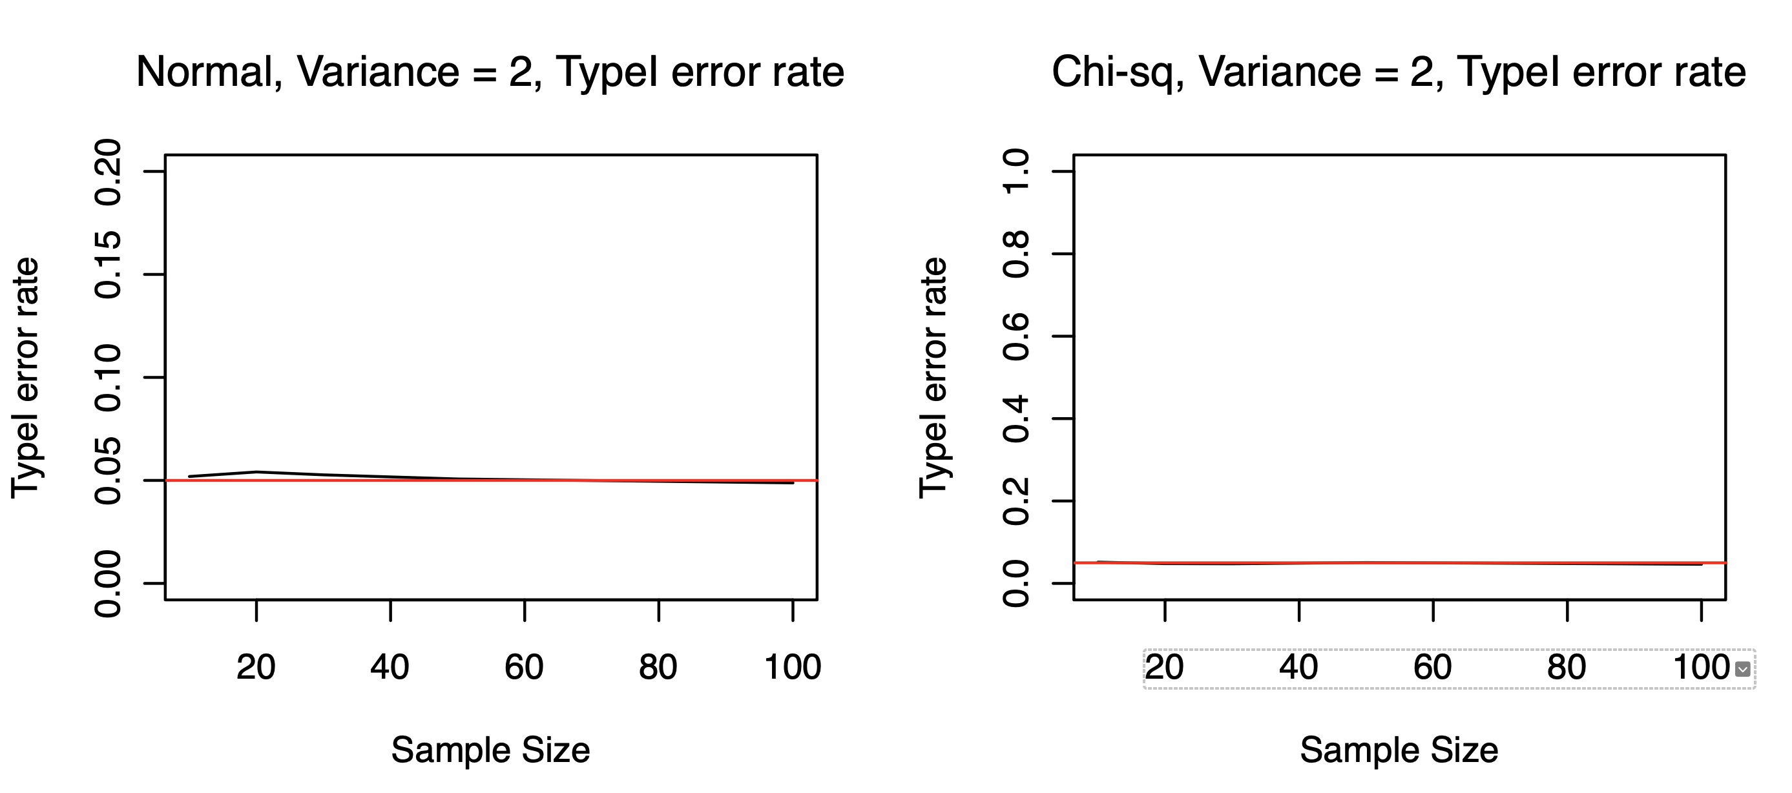

Observation: We cannot observe obvious inflated type I error rate when errors are generated from Chi-Square distribution.

* **b1 fixed, variance value change**

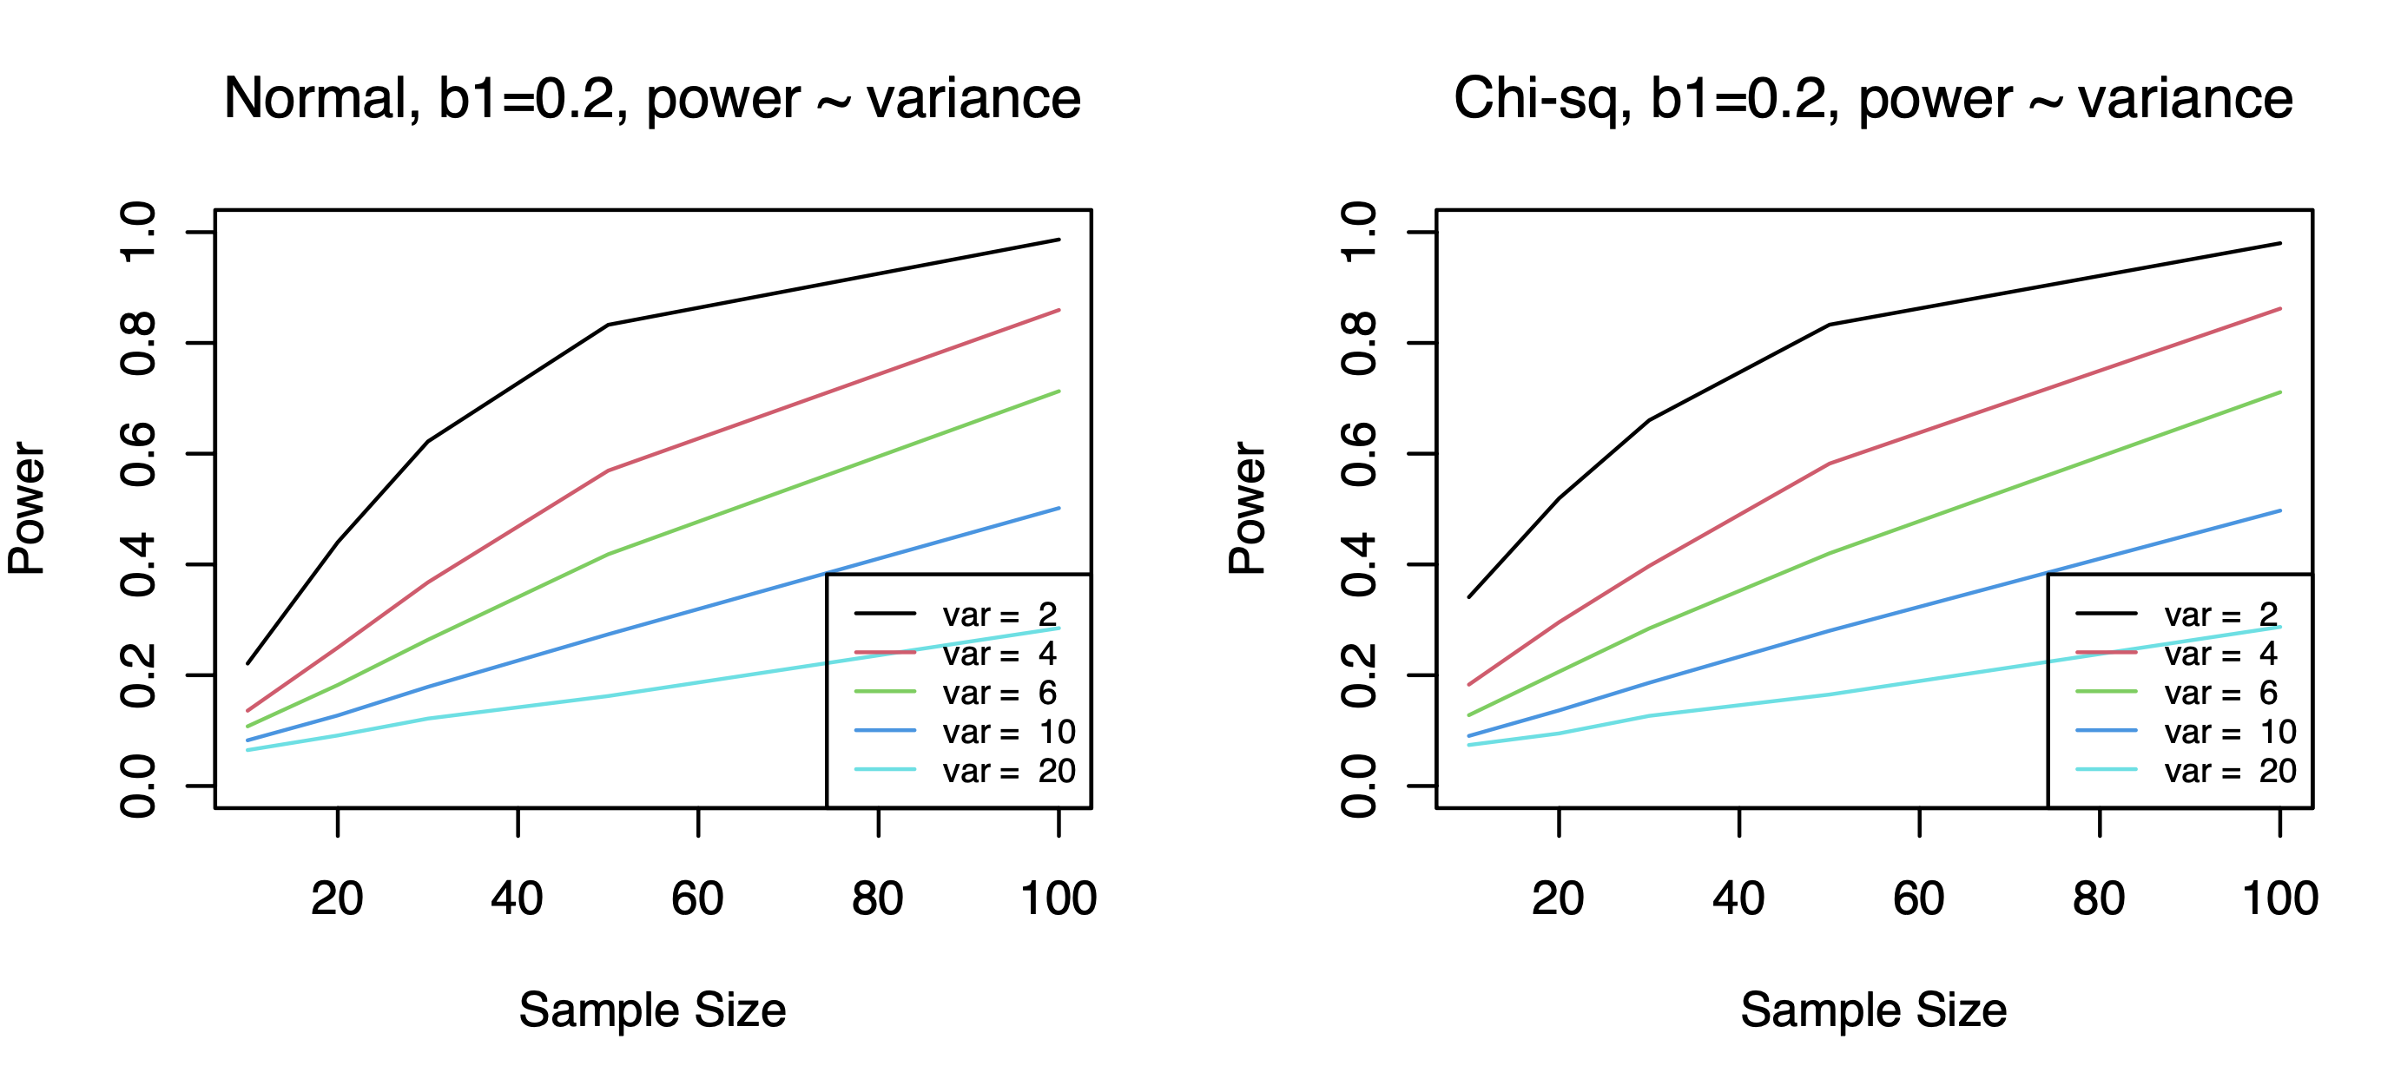

Observation: when b1 is fixed, power decreases while variance increases

* **Normality test**

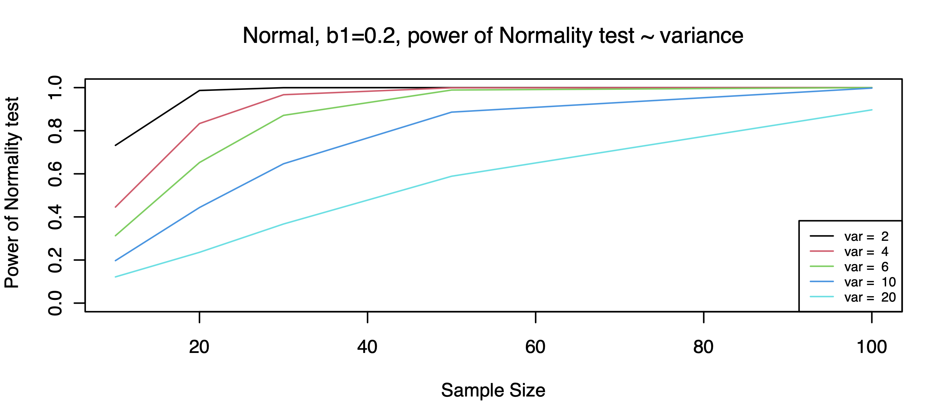

Observation: generally, the power of normality test increases as the increase of the sample size. And when variance increase, we observe that the power of the normality test decreases.

* **Utility of Normality test**

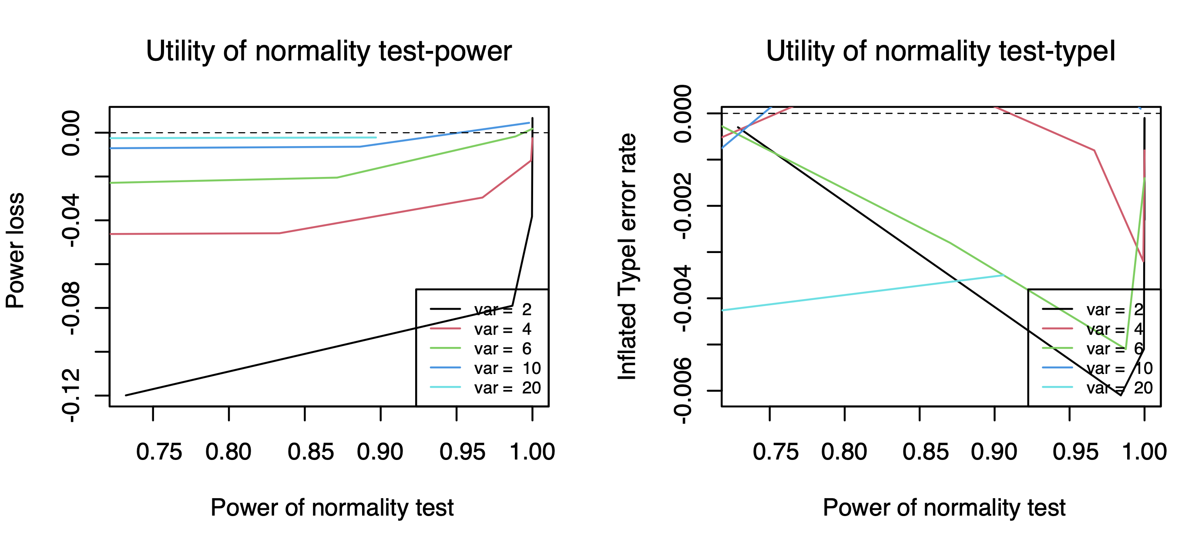

Observation: *Power*: generally the powers when errors are generated from chi-square distribution are higher. And as variance increases, the power difference is getting smaller.

*TypeI error rate*: we cannot observe obvious inflated typeI error rates when errors are generated from chi-square distribution.

1. **Beta Distribution**

* **Find b1 value with good power**

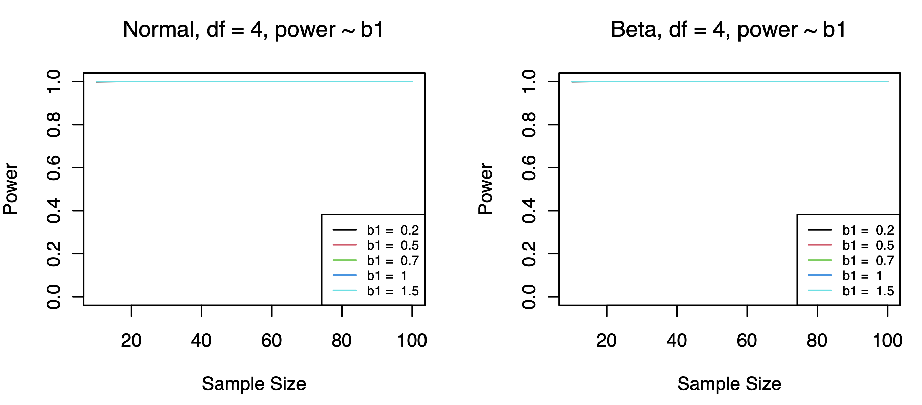

Observation: There’s no obvious power difference across all the b1 values.

* **Type I error rates**

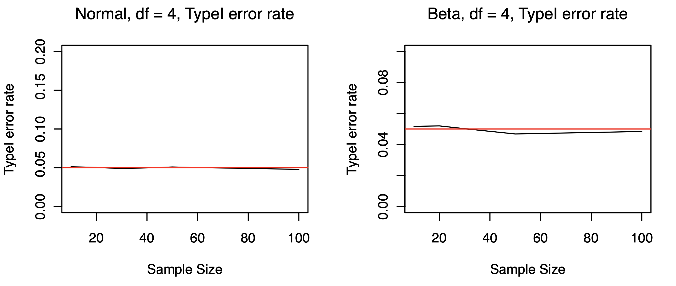

Observation: We cannot observe obvious inflated type I error rate when errors are generated from Beta distribution.

* **b1 fixed, degree of freedom value change**

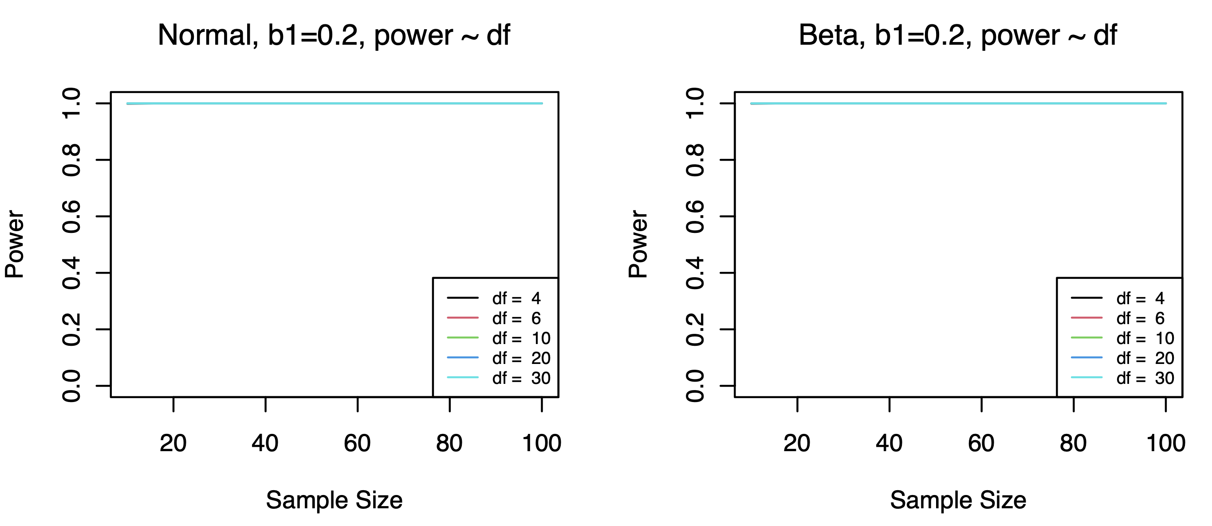

Observation: There’s no obvious power difference across all the df values.

* **Normality test**

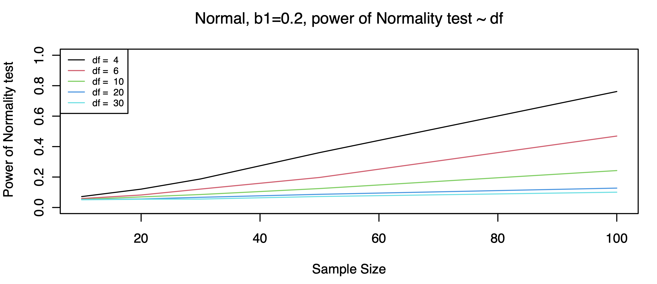

Observation: Powers of normality test here are generally lower, and as the value of degree of freedom increases, the power of normality test decreases.

* **Utility of Normality test**

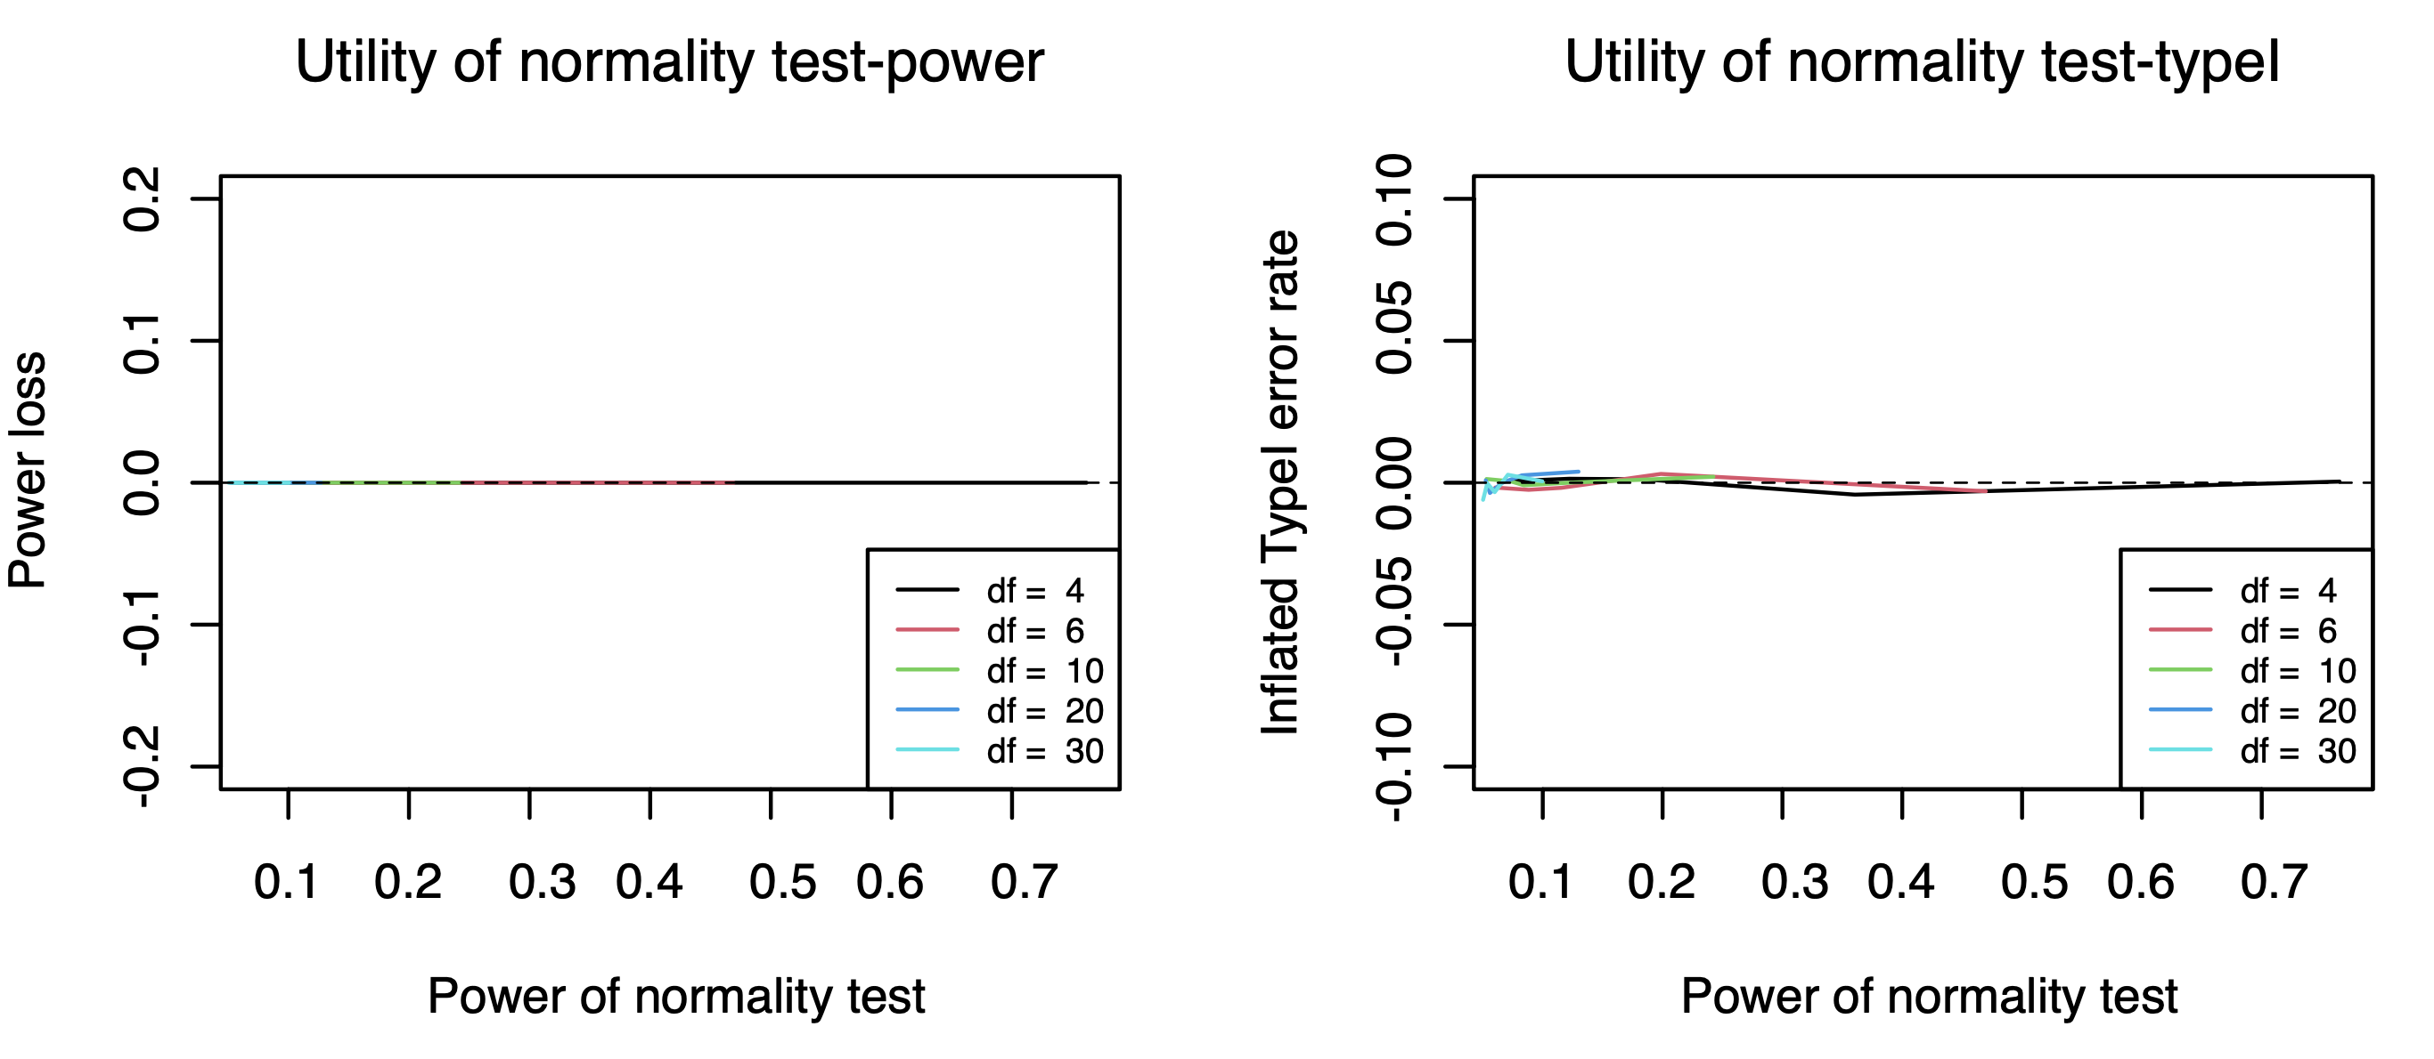

Observation: We cannot observe obvious power loss or inflated type I errors here.

1. **Student’s t Distribution**

* **Find b1 value with good power**

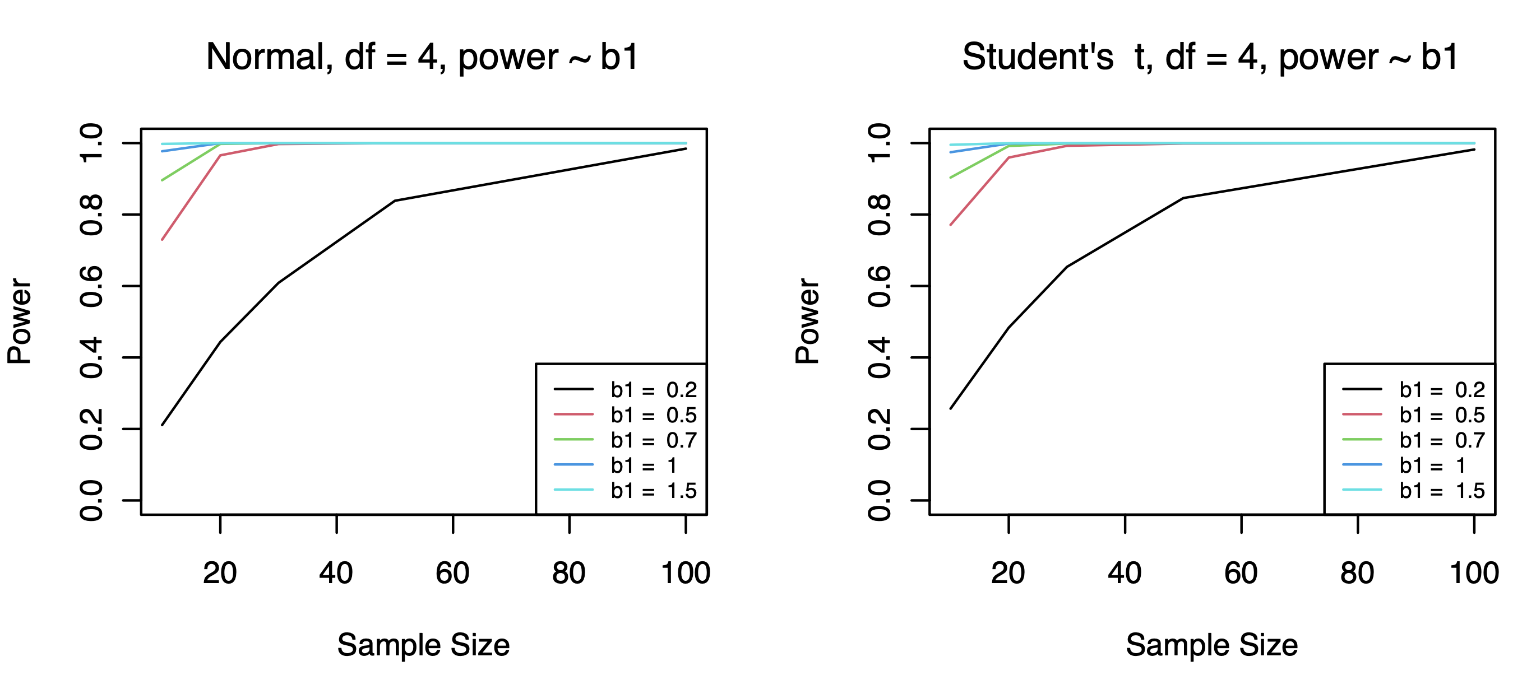

Observation: when b1=0.2, the power trend is clearer, power not overwhelming large.

* **Type I error rates**

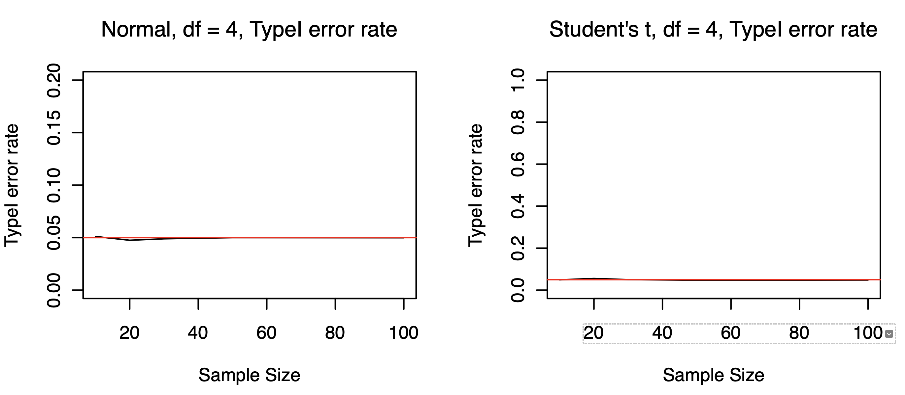

Observation: We cannot observe obvious inflated type I error rate when errors are generated from Student’s t distribution.

* **b1 fixed, degree of freedom value change**

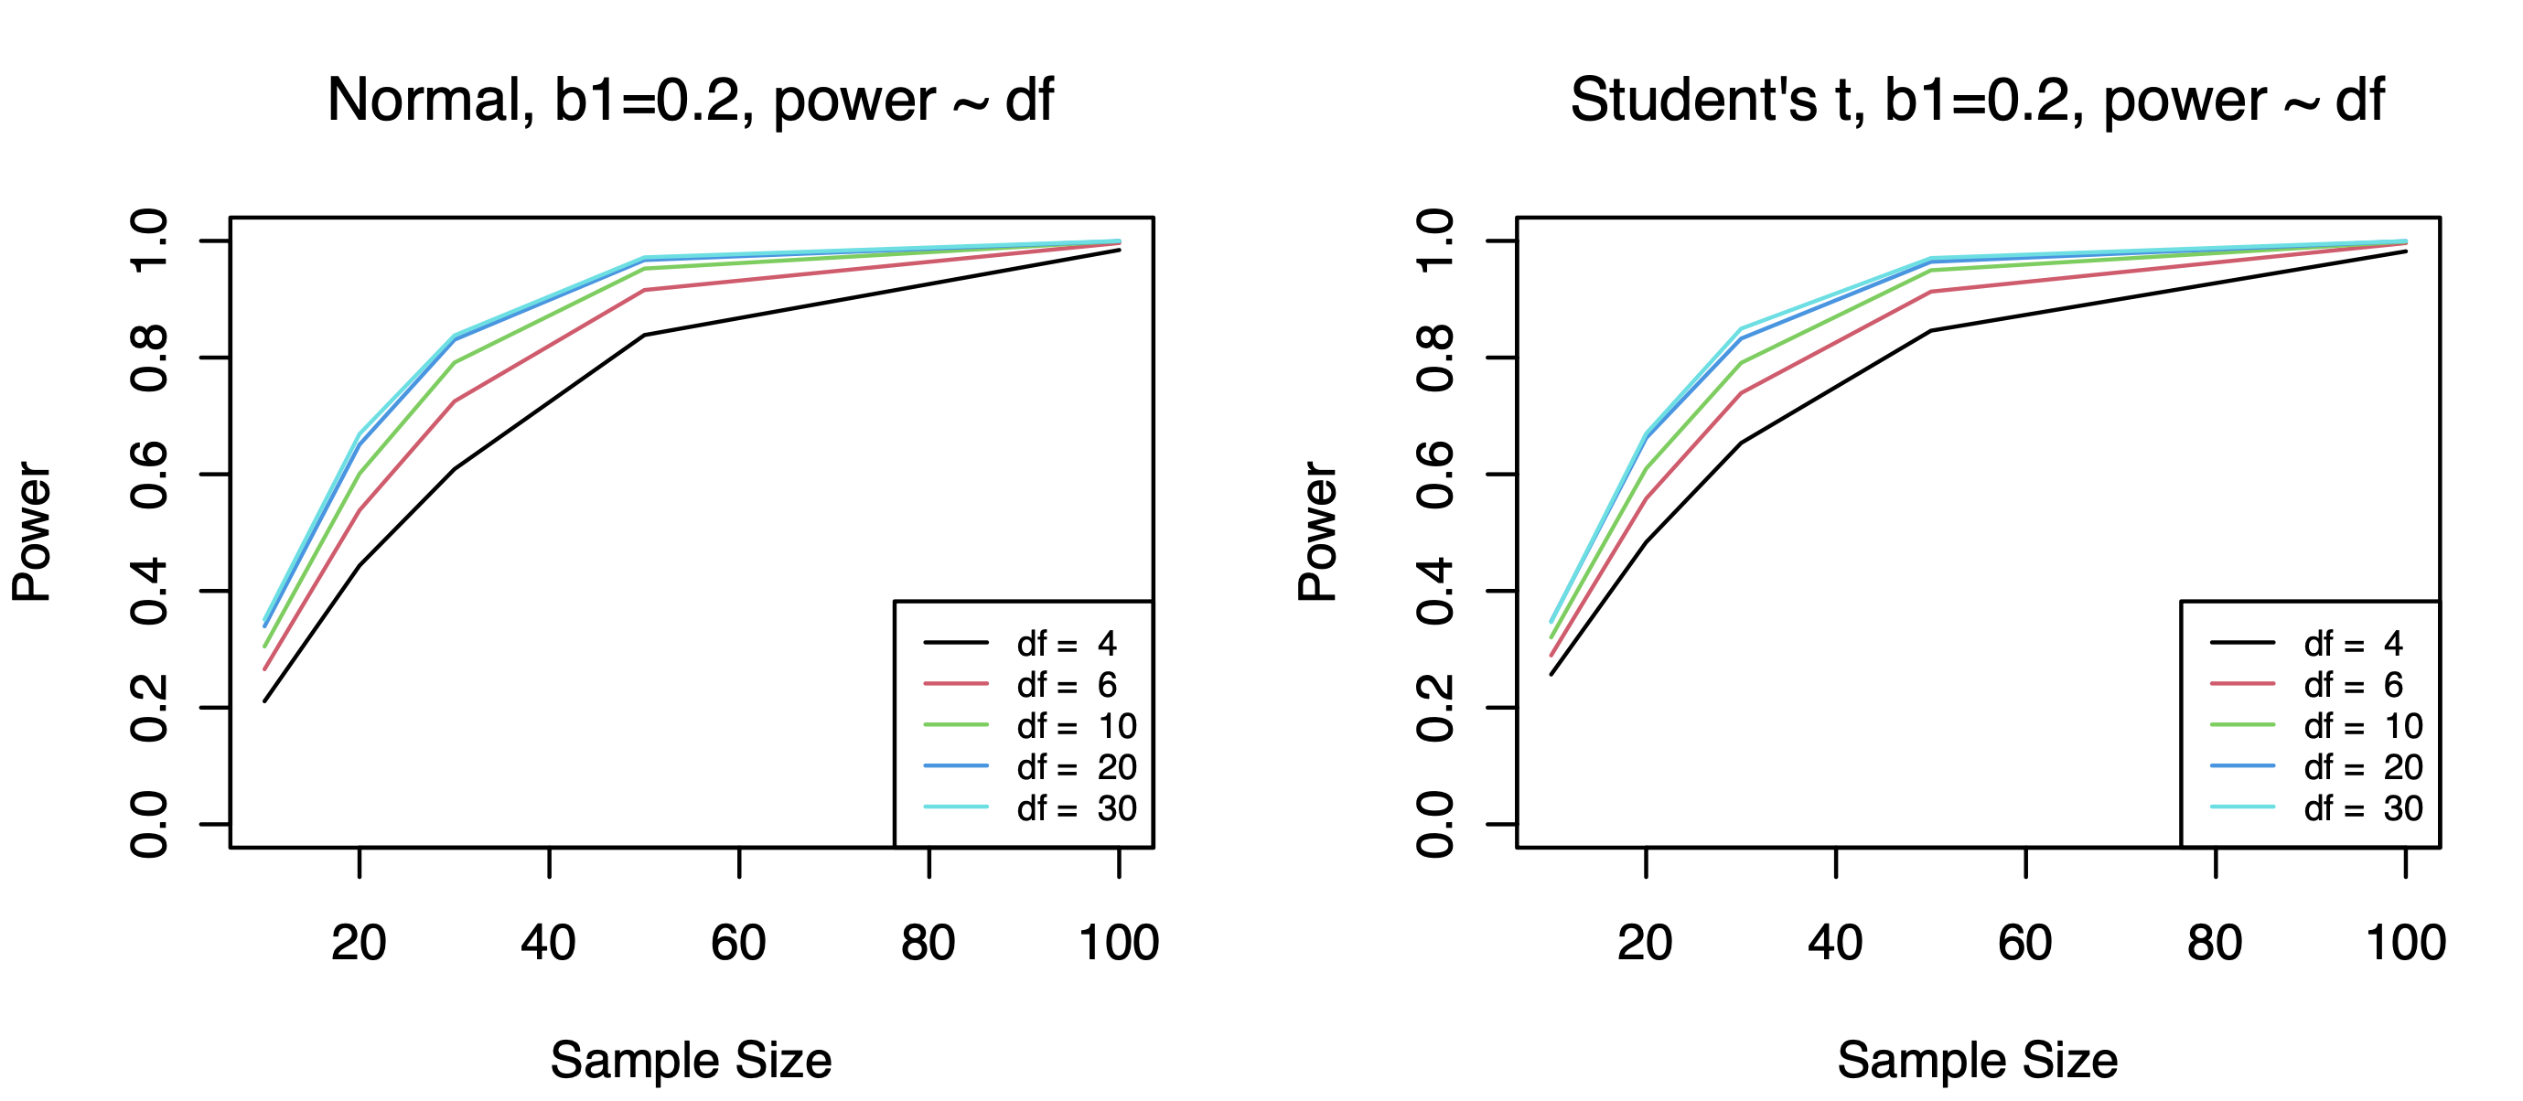

Observation: generally, power increases as the sample size increases. And power increases while the value of degree of freedom increases.

* **Normality test**

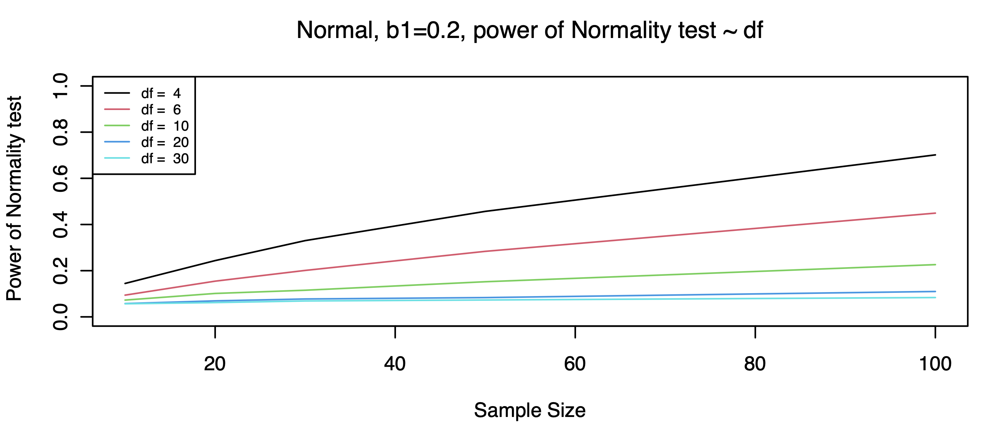

Observation: Powers of normality test here are generally low, and as the value of degree of freedom increases, the power of normality test decreases.

* **Utility of Normality test**

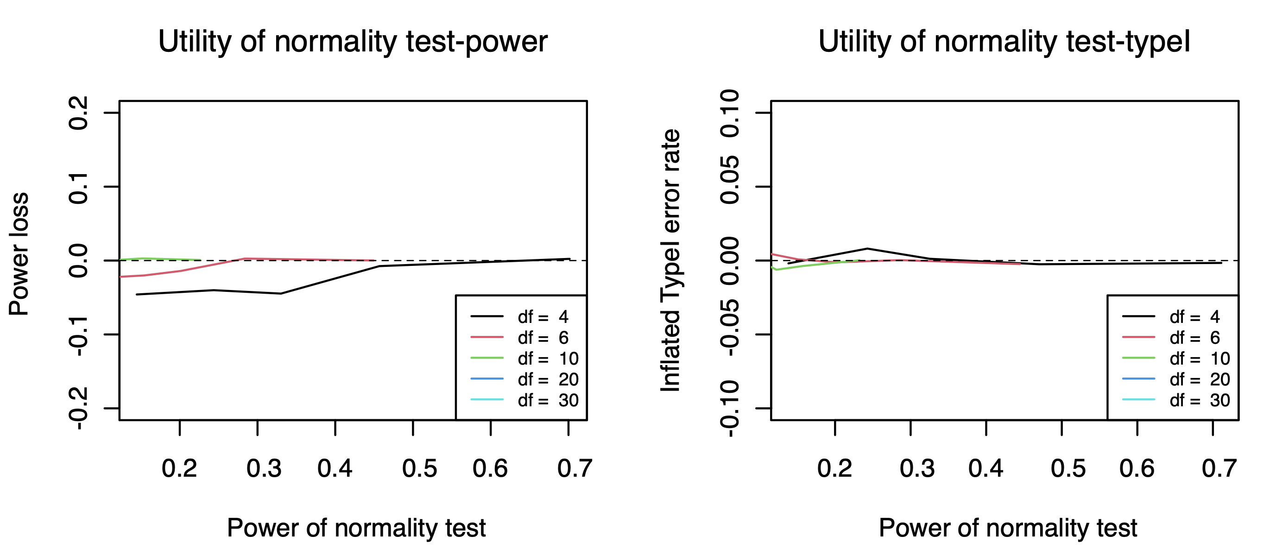

Observation: we cannot observe obvious power loss and inflated type I error rates here.

1. **Exponential Distribution**

* **Find b1 value with good power**

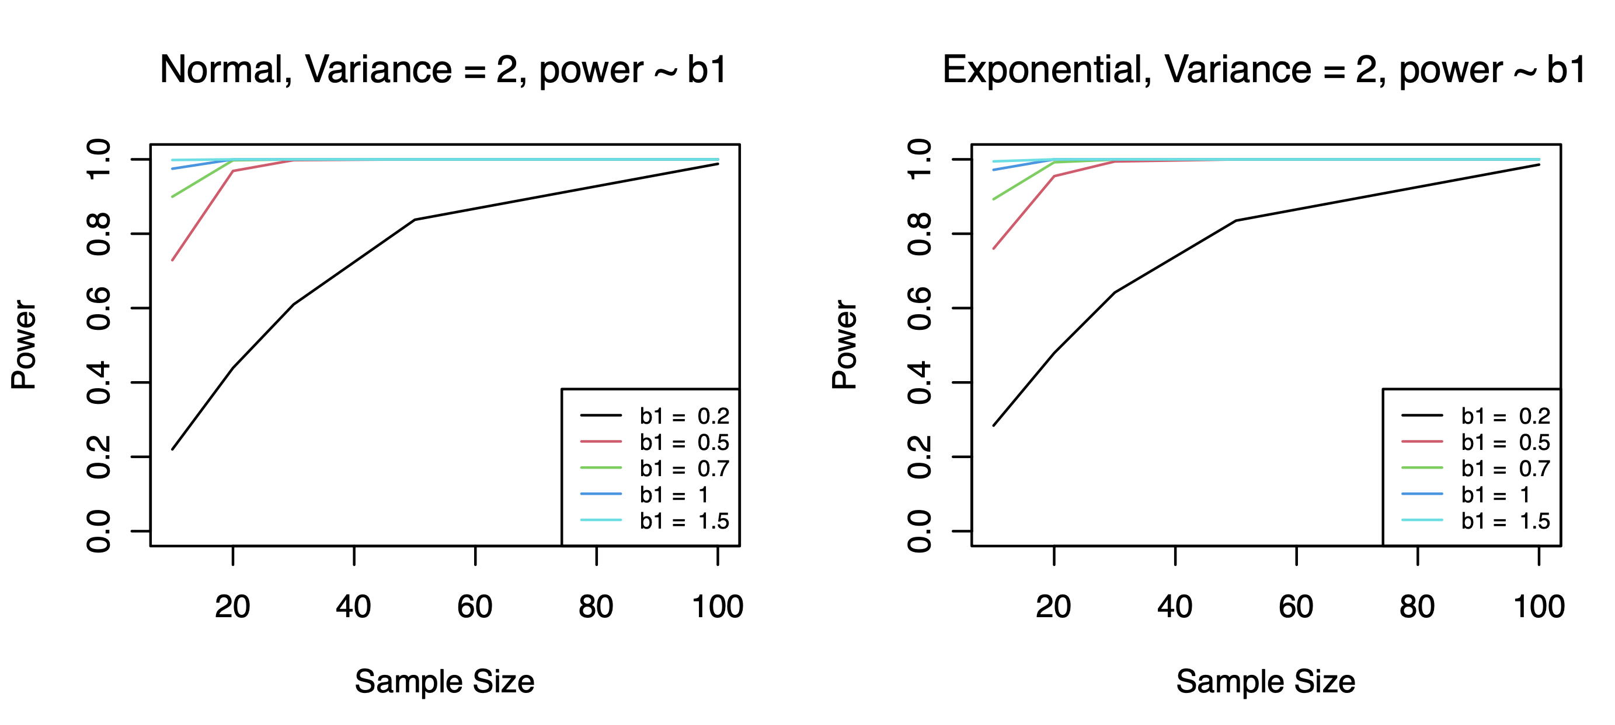

Observation: when b1=0.2, the power trend is clearer, power not overwhelming large.

* **Type I error rates**

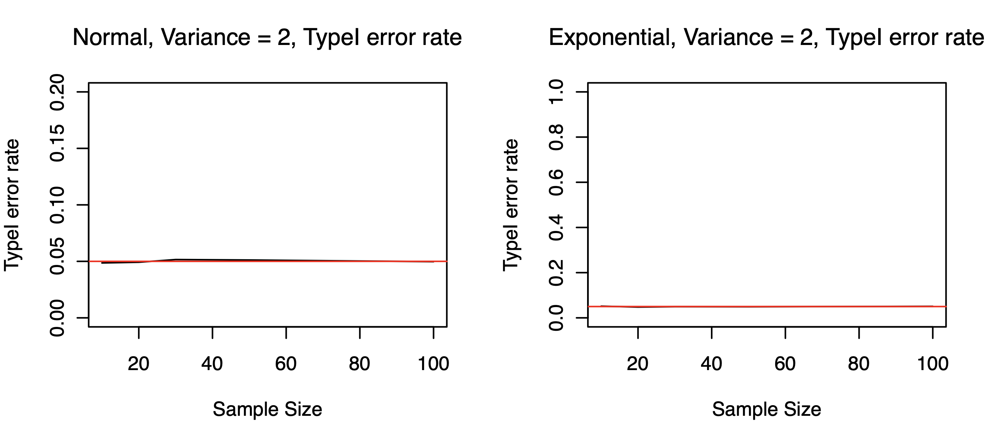

Observation: We cannot observe obvious inflated type I error rate when errors are generated from Exponential distribution.

* **b1 fixed, variance value change**

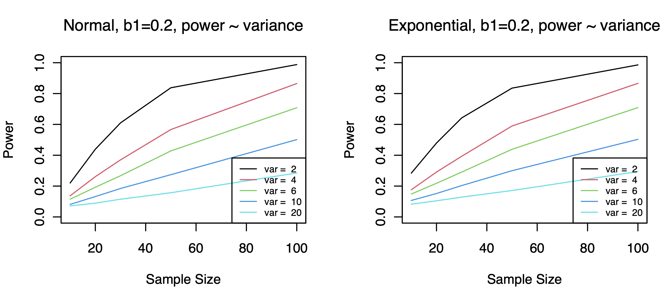

Observation: when b1 is fixed, power decreases while variance increases

* **Normality test**

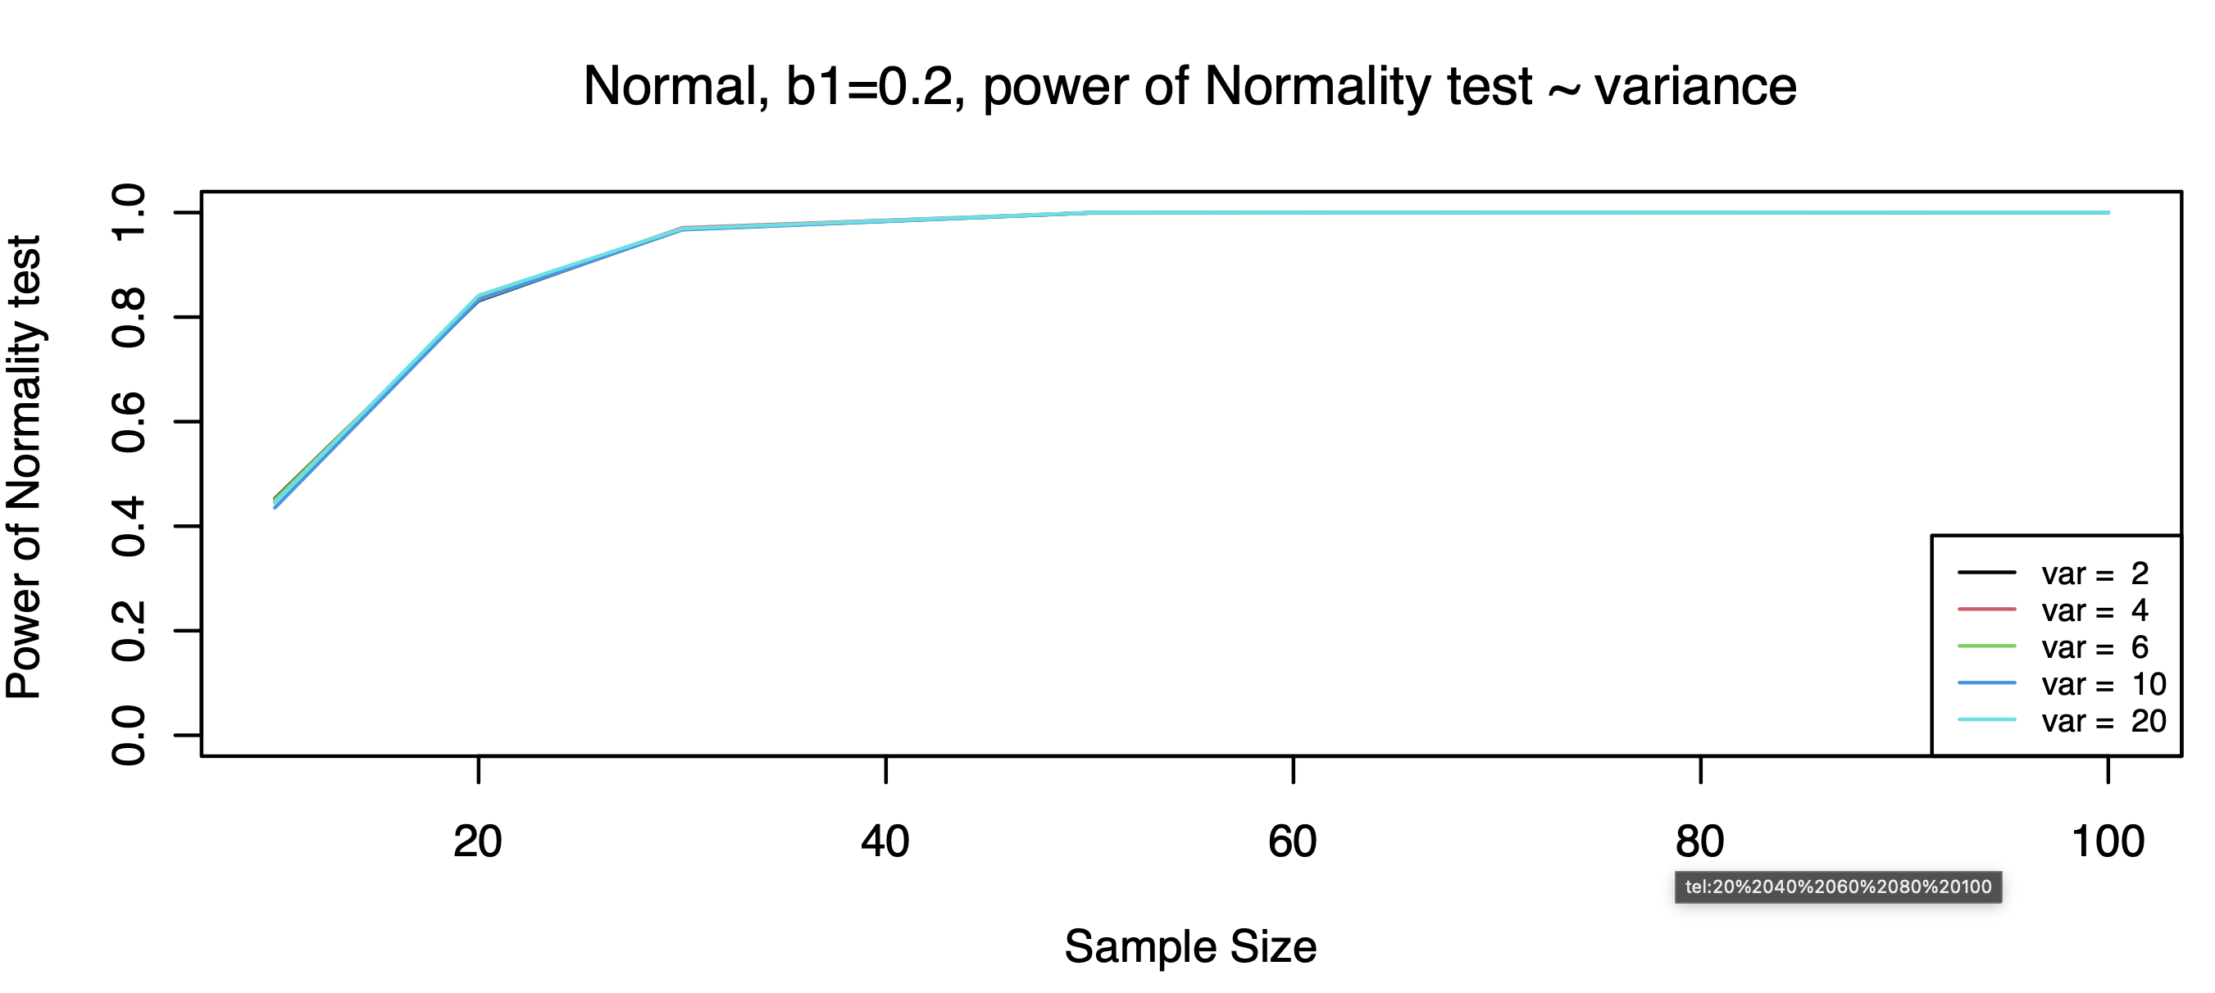

Observation: generally, the power of normality test increases as the increase of the sample size. And when variance increase, we cannot observe big difference between the powers of the normality test.

* **Utility of Normality test**

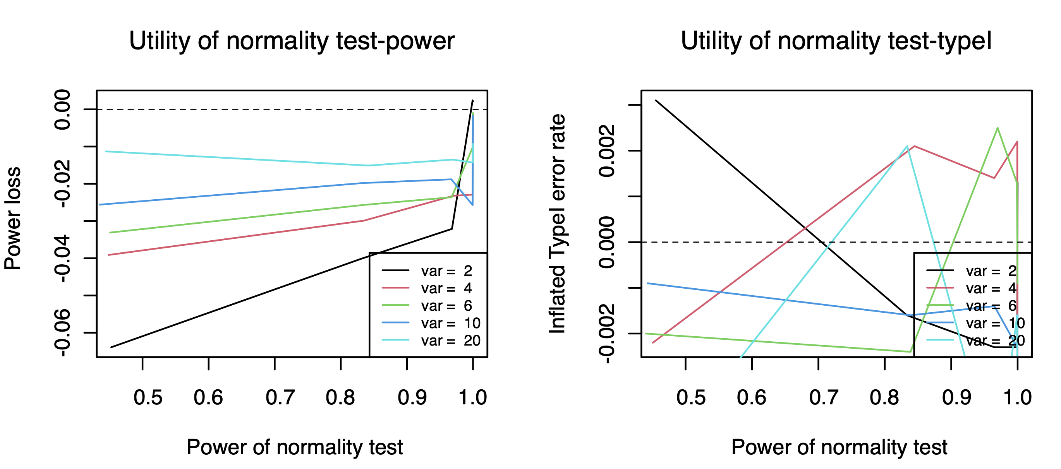

Observation: *Power*: generally the powers when errors are generated from Exponential distribution are higher. And as variance increases, the power difference is getting smaller.

*TypeI error rate*: we cannot observe obvious inflated typeI error rates when errors are generated from Exponential distribution.

1. **Uniform Distribution**

* **Find b1 value with good power**

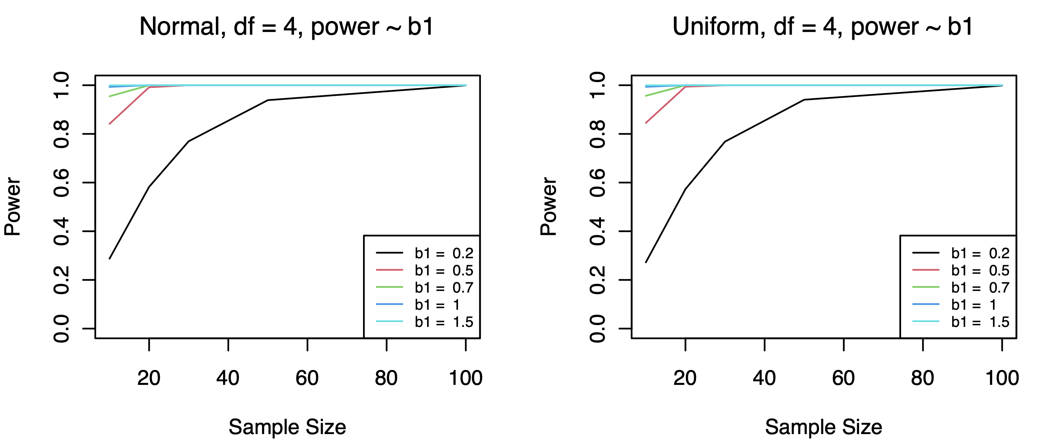

Observation: when b1=0.2, the power trend is clearer, power not overwhelming large.

B1 value use 0.2-0.5, maybe 0.1 to observe better plot(otherwise power too high)

* **Type I error rates**

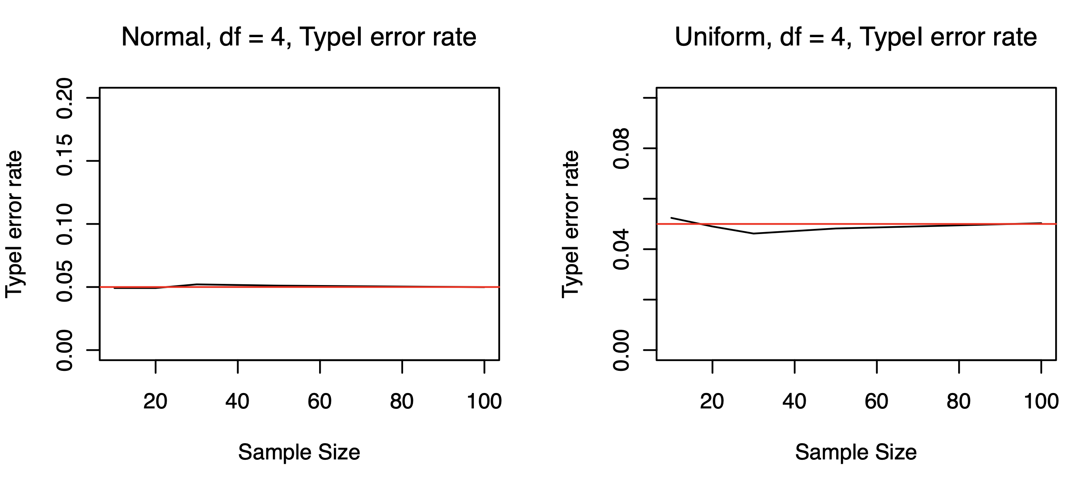

Observation: We cannot observe obvious inflated type I error rate when errors are generated from Exponential distribution.

* **b1 fixed, variance value change**

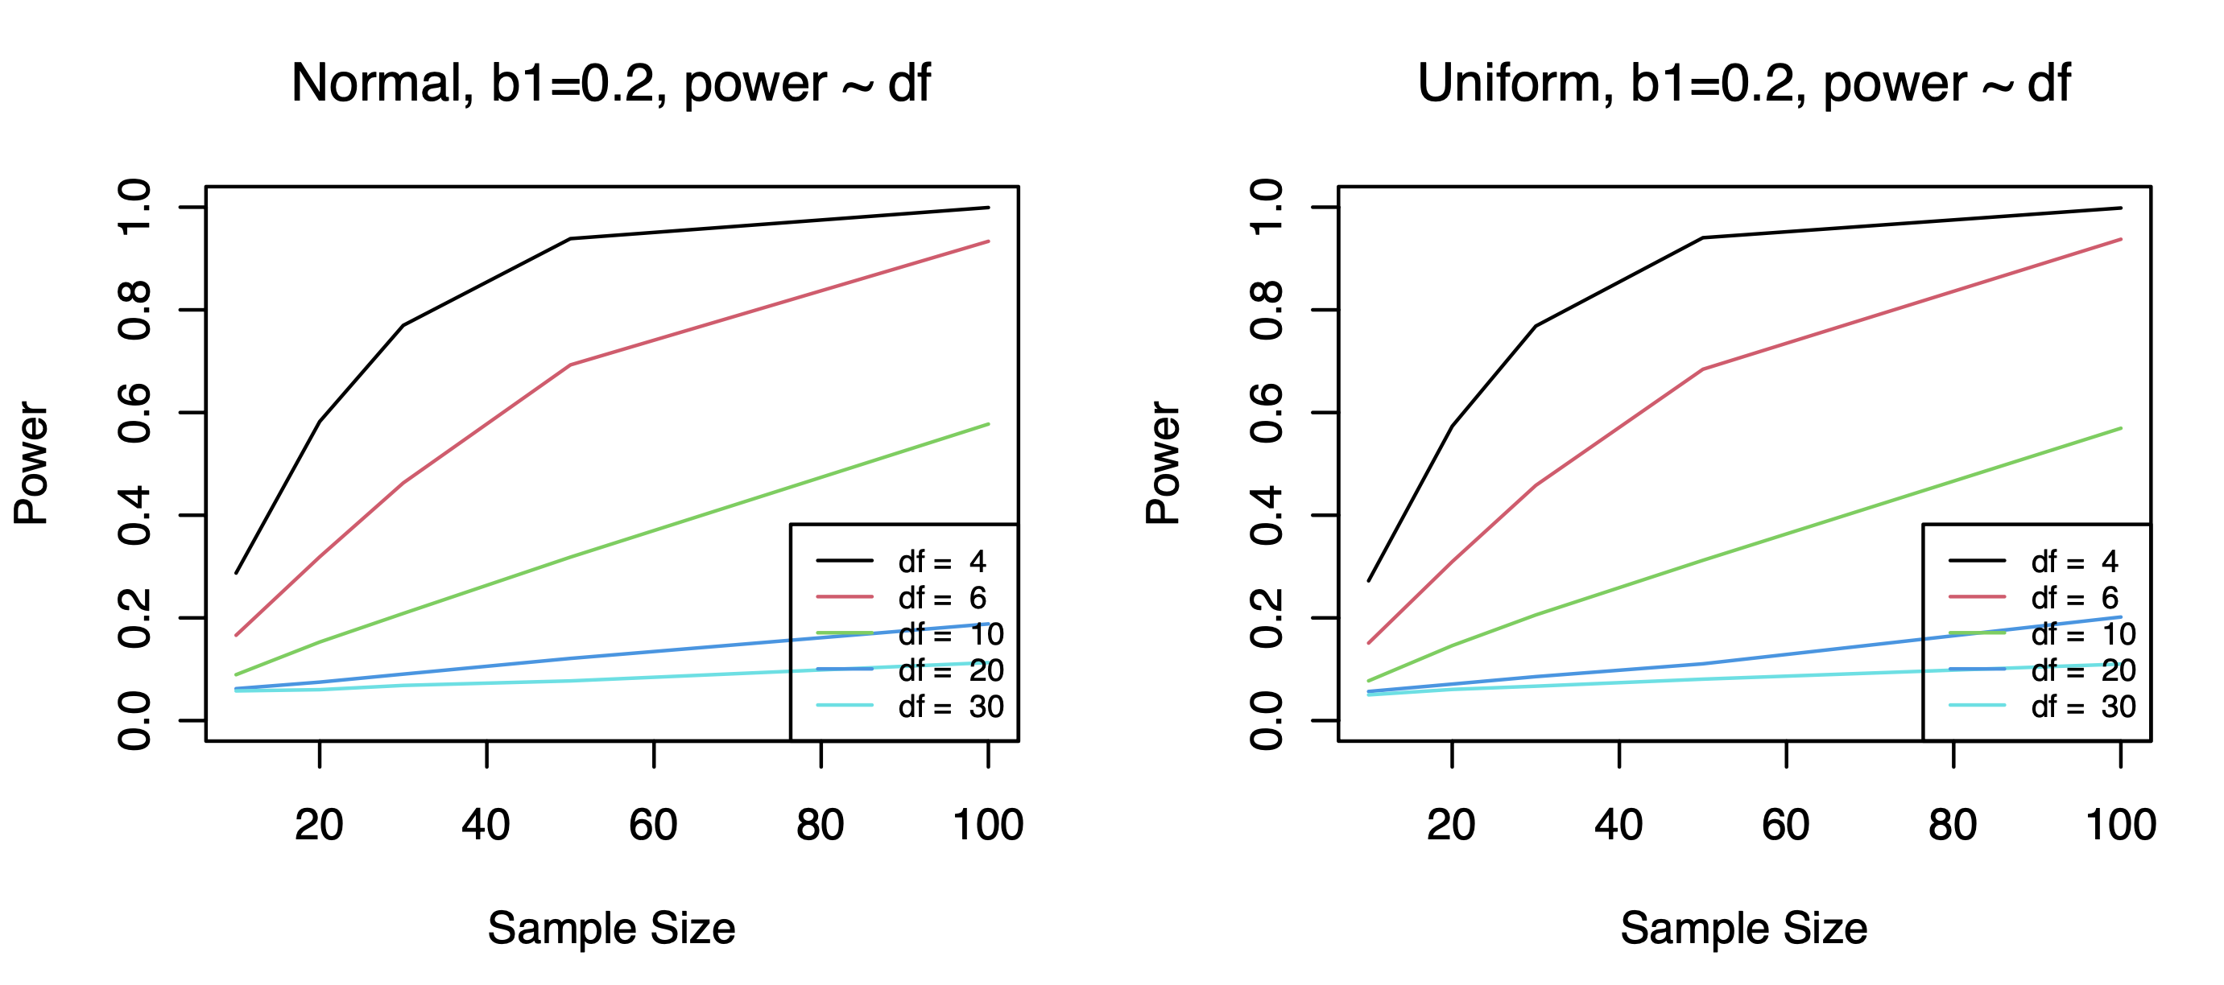

Observation: when b1 is fixed, power decreases while df value increases

* **Normality test**

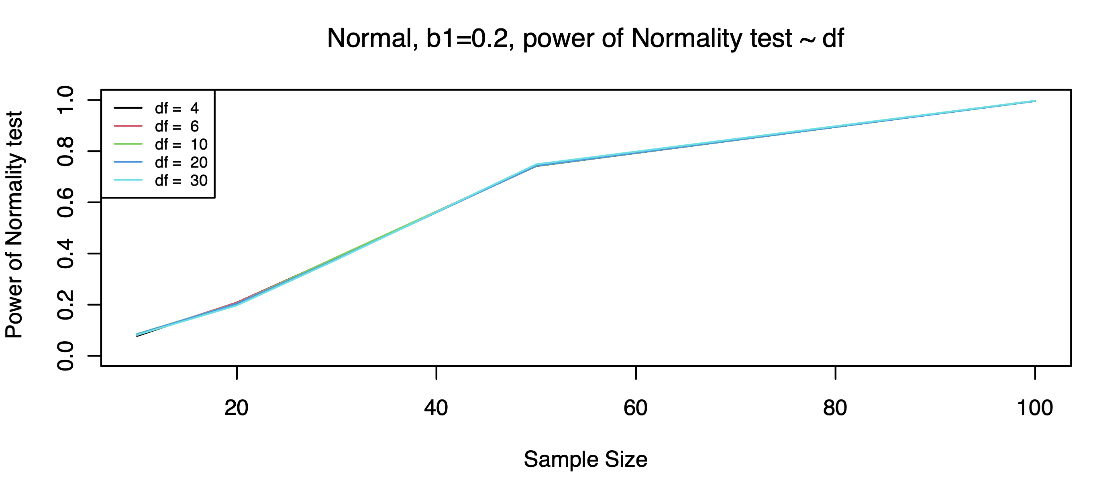

Observation: generally, the power of normality test increases as the increase of the sample size. And when df value increase, we cannot observe big difference between the powers of the normality test.

* **Utility of Normality test**

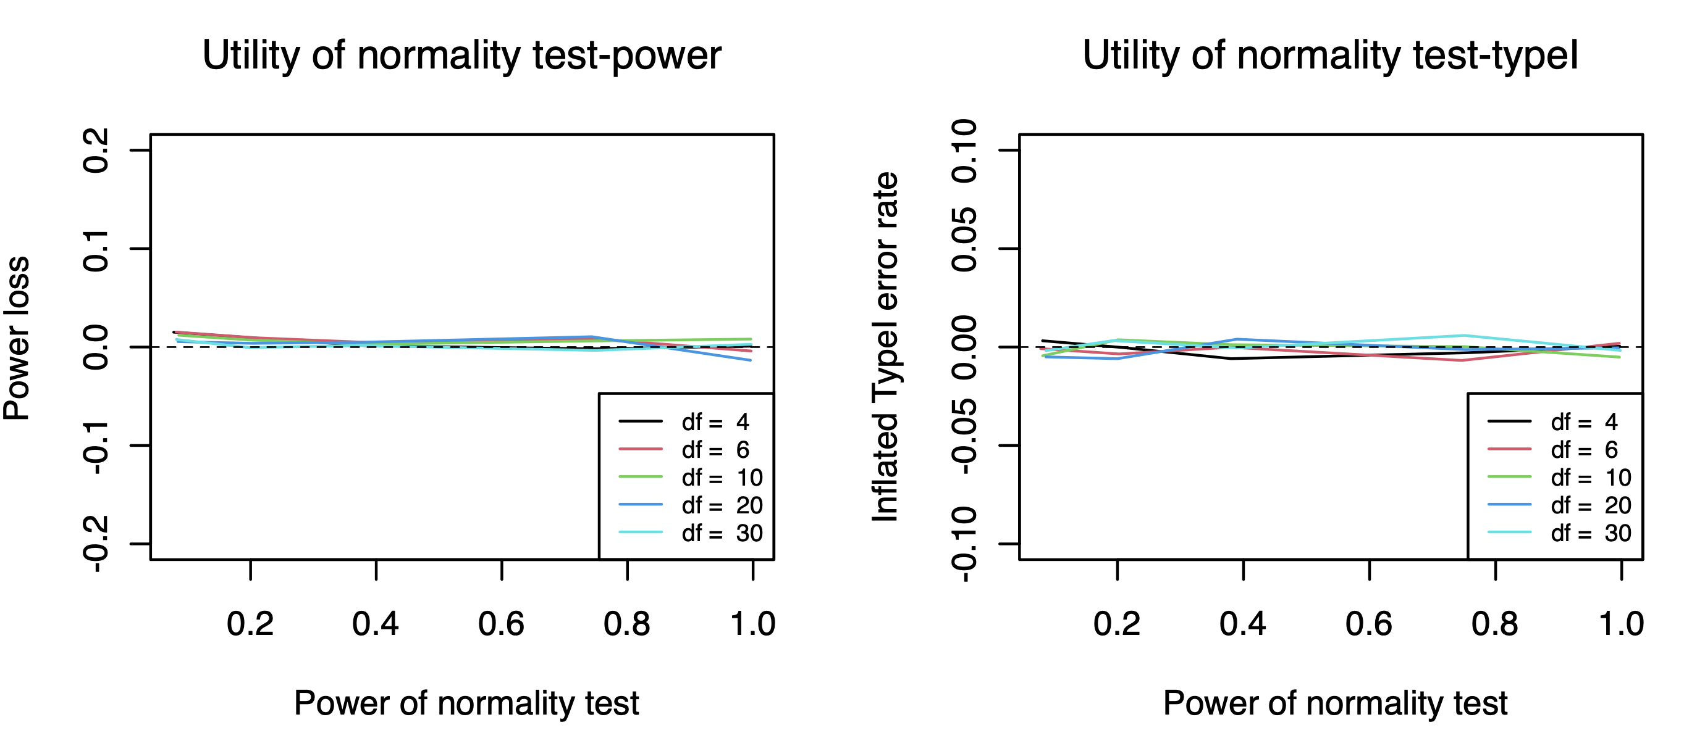

Observation: we cannot observe obvious power loss and inflated type I error rates here.

* Got similar results and plots after changing the df values smaller (type I errorsexpect to be higher)
* Beta dist: changed b1 values 10x bigger to get the effect that variances 10x bigger --- powers are still too high. And similar plots as before.